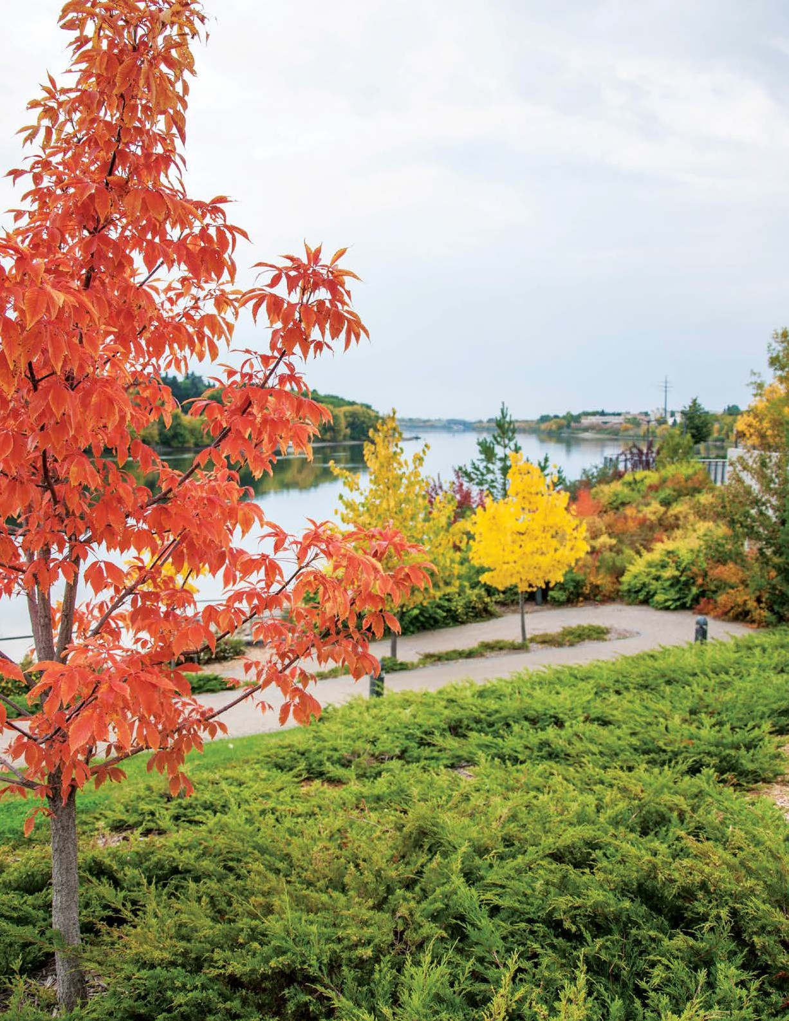

A CITY OF SASKATOON SEMI-ANNUAL PUBLICATION FROM PLANNING & DEVELOPMENT FALL/WINTER 2018

Homelessness in Saskatoon Regional Partnerships Cannabis Regulations Brownfield Renewal Strategy The Coming Spring Public Art Downtown Development Major Corridors

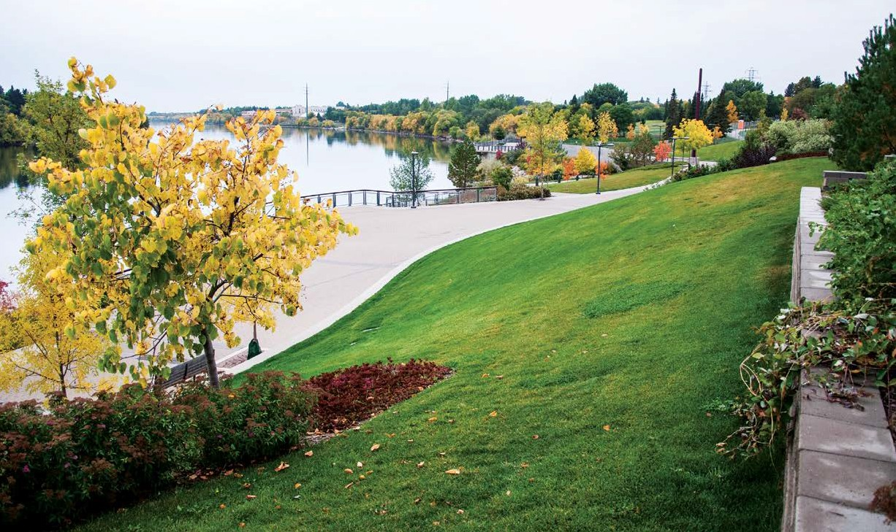Message from the Director
PLANNING + DESIGN FALL/WINTER 2018
Occasionally it seems relevant to go back to basics and talk about why Planning occurs at all. What value does it bring to the community?

There are many reasons, including making sure that all the different amenities, like parks and schools, are located near homes, or that an industrial area has the right road access. One fundamental principle, though, is that Planning is about creating certainty - for residents, businesses and industries. It helps all of these groups to know where different land uses can occur and where they can’t. Sometimes it is easy to miss the “why” behind these decisions and over time, the “why” that created the separation may no longer exist.

Zoning regulations are the tool that help enforce the values around how our community is built. As industries change practices or adopt new technologies, the zoning regulations that are needed may no longer be the same. As preferences in housing styles change, the regulations may not allow that change to occur. Zoning needs to change over time. It is time for Saskatoon’s Zoning Bylaw to go through a comprehensive review to ensure that current regulations will achieve outcomes that we all want; as residents, employees, business owners, park users and students. A proposal to undertake this review has been included in the 2019 Capital Budget. Although many pieces of the current Zoning Bylaw are still functional, we want to ensure the right regulations are in place to accommodate changes in industries and preferences.

Through Local Area Plans, Streetscape Master Plans and other strategies, Planning provides the tools to change and adjust the

built environment over time and address things like safety, beauty and even whimsy. Additions to public spaces can create new interest, encourage new activities and allow people to see a space in a brand new way. The Urban Design Program works with the Business Improvement Districts to make such improvements. The program is currently working on plans to reinvent a downtown alley. This redesign will challenge our views on how alleys can be used and appreciated.

Local Area Plans (LAPs) can help neighbourhood residents steer the changes they’d like to see, re-inventing or strengthening their own neighbourhood to respond to new conditions. The Montgomery Place LAP is nearing the final stages of approval. The Plan for Growth, which is moving through implementation, will also work with neighbourhoods to strengthen connections from major travel corridors to area amenities. It will also identify ways to transition from major corridors to existing neighbourhoods. This is a more proactive approach that will move in tandem with upcoming changes, like the Bus Rapid Transit network.

Planning works in many ways to help the community move through changes that we’re all experiencing. I hope that the articles in this edition of Planning + Design give you examples of how our work helps build the community.
Lesley Anderson, MCIP, RPP
Director of Planning and Development
306-975-2650 / lesley.anderson@saskatoon.ca

PLANNING & DEVELOPMENT, COMMUNITY SERVICES DEPARTMENT

NEIGHBOURHOOD PLANNING

Saskatoon’s 2018 Point-In-Time Count helps direct community’s response to homelessness
Daryl Sexsmith, Housing Analyst / 306-975-7693 / daryl.sexsmith@saskatoon.ca

On April 18, 2018, there were a total of 475 homeless people counted in Saskatoon, including three youth and 11 children. Included were 86 people who identified themselves as part of Saskatoon’s hidden homeless population. The hidden homeless were not sleeping outside or in a shelter, but on that particular date had no permanent home. Many described themselves as ‘couch surfing’ with friends and family.

The Point-In-Time Homeless Count (PIT Count) was conducted by the Saskatoon Housing Initiatives Partnership (SHIP) and the Community-University Institute for Social Research (CUISR) with the help of more than 150 volunteers who interviewed community members experiencing homelessness that day.

The intention of a PIT Count is not to record every individual without a permanent address, but rather to observe trends within the homeless population, determine if homelessness is growing and help decision makers allocate resources within the community.

This was the fourth PIT Count in Saskatoon over the past 10 years. It indicates that homelessness continues to grow along with the general population, as shown in the chart below:

Saskatoon's Population Growth and Homeless Count
Saskatoon's Population
PIT Counts include further details that inform the community’s response to homelessness. They include how long people are homeless, the age of the homeless population, their family make up and what supports could move them into permanent housing.

Following Saskatoon’s third PIT Count in 2015, a number of community agencies including the City of Saskatoon created Saskatoon’s Homelessness Action Plan. The City provides annual funding of $130,000 to SHIP to coordinate the implementation of the Action Plan. In addition, City officials serve on SHIP’s board of directors that provides oversight to the work.

A key part of the Action Plan involves strengthening housing placement and support programs in Saskatoon. The first program started in 2014, and Saskatoon now has six agencies that provide Housing First and Rapid Re-housing programs to people experiencing homelessness.

Housing First and Rapid Re-housing programs help people who have been homeless for a period of time to find affordable housing. The programs also provide intensive case management to help people stay housed by addressing underlying issues that led to homelessness. It can include help managing addictions, mental health supports, assistance finding and maintaining employment, budgeting and life skills training.

Since 2015, 589 people have been housed and supported through Housing First and Rapid Re-housing programs in Saskatoon. There
475

Homeless Count

239,032
450

258,112
278,500
have been many success stories and this year’s PIT Count will help community agencies focus resources where they can have the greatest impact in moving people out of homelessness.

214,944
260
379

Please note a correction to Page 11 of the Spring/Summer 2018 issue, in the article Infill Round Table.
The first sentence of the third paragraph should have read:

“In response, the Saskatoon and Region Home Builders’ Association brought forward a proposal to convene an Infill Roundtable with representatives from the development industry, the Mayor’s office, City Councillors and the Civic Administration.”

We apologize for the error.
2008 2012 2015 2018

REGIONAL PLANNING
Regional Partnerships – What’s new?
Dana Kripki, MCIP RPP, Senior Planner / 306-975-1432 / dana.kripki@saskatoon.ca

Peter Ballantyne Cree Nation is the newest partner in the Saskatoon North Partnership for Growth (P4G) Region. The recent establishment of a working relationship with the First Nation and Peter Ballantyne Group of Companies has given us the opportunity to include their 160-acre land selection on the P4G Regional Land Use map.

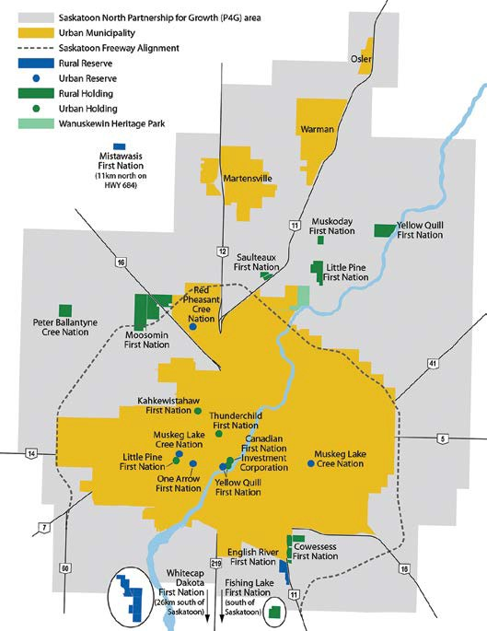
Muskeg Lake Cree Nation celebrated the 30th anniversary of the creation of asimakaniseekan askiy (Soldier’s Land) Urban Reserve on Sept. 27, 2018. The urban reserve, located in the Sutherland Industrial neighbourhood of Saskatoon, was the first of its kind in Canada.

Development at the urban reserve property has been ongoing since its inception in 1988. Most recently in 2016, construction of Phase II was completed and several new businesses have since opened, including Lead Pilates.

Phase III is now underway and includes a 50,000 sq ft building and a mini storage facility. Construction for an additional structure is planned for later next year, with expected completion in 2020. The anticipated number of new tenants is three to five in 2019 and six to 10 in 2020.
There are about 60 businesses on site, with estimated total employment between 600 and 800 employees. Total developed space is about 135,000 sq ft and includes a mix of commercial and light industrial uses.

First Nation Community Profiles: Regional Planning is pleased to announce Thunderchild First Nation Community Profile is now available online here: saskatoon.ca/business-development/ planning/regional-planning/urban-reserves-treaty-land- entitlement. First Nation Community Profiles are a two-page summary intended to promote economic partnerships and opportunities. They also highlight leadership, strengths and assets of each of the 15 First Nations with land holdings and reserves in and around Saskatoon. Each profile has been recently reviewed and updated to reflect changes in statistics, leadership or other information. Two additional profiles are currently in the draft stages.

ayisiyiniwak: A Communication Guide 2nd Edition, (fall 2018)
Over the summer, Regional Planning and Aboriginal Relations have been working with community partners to update ayisiyiniwak. The second edition of the guide will incorporate:
- Updated Cree translations (including the title) as reviewed by nehiyaw, or Cree speaking linguists. The translations will be based on Standard Roman Orthnography, a widely accepted translation standard that has been developed under the leadership of Dr. Freda Ahenakew.
- Additional Métis content through a partnership with Gabriel Dumont Institute
- New sections on the following ceremonies, topics and definitions:
  - Syllabics
  - Elder’s Helper
  - Gifting (star blankets)
  - Two Spirit
  - 60’s Scoop
  - Knowledge Keeper
- Many new suggested readings and digital resources are being added to the ‘Recommended Resources’ section.

Terminology Update: Through consultation with community partners including the Gabriel Dumont Institute, the Office of the Treaty Commissioner and the Saskatchewan Indigenous Cultural Centre, we have been advised that it is now acceptable to use the term Indigenous (rather than Aboriginal), when referring collectively to First Nation, Métis and Inuit peoples. Where appropriate, this change will be incorporated throughout ayisiyiniwak – 2nd Edition.

BUSINESS LICENSE PROGRAM
Cannabis Regulations in Saskatoon
Ellen Pearson, MCIP, RPP, Senior Planner / 306-975-7710 / ellen.pearson@saskatoon.ca

As legalization of cannabis is expected on Oct. 17, 2018, the City of Saskatoon has been preparing for the introduction of this new industry. City staff have been addressing municipal regulations with respect to land use and business activity.
PLANNING & DEVELOPMENT, COMMUNITY SERVICES DEPARTMENT

The federal, provincial and municipal governments each have a distinct role in regulation of legalized cannabis. Provinces across Canada have elected to regulate cannabis and cannabis-related businesses in a variety of ways. In Saskatchewan, the province has chosen to allow retailing and wholesaling to be conducted by the private sector and regulated by the Saskatchewan Liquor & Gaming Authority through a permit process. A limited number of seven cannabis retail permits will be issued in Saskatoon. The City of Saskatoon has the authority to regulate cannabis business licensing, zoning and community standards. The overall goal is to provide certainty for new businesses in the emerging cannabis industry, and also mitigate possible adverse effects on neighbourhoods and citizens.

The City reached out in early 2018 to help determine the direction it would take in regulating cannabis. A public survey, a statistically- representative survey and stakeholder group consultations were undertaken. That engagement process showed a desire among the public and stakeholders to ensure that cannabis retail stores are appropriately separated from sensitive and incompatible land uses. It indicated that a specialized approach to regulating this new business is warranted, given that the true impacts on the community and neighbouring properties are unknown.
Zoning Bylaw No. 8770 was updated with land use definitions for both cannabis retail stores and cannabis production facilities, and to provide for districts where these would be permitted land uses. It was determined that cannabis production facilities could be located in industrial zones. Public engagement input expressed high support to permit cannabis retail stores in major commercial areas, moderate support in industrial areas, and low support in small-scale neighbourhood commercial areas. The bylaw amendments are consistent with that input.

Amendments to Zoning Bylaw No. 8770 and the creation of the Cannabis Business License Bylaw No. 9525 also specified separation distances from these new land uses. City Council approved a 60m separation distance from cannabis retail stores and elementary and high schools, parks, community centres, public libraries and child care centres. In addition, a 160m separation distance between cannabis retail stores was included to prevent clustering of these businesses. The Cannabis Business License Bylaw No. 9525 also outlined provisions for how these new businesses would operate, including a $20,000 business license fee requirement to mitigate the costs of cannabis regulation; restricting youth access; signage regulations and safety requirements.

As the legal cannabis industry is new in Saskatoon and the rest of Canada, impacts to the city and its citizens are unknown. The City of Saskatoon will evaluate these impacts and determine if regulation changes are needed in the future.

LONG RANGE PLANNING

City of Saskatoon Corridor Growth Brownfield Renewal Strategy
Miguel Gaudet, P. Eng. / 306-986-0993 / miguel.gaudet@saskatoon.ca

A brownfield is an abandoned, vacant, derelict or underused property that may have actual or perceived contamination. Unmanaged and unaddressed brownfield sites can contribute to environmental concerns, neighbourhood degradation and overall economic loss to both the community and the City of Saskatoon. Brownfield redevelopment can be challenging due to the extra costs and complexity of navigating the environmental management process and regulations.

Over the years, the City has recognized various issues with brownfield sites and has implemented several programs and best practices to help alleviate the problem.

- The City administered the Municipal Enterprise Zone (MEZ) program from 2002 to 2009. It provided incentives for brownfield redevelopment within Saskatoon’s core neighbourhoods.
- Components of the MEZ program later morphed into the Vacant Lot and Adaptive Reuse Program which is still active and used by local developers and property owners today.
- The City’s Environmental & Corporate Initiatives Division (ECI) has supported many projects with environmental advisory and assistance to internal working groups focussed on City- owned brownfield sites and contaminated areas. This assured that best management practices and regulatory compliance were used when working on, developing, selling or buying brownfield properties.
Detailed planning for the Bus Rapid Transit (BRT) project and the Corridor Growth Portfolio were kicked off with the Growth Plan’s approval in principle in 2016. The goal of the Corridor Growth Portfolio is to densify, revitalize and implement transit-oriented development principles. These will align and complement the introduction of BRT along the City’s major traffic corridors. One identified challenge to corridor revitalization was the presence of brownfields. The Brownfield Renewal Strategy (BRS) was launched during summer 2017 to build on previous successes regarding contaminated sites. The BRS also examined ways to reduce barriers associated with the redevelopment and renewal of properties that may have been negatively impacted by past commercial and industrial activities.

Year one of the BRS project saw the project team secure FCM Green Municipal Funding to support costs of an external technical expert to conduct research, assessments and advise on strategy creation. Dillon Consulting (Dillon) was hired in fall of 2017, and has provided the project team with:
- A Strategy Recommendations Report which outlined options for a corridor brownfield renewal program. While financial incentives provide some relief to property owners and developers, the emphasis in the Dillon report was on non- financial process improvements to help facilitate brownfield redevelopment or reuse. These options included: developing internal expertise and capacity for brownfield redevelopment applications; flexibility in redevelopment; providing guidance

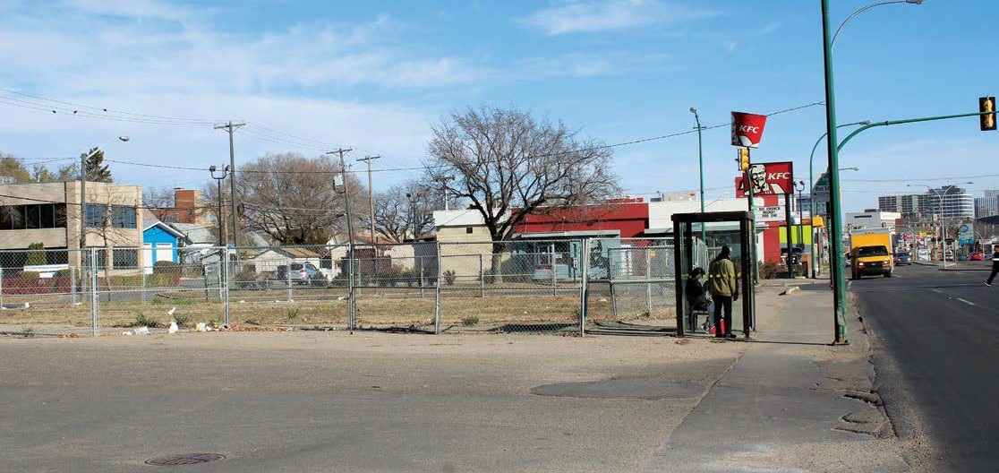
Example of corridor brownfield

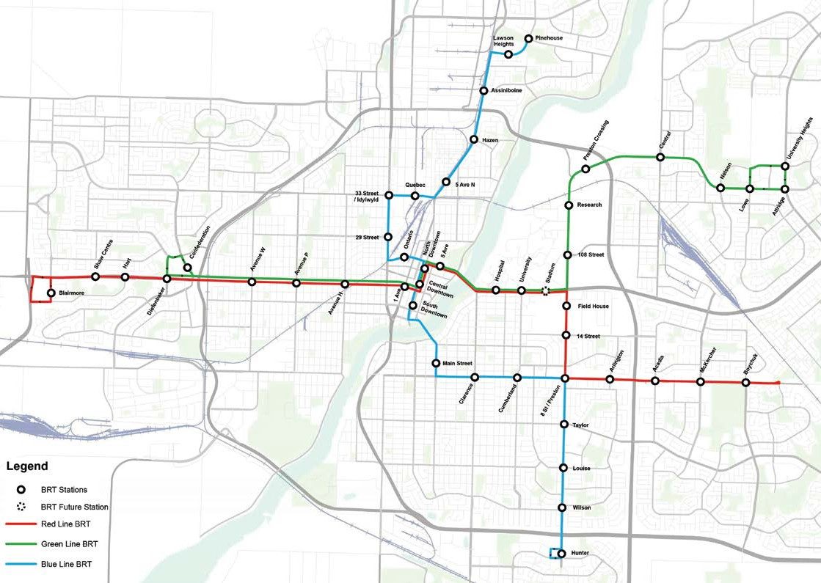

through a contamination management manual; implementing an interim-use policy for temporary reuse of brownfield sites; and establishing corridor-specific remedial endpoints to better mesh with anticipated future land use.
- An inventory of potential brownfield sites along the Red Line BRT Corridor contained around 90 sites including various properties which were previously used as gas stations, dry cleaners, automotive services and car washes; all of which raise environmental concerns for future use. The report included
a Brownfield Scoring Tool which allows planners to prioritize potential redevelopment. The northeast arm of the Green Line was not considered due to its relatively young age and low risk for brownfield issues.
- A Limited Soil Assessment Report and Site Management Plan. In order to better understand the environmental conditions of key redevelopment areas and corresponding proposed BRT Transit stations, subsurface soil testing was completed at six
locations along the Red Line corridor. The results have informed the project team of typical contaminants and approximate concentration levels within the area of investigation.
A site management plan addressed soil management in the event of ground disturbance and high-level costs for contamination mitigation. This information will be used to create future contamination management guidance documents.

The BRS project is in year two and Dillon will continue gathering information and deliverables for the Blue Line BRT corridor. The Brownfield Renewal Strategy Phase 2 involves creating policy framework and tool kit to implement the strategy, based on Dillon’s recommandations. Work will be closely tied to the Corridor Planning Program, with deliverables integrating with the principles and outcomes of Corridor Growth. The City is preparing a brownfield program proposal for recommendation to Standing Policy Committee and City Council during the first half of 2019.

For more information on the project, please visit saskatoon.ca/growth or contact Miguel Gaudet at miguel.gaudet@saskatoon.ca.

NEIGHBOURHOOD PLANNING
Artwork Commemorates Aboriginal Contributions
Henry Lau, MSAA, MRAIC, LEED® AP, Architect, Urban Design / 306-975-2866 / henry.lau@saskatoon.ca

“The Coming Spring,” by accomplished Canadian artist Gordon Reeve, was commissioned by the Saskatoon Tribal Council and the City of Saskatoon, with funding from the Government of Canada through the Canada 150 Fund. Its creation is in response to the Truth and Reconciliation Commission of Canada’s Calls to Action, No. 79: Participate in a strategy to commemorate the contributions and history of Aboriginal peoples to Canada.
– 8 –

The sculpture’s 27-foot tall arch and two spires are constructed of stainless steel that reflects the sun and moon. The longer 47-foot spire, pointing north, symbolically represents the First Nations’ long history. The 39-foot spire, pointing south, symbolically represents the history of the Métis Nation. Both are anchored in the earth. Suspended high on each spire are moving chimes. The sounds they make suggest the voices of children heard at a distance representing the children taken by the residential school system from all of the communities in Treaty Six Territory.

The concept for the artwork was selected and developed with extensive input from the community and guidance from Elders and residential school survivors. Gordon was able to work with the community to bring their vision to life through “The Coming Spring.”

“This public art project is a testimony of excellent collaborative work and community development,” says Alejandro Romero, Culture Consultant with the City of Saskatoon and Project Manager for “The Coming Spring” Canada 150 project. “It will stand for decades and will allow people to reconcile with themselves. It is a place for education, gathering, reflection and will become a landmark for citizens and visitors. The art shows how internal and external partnerships can work together and leave a legacy for generations to come.”
The Coming Spring is located within Reconciliation Circle in Victoria Park, north of the festival site and east of Spadina Crescent West. The location was identified by First Nations and Métis Elders as having particular significance: It has been the site of two reconciliation gatherings, is large enough to accommodate community events, and has a view of the park, trees and the South Saskatchewan River which tie into the treaty statement “as long as the sun shines, the grass grows and the river flows.”
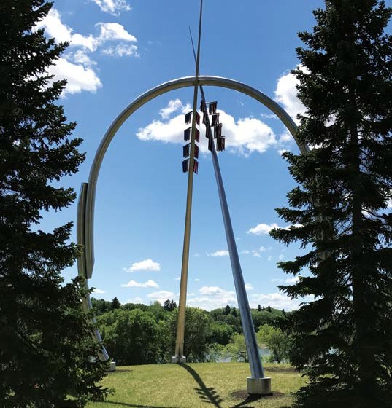

LONG RANGE PLANNING

Cut the Red Tape: Streamlining the Downtown Development Process
Brent McAdam, MCIP, RPP, City Centre Planner / 306-986-3688 / brent.mcadam@saskatoon.ca

Saskatoon’s Growth Plan has a key objective of balancing growth between infill and greenfield locations. As much of the city’s present growth happens on the periphery, transformational change is necessary to begin to tip the scale. Our downtown has much to celebrate, but with about 25 per cent of land area devoted to surface parking, it’s not living up to its full potential as our thriving urban heart. Its current population of about 3,300 is far below the 15,000 envisioned by the City Centre Plan.

So how do we get there?
City Council has named development of the downtown as a priority, and the City of Saskatoon is taking action to incentivize
significant new development activity. Much has been learned about barriers that stand in the way of infill development through the Mayor’s Infill Roundtable, a collaborative effort between civic politicians, City administration, the development community and related stakeholders.

From this, the “Cut the Red Tape” initiative was born. It is a proactive approach to encouraging downtown development, removing regulatory barriers, improving City processes and strengthening financial incentives.

Continued on page 11

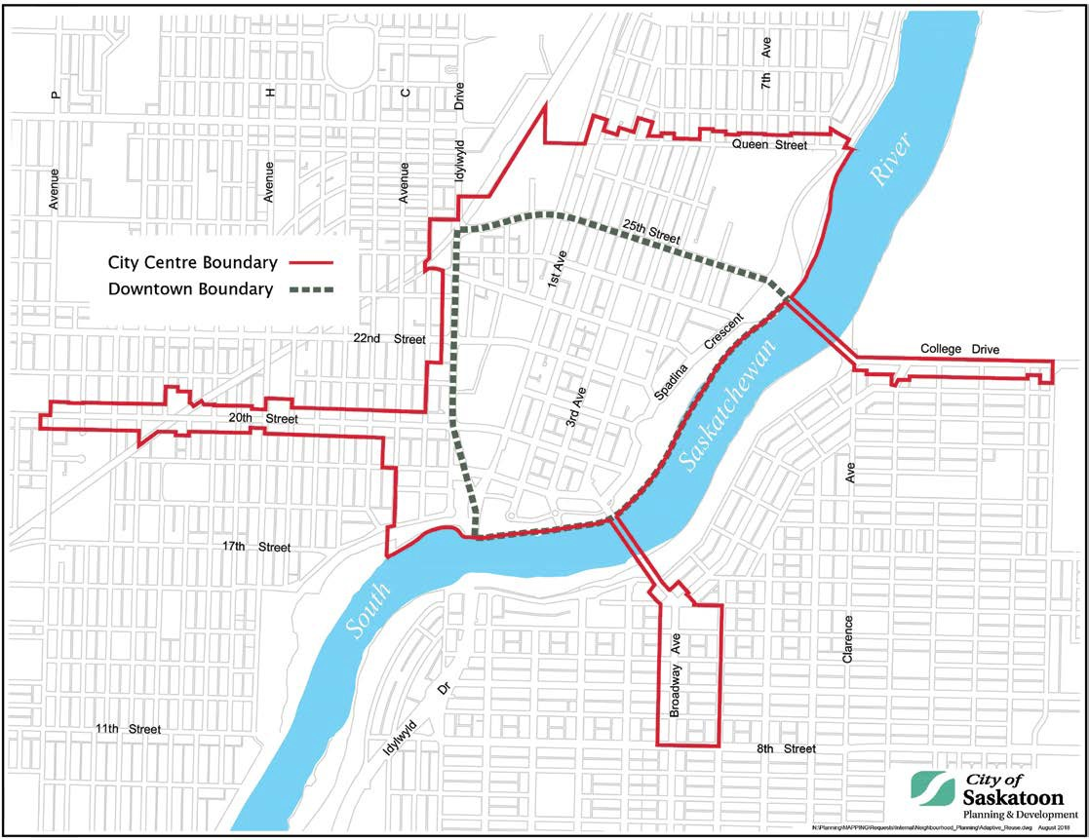

WORDS FROM THE INTERNS

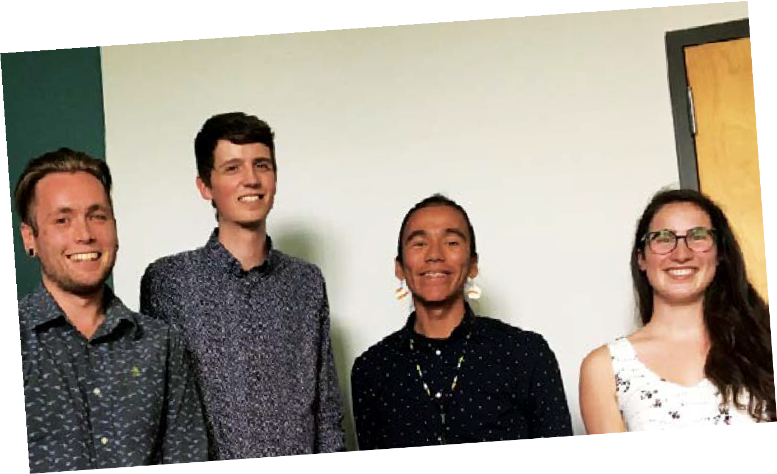The City of Saskatoon was lucky to have four fantastic Planning Interns this past summer: Todd Mitchell, Dallen Osachuk, Jessica Russell & Leigh Thomas. Here is a reflection of their experience.

Todd Mitchell

As the end of summer quickly approaches, I have been reflecting on my internship with the City of Saskatoon the city I have proudly called home for 25 years. For thre months I had the pleasure of working primarily in t Business Licensing program, with additional tasks in Bylaw
e
he
—
Compliance and heritage. My main project this summer was conducting the 2018 Institutional Space Survey; a comprehensive study of employment numbers and floor space occupied by government and non-profit organizations within Saskatoon city limits. Given that non-profits and government agencies do not requirea business license, this project helps fill thegap in knowledge regarding employment trends and geographical distribution of institutional employers. Survey results will help guide planning and economic decisions for the city, and it is fulfilling to know my work during this internship could have important implications.

My second project was updating the Business Start-Up Guide, a document which assists future entrepreneurs on required processes for starting a business in Saskatoon. Given that 97 per cent of Saskatoon businesses are considered ‘small businesses,’ my hope is that the guide will be used by many people to help Saskatoon increase its economic, cultural and creative capital in the coming years. Through updating the Business Start-Up Guide, renewing business licenses and doing site inspections, I gained valuable insight into how business is conducted in Saskatoon and why certain regulations and policies are necessary.

I also performed research on heritage designation and its effects on property value. By reviewing the academic literature and several Canadian case-studies, I created a report outlining economic and cultural benefits of heritage property designation. Given that I spent many lunch breaks looking awe-inspired towards the Bessborough Hotel, gaining experience in heritage planning was an experience I truly valued.

The knowledge I have gained this summer, both about urban planning and myself, will be undeniably beneficial as I return for my final year of university. I want to thank everyone in Community Standards for your patience, expertise and assistance as I gained exposure to the real behind-the-scenes work that planners do. I can truly say that this internship was one of the most valuable, rewarding and informative experiences in my life—largely due to the wonderful team I had the opportunity of working alongside. I hope that someday I will be able to reclaim my brightly-lit cubicle and join you again!

Dallen Osachuk
This summer, I worked in the Neighbourhood Planning Section of the Planning & Development Division. I had no idea what to expect walking up to the Civic Square East building on day one. Thankfully, any nerves were gone by lunch time. I was immediately impressed by the willingness of everyone to make me feel less like an expendable intern and more like a valued team member.

I was tasked with updating the internal Neighbourhood Monitoring Report, which helps identify and prioritize communities that may benefit from participating in the Local Area Plan (LAP) process. I consolidated indicator data to gauge statistical trends among neighbourhoods. I also had the chance to initiate a process to evaluate previous LAPs. This consisted of breaking down an old LAP and giving an honest opinion on the implementation of each recommendation. This summary was considered alongside academic research to draft an evaluation matrix used to grade the plan, identify successes and areas for improvement.

Between the acronyms and committees to the meetings and engagements, this summer has been chock full of valuable personal and professional experiences that are simply not available in a classroom setting. I’d like to thank everyone, both in Neighbourhood Planning and the rest of the division for the warm welcome, the camaraderie, the opportunity to learn and in making my summer internship a true delight.

Jessica Russell
It is difficult to believe how quickly my time as a planning intern with the Community Services Department has gone by.

I have been working in Bylaw Compliance within the Community Standards Division. I got to act as a would-be zoning bylaw inspector, reviewing zoning compliance files on landscaping and parking requirements. This included examining landscaping and site plans, conducting site visits, and ensuring that parking and landscaping were in compliance with the City of Saskatoon Zoning Bylaw.

– 10 –

Continued from page 9

In addition to my work in zoning compliance, I was given the opportunity to work on a research project involving parking and landscaping regulations for single family dwellings. I examined the zoning bylaws of various Canadian cities, towns, and townships to gain insight on regulations and policies surrounding parking and landscaping for single family dwellings in municipalities across the country.

My experience as a planning intern with Community Standards this summer has been incredibly rewarding. Not only have I learned an immeasurable amount about municipal planning and development, but I have gained invaluable personal experience and a new sense of professional confidence as a soon-to-be planning professional.

I would like to thank everyone for offering their guidance and knowledge during my time as a planning intern and, for such an enjoyable 12 weeks in the Community Services Department!

Leigh Thomas
piyêsiw okanawêyihcikêw (nêhiyaw/Cree name)
tânisi kitatamiskâtinâwâw, [Hello, I greet you all]
First and foremost, I want to thank the City of Saskatoon and the Saskatoon Tribal Council for this amazing opportunity to learn over this summer. I want to give a huge thank-you to everyone I worked with this summer for the knowledge, skills and understanding they shared and imparted to me.

I had the opportunity to practice a number of important skills that will be extremely valuable throughout my planning career such as; organizing complex meetings with local organizations, best practice research and building my communication skills in writing and public speaking.

One major piece of my work plan was editing and drafting content to add to the “ayisînowak: A Communications Guide.”

Other projects included drafting outlines and engaging with the community through events like “The Coming Spring” art unveiling, “The Chief Mistawâsis Bridge naming” and the “Rock Your Roots: Walk for Reconciliation,” to name a few. I really enjoyed this summer internship experience and every project I was able to work on. I hope the best for everyone reading this and thank you all again for this amazing summer learning opportunity.

êkosi pitamâ, [That’s all for now]

What We’ve Done Already:
- Created the City Centre Planner position within Planning and Development, a resource dedicated to development projects in the City Centre (see map, page 9). This position provides a “one-stop shop” service for developers while also leading policy and process review respecting development in the City Centre.
- Narrowed the required scope for Traffic Impact Assessments for Downtown projects. Downtown traffic patterns are set with existing roadways and are unlikely to change as a result of new development.
- Waived the requirements for on-site management and storage of stormwater with Downtown projects. The Downtown is already effectively 100 per cent impervious with asphalt, concrete, and rooftop surfaces dominating. New development will not adversely impact current conditions.
- Waived the payment of offsite levies (development fees) for Downtown projects.
- Amended the Vacant Lot & Adaptive Reuse Incentive Policy to remove the cap on maximum grant amounts for eligible Downtown projects.
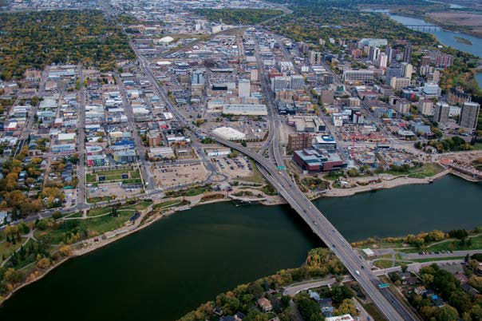

What We’re Working On:
- Pre-engineering the Downtown by identifying and funding infrastructure upgrades necessary to support new high-density development. This will eliminate the current responsibility and cost placed on developers in identifying servicing strategies for underground services when proposing new development.
- Reducing (to a limit) the fees required for detour and lane closures and the temporary use of on-street parking often required by developers during Downtown construction.
- Reviewing the specific zoning conditions of the B6 and RA1 districts in the Downtown to identify possible changes to encourage development.
- Reporting to City Council the possibility of expanding these measures to other infill areas outside the Downtown.

Increasing the amount of infill development in our city is essential to our growth. Our Downtown is a prime location for infill and a logical starting point for the measures being undertaken to “Cut the Red Tape” and usher in a new era of urban growth in Saskatoon.

– 11 –
saskatoon.ca

LONG RANGE PLANNING
Reimagining Growth: The Potential of our Major Corridors
Lee Smith, MCIP RPP, Senior Planner / 306-986-3668 / lee.smith@saskatoon.ca

The Growth Plan to Half a Million was adopted in principle by Saskatoon City Council in 2016. Central to the success of the Growth Plan is a re-envisioned transit plan based around Bus Rapid Transit (BRT). We have been working on detailed planning for the BRT system and for transit-oriented development along the BRT corridors. This June, a series of information reports on the BRT were presented to the Governance and Priorities Committee (GPC). The presentations of the reports, along with All Ages and Abilities Downtown Cycling Network, generated discussion and follow-up direction for city administration. The Growth Plan implementation team is now hard at work conducting analysis of alternate design and route options and planning for further stakeholder engagement over the next few months. It is anticipated that results will be presented in a detailed report to the GPC, and ultimately City Council, for a decision on routing in early 2019. Detailed designing can begin once that process is complete.
The current issue of Planning + Design is available for download at saskatoon.ca.
The information contained in this publication is not copyright protected and may be used freely. The Community Services Department believes all information and sources in this publication to be correct, but cannot guarantee accuracy and assumes no responsibility for its use. Planning + Design is provided as an informational service to the general public and agencies who regularly do business with City Hall. Readers should not act upon the information contained in this publication without seeking professional advice.
City of Saskatoon
Planning & Development 222 – 3rd Avenue North Saskatoon, SK S7K 0J5 306-975-2645
city.planning@saskatoon.ca

Corridor Growth is another key initiative of the Growth Plan and is in strategic conjunction with the Transit Plan and BRT network. The Corridor Growth suite of initiatives includes the Corridor Planning Program, Transit Villages and the Brownfield Renewal Strategy. The latter seeks to support redevelopment and revitalization of abandoned, vacant or derelict properties along major corridors. Check out the Brownfield Renewal Strategy article in this issue of Planning + Design!

The Corridor Planning Program looks to identify ways to transform the proposed BRT corridors into mixed-use, transit-oriented destination locations that connect neighbourhoods. The Corridor Planning team is working on engaging further with corridor stakeholders and the wider public, showcasing options for realizing the development potential of our major corridors (focusing on 22nd Street West and 8th Street East). At the March 7th ‘Come & Grow’ event and its follow-up surveys, we heard that the community would like to see greater walkability and building density along these corridors. We also heard about current challenges and needs associated with the walking experiences along 8th Street and 22nd Street.

The team’s most recent initiative was small-scale, pop-up style engagement with the public directly on the corridors themselves. We went where the people already are and set up two events in the third week of August at high-traffic locations on 8th Street and 22nd Street — near each Dairy Queen location. These spots were chosen not just for their summertime treats and family-friendly atmosphere, but because they offer an opportunity to reimagine the pedestrian realm along our major corridors. We brought street furniture and greenery in addition to the usual engagement
materials to help spark creativity and open-ended visioning about the future of these important city streets.

The pop-up events were a huge success! We received feedback from about 55 participants on the interactive display boards. The impromptu street furniture was also very well received, and the benches were even made permanent - on a trial basis - at the 8th Street Dairy Queen! What we heard, overwhelmingly, was that these two major corridors are uncomfortable and unsafe for walking. There is a great deal of support for making pedestrian- friendly changes. We also received lots of support for the kinds of high-density residential and mixed-use development along these corridors that is needed in order to meet Growth Plan targets and support BRT ridership.
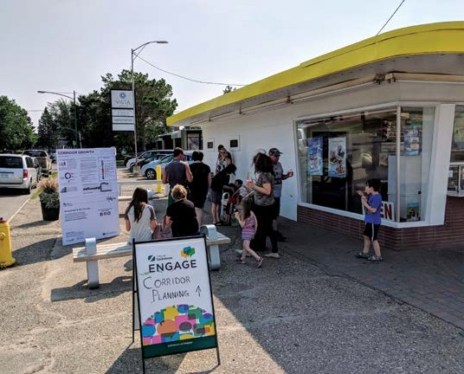
Corridor Planning pop-up engagement event, 8th Street Dairy Queen location, August 21st 2018.
The team will continue working on the overall transformation plan for the corridors based on Growth Plan targets, Transit-Oriented Development Design Guidelines, Complete Streets Design and Policy Guide and best practices from other cities. Collaboration with internal working groups will be important to the success of this project as we go forward.

The team plans to host the next Corridor Planning Program engagement event(s) in November. We intend to present concepts, visions and options for redevelopment, including land use and public realm design. We will also receive feedback on preferred options from stakeholders and the public. Stay tuned for an announcement of upcoming events and keep up with our engagement efforts at saskatoon.ca/engage/corridor-planning-program.

