A CITY OF SASKATOON SEMI-ANNUAL PUBLICATION FROM PLANNING & DEVELOPMENT SPRING/SUMMER 2019

Come & Grow 2019 Zoning Bylaw Review
Mural created by Emmanuel Jarus
Green Infrastructure Strategy Montgomery Place Local Area Plan Building a Safe Bus Rapid Transit System
Vacant Lot and Adaptive Reuse Incentive Program Ride sharing through Transportation Network Companies
Building Transit-Friendly Neighbourhoods outside Saskatoon’s Core

Message from the Director

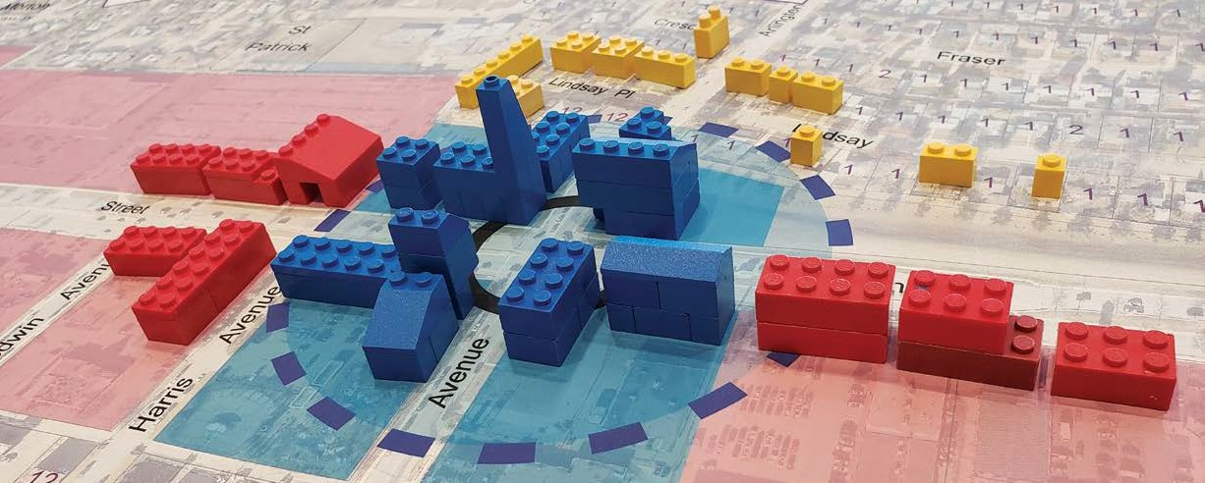Planning and Development has a number of projects that will usher us into a new era of customer service. The changing expectations in the community have led us to this point; as people are affected by new developments, we see requests for better communication and better methods of dealing with impacts to neighbours. We also receive requests for new regulations that will respond to neighbours’ concerns. We also see requests from the development industry who wish for clearer requirements, more timely responses on requests and more information overall to help streamline development processes. These types of improvements, both from residents and the industry, are all reasonable expectations.
PLANNING + DESIGN SPRING/SUMMER 2019

Addressing these expectations is at the forefront for Planning and Development and other partners who review development applications. In 2018, we partnered with Building Standards to undertake an operational review of our practices which has identified a range of actions to pursue throughout 2019. Technology improvements, organizational improvements, potential new positions and new methods for the overall review process will all be considered.

In addition to our processes around development applications, we also recognize the need to set clearer standards for the pre- application stage. Saskatoon has a well-established process for moving from rural development to a new neighbourhood. However, some required components and expectations need to be made clearer.

- We are creating new guidelines for Area Concept Plan creation. These guidelines outline necessary background studies, expectations for those studies including the approval process, standard items to be included in the Plan and other site- dependent considerations.

- We have also been working with the Sustainability Division to create new standards for the performance of Natural Area Screenings. This background study is required for new Area Concept Plans.
- Natural Areas Standards are being created to provide a consistent framework for approving development that has the potential to impact natural areas and assets. It will also provide policy and guidance for development and land management within and next to natural areas. This work is part of the overall Green Strategy that is jointly led by the Sustainability Division and Planning and Development.

- Work on a Developers Handbook and an online information portal is underway. Both will help new and experienced developers through the steps and provide enhanced information that is needed for new projects.

One of our immediate 2019 actions has been an in-depth look at communications around individual land use changes like re- zoning and discretionary-use applications. Working with our Communications and Engagement team, we have looked at what is legally required, what we currently do and where we can enhance communication. We have recognized that we can provide better quality information throughout the process.

Overall, we believe these changes will allow neighbours and the community to better understand what is happening near them and what they can expect from us. Part of building a great city is taking a broader look at how each site contributes to making a better whole. We hope these changes will help lessen the growing pains as our city changes.

Lesley Anderson, MCIP, RPP
Director of Planning and Development
306-975-2650 | lesley.anderson@saskatoon.ca

PLANNING & DEVELOPMENT, COMMUNITY SERVICES DEPARTMENT

NEIGHBOURHOOD PLANNING
The Vacant Lot and Adaptive Reuse Incentive Program
Holden Blue, Planner | 306-975-7642 | holden.blue@saskatoon.ca

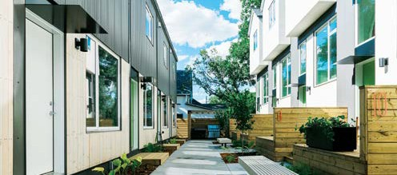The Vacant Lot and Adaptive Reuse Incentive was created to encourage development of vacant lots, brownfield sites and the reuse of vacant and underused buildings in Saskatoon’s established neighbourhoods and city centre. The program offers financial or tax-based development incentives to property owners of eligible sites. Under the program, applicants may choose between a five-year tax abatement or a cash grant. Incentives are provided following the successful completion of a project.
Shift Development’s Element Urban Village: Phase II
The Vacant Lot and Adaptive Reuse Incentive Program provides incentives based on the inclusion of a project’s development features that are linked to policy objectives in the Official Community Plan. Element Urban Village: Phase II achieved
this by constructing a walkable, multi-unit residential dwelling complex. It is verified as highly energy efficient through Natural Resource Canada’s EnerGuide rating system. Development features can include (but are not limited to) housing type, energy efficient design elements, contributions to the public realm, environmental site remediation and sustainable development features.

For more information on the Vacant Lot and Adaptive Reuse Incentive program, visit saskatoon.ca.
The level of incentive is determined based on the incremental taxes that result from the new development on the site or building. A maximum incentive amount is determined by the incremental taxes multiplied by five years. The final incentive equals a percentage of the maximum incentive amount is determined by an evaluation system score, based on points linked to policy objectives in the City’s Official Community Plan.

PLANNING + DESIGN SPRING/SUMMER 2019

DEVELOPMENT REVIEW

City of Saskatoon Zoning Bylaw Review
Paula Kotasek-Toth, MCIP RPP, Senior Planner | 306-975-7621 paula.kotasek@saskatoon.ca

The City of Saskatoon is undergoing a review of The Zoning Bylaw No. 8770. This bylaw regulates development to provide amenities for the area and for the health, safety, and general welfare of the inhabitants. This bylaw last underwent a comprehensive review between 2007 and 2009, and industry trends and changes have left gaps that require a reassessment of the bylaw’s goals.

A wide range of amendments that align with strategic themes have been identified. These include business-friendly initiatives, economic development, environmental initiatives and current planning trends. This last theme includes ensuring that current and desired trends in commercial, residential and community development are incorporated in Saskatoon’s planning regulations. The Zoning Bylaw review is also an opportunity to align with existing strategic plans like the Growth Plan to Half a Million, the Culture Plan, the emerging Green Strategy, the Saskatoon North Partnership for Growth Regional Plan, the Downtown Cutting the Red Tape initiative and the renewed Official Community Plan (slated for completion in 2019).

So far, amendments range from housekeeping updates to new districts that will accommodate current development trends. Addressing these initiatives will streamline development applications by ensuring that regulations are appropriate and in place for the desired types of development.

The Zoning Bylaw Review team will seek input from both internal and external stakeholders with consultation beginning this spring. The project manager for the Bylaw review is Christine Gutmann from the newly-created Project Planning Services Section of Planning and Development.
Example of rooftop garden.

BUSINESS LICENSE PROGRAM
The City of Saskatoon Business License Program licenses Saskatoon businesses operating from a fixed address. This includes home- based businesses and those operating from commercial and industrial locations.

At the end of 2018, there were 11,686 businesses licensed by the program. Figure 1 illustrates Saskatoon’s overall business growth and identifies the total number of home-based and commercial/industrial businesses licensed from 2014 to 2018. Figure 2 illustrates the number of new business licenses issued for the years 2014 to 2018. The number of new home-based businesses continues to exceed the number of new commercial/ industrial businesses.

For more business license statistics or to view the Business Profile 2018 Annual Report, please visit saskatoon.ca/businesslicense.

Total Businesses (2014-2018)

New Businesses (2014-2018)

Community Standards
222–3rd Avenue North, Saskatoon, SK S7K 0J5.
Tel: 306-975-2760
Fax: 306-975-7712
Email: business.license@saskatoon.ca

PLANNING & DEVELOPMENT, COMMUNITY SERVICES DEPARTMENT

LONG RANGE PLANNING
Green Infrastructure Strategy
Genevieve Russell, SALA, CSLA, Special Projects Manager | 306-986-3650 | greeninfrastructurestrategy@saskatoon.ca

Considering the ways we interact with our natural environment and managing our impacts are key to maintaining a healthy, sustainable city. This is especially important as the city grows and we replace old infrastructure and increase density in established areas. In order to respond strategically to this urban development, the City is crafting a Green Infrastructure Strategy. The strategy’s purpose is to develop an integrated approach to planning and maintaining a sustainable, biodiverse city, one in which natural areas and other green and open spaces are considered important.

Phase 1, The Green Infrastructure Strategy Baseline Inventory, was recently completed. It documents the various types of green spaces and how they are distributed throughout the city. It also documents policies and regulatory tools that govern green infrastructure, the stresses on our green infrastructure, how green and grey infrastructure interface and how green space relates to our heritage and culture. This baseline inventory review resulted in 32 key findings that represent both vulnerabilities and opportunities. These will be used in Phase 2 to develop options and recommendations for the Green Infrastructure Strategy Action and Implementation Plan.

Phase 1 also developed a set of 10 guiding principles of the strategy. These principles will be used to analyze the existing green network and to develop the action plan to achieve the desired green network.
The Guiding Principles are:
- High Quality – Green spaces are evaluated and used for their best purposes, taking into consideration the types of infrastructure and amenities they have, the value of the functions they provide and community needs.

- Integrated & Multifunctional – Green spaces are integrated into the city fabric to form a network that serves multiple uses and needs.

- Public Safety – The green network is safe, accessible and inclusive for all.

- Recognizable & Unique Places – A range of green space types and functions reflect heritage, traditional land uses and community identity and needs.
- Sustainable – The green network responds to operational requirements, flood resiliency, community capacity and environmental and local needs.

- Wellness: Physical & Mental – the green network meets community needs, recognizing that access to green space is strongly related to residents’ physical, spiritual and mental wellbeing.

- Climate Change Adaptation & Mitigation – Our contributions to climate change are mitigated and our ability to adapt to local change is enhanced.

- Ecological Integrity – Biodiversity and connectivity of the urban green network is conserved and supported.

- Education & Awareness – Educational opportunities incorporate ecological, cultural and traditional knowledge. The community is aware of appropriate uses of green spaces.

- Equitable & Accountable – Green infrastructure is distributed throughout the city to provide access to all residents.

The City of Saskatoon will not be able to achieve the green infrastructure goals alone; the involvement and effort of the broader community is needed. A workshop was held to review the preliminary baseline inventory. Workshop participants represented a diverse set of community groups and organizations with mandates linked to ecology, culture, land development, heritage, food security and health care. Their feedback was used to refine the inventory, guiding principles and to generate key findings. Participants expressed cautious optimism that green infrastructure is becoming a higher priority for the City.

Phase 2 will also include community engagement. Look for upcoming engagement events coming this fall!

For more information about the next phases of the Green Infra- structure Strategy and for a copy of the Green Infrastructure Baseline Inventory Report please visit saskatoon.ca/greeninfrastructure.
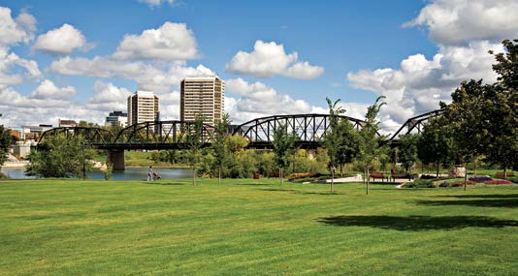

LONG RANGE PLANNING

Building Transit-Friendly Neighbourhoods outside Saskatoon’s Core
Ty Czerniak, MCIP, RPP, Planner | 306-975-7869 | ty.czerniak@saskatoon.ca

While shopping malls anchoring a sprawling suburb of single-family homes was once the epitome of commercial development in North America, this paradigm is beginning to shift for Saskatoon. Public transit is playing a key role in that transformation. In 2016, City Council unanimously endorsed the Plan for Growth, an ambitious and long-term project intended, among other things, to transform the transit system and redefine where and how the city will grow as it approaches half a million people. The new bus rapid transit system (BRT) alone is estimated to cost between $90 and $150 million, with the City also exploring other significant investments in the transit system. Much of that new investment will take place along Saskatoon’s major corridors (22nd Street, 8th Street) in an effort to create both a faster and more frequent transit service and an urban fabric that provides higher-density land uses to support the BRT.

Building better urban transit is just the beginning. It is equally important to build better neighbourhoods along transit lines and around stations to maximize the value of these multi-million dollar transit investments. As a way to capitalize on those investments and redirect some of the city’s growth inwards, the Growth Plan contains an exciting and key component: Transit Villages. Transit Villages are envisioned as a series of exceptionally designed, high- density mixed-use urban enclaves at strategic locations along the city’s major transit corridors, connected by BRT to the city centre and to one another.

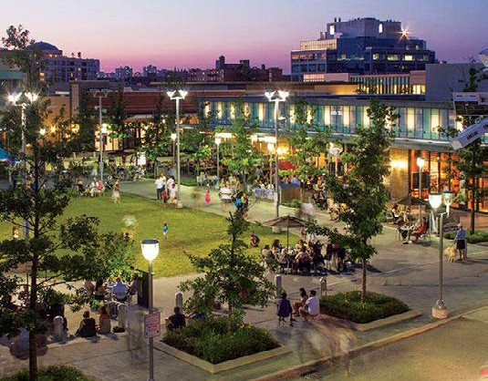The centrepiece of each transit village will be the transit terminal framed by public spaces that incorporate transit-oriented principles like compact and highly-walkable developments, enhanced multi-modal connections, a range of land uses with vibrant ground floors, carefully managed parking and high-quality public spaces. Transit Villages will be occupied by extensive retail, commercial, recreational and entertainment services as well as
Multi-Purpose Plaza Fronted by Active Uses and Served by Transit.
Image courtesy of DIALOG

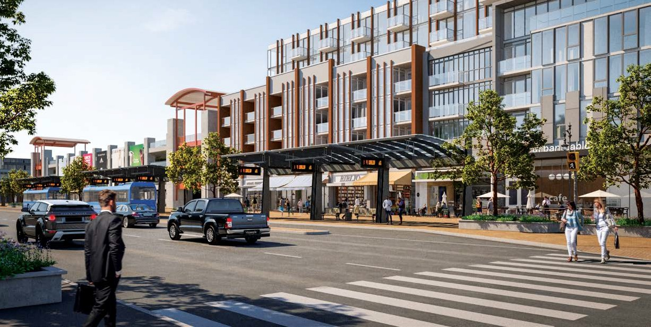
PLANNING + DESIGN SPRING/SUMMER 2019
BRT station as an example of transit-oriented development.

PLANNING & DEVELOPMENT, COMMUNITY SERVICES DEPARTMENT

public parkettes, plazas and sitting areas. These elements will be tied together by a coherently designed, pedestrian-oriented development that connects to the centrally-located transit station. The shift to transit-oriented development (TOD) signals an exciting and major departure from the private automobile-dominated city building that has historically dictated land use decisions.
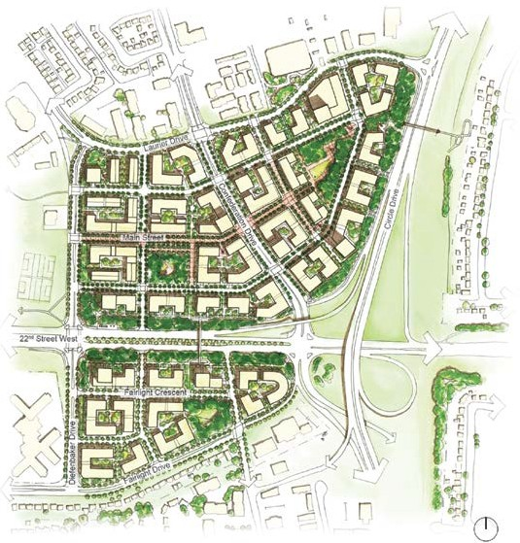
Confederatition Mall Transit Village Demonstration Plan.
There are five proposed Transit Village locations (see map). Three urban transit villages are on the sites of existing commercial shopping centres (malls), while the remaining two are located in undeveloped greenfield sites. These sites were selected for a number of reasons, but particularly for their location along the BRT corridor. Once the BRT system is up and running, those transit villages in built-up areas will present even greater opportunities for significant infill, redevelopment and an overall improvement to land use. In essence, the Transit Village initiative will encourage growth in areas where significant investment in public transit
infrastructure is planned. The new BRT system will serve as the catalyst to this new growth, stimulated through special zoning, policy and incentives for redeveloping using TOD design standards.

So, how can Saskatoon ensure this ambitious initiative becomes a reality over the next few decades? Research from other transit villages or TOD projects shows that success is most often due to three key factors:

- The creation of a specific plan in the project’s early stages that serves as a blueprint for targeting growth near the transit station;
- The existence of a proactive and engaged development authority who aggressively works to implement the plan through such means as assembling irregular parcels into developable ones, or creating development incentives for landowners;
- Having local government and civic administration who can champion the project and help guide it through implementation.

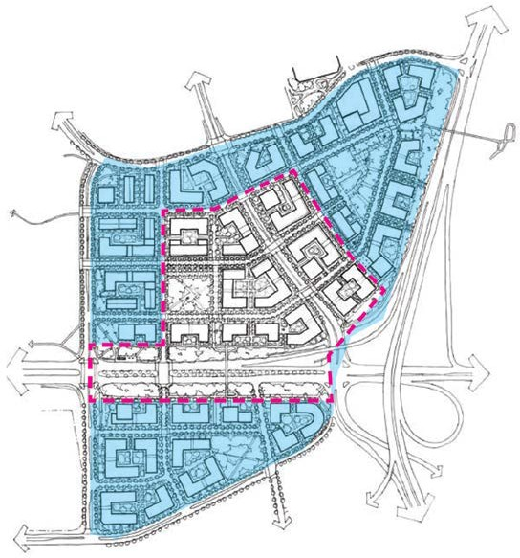
Confederation Transit Village phasing Plan.

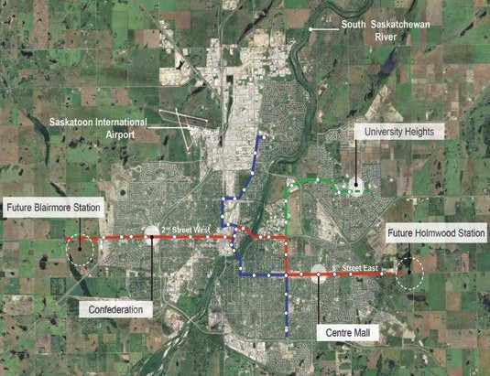Several engagement events were held in late 2018 and early 2019 to hear ideas about planning and growth along BRT corridors. Healthy attendance by the public, city councillors, the mayor and other interested stakeholders signified a worthy amount of community support for the project. Information gathered will help inform future land use, urban design and zoning decisions for the corridors and transit village sites. The project team is now finalizing the Transit Villages Report, expected to be presented to city council for endorsement along with implementation recommendations in the second quarter of 2019.
Five Transit Village Locations.
BRT Network
Red Line
Green Line
Blue Line (north-south route, next phase of implementation) BRT Stations

For more information, please see the Transit Villages project website at saskatoon.ca/engage/transit-villages.

LONG RANGE PLANNING
Crime Prevention Through Environmental Design
Joel Bird, Planner | 306-986-0829 | joel.bird@saskatoon.ca

Adopted by city council in 2016, the Growth Plan to Half a Million contains several major themes, including Transit and Corridor Growth. Bus Rapid Transit (BRT) will form the backbone of Saskatoon’s new transit system, helping catalyze corridor growth along its Red, Blue and Green Lines. Similar to light rail, sky trains and subway systems, BRT will provide highly reliable service that features shorter wait times, improved directness of travel, fewer stops and an improved sense of safety and comfort at its stations.

In late 2018, preliminary BRT system plans were submitted to the SafeGrowth/Crime Prevention Through Environmental Design (CPTED) review committee. Given the scale of the project, it was determined that a separate CPTED Subcommittee would be a more efficient way to assess the system. Considerations include: the BRT system, routing options, the 42-station pair locations (each with unique site conditions), surrounding land uses and user groups. The team determined that the Downtown to Nutana routing options and associated stations should be assessed first, followed by groups of stations in decreasing order of safety concern. The team also determined that subsequent BRT CPTED reviews would likely be required in the detailed phase.
In December 2018, Neighbourhood Safety issued two CPTED reports for the respective Downtown and Nutana routing options and associated stations. From a SafeGrowth/CPTED perspective, the geographic and social context of the BRT stations, and their potential to integrate into the adjacent geography, will have the greatest effect on reducing crime opportunities and increasing transit users’ feelings of safety. The proposed Blue Line has multiple routing options, including opportunities to connect 3rd Avenue to Broadway Avenue, 1st Avenue to 19th Street to Broadway Avenue, or 1st Avenue to Idylwyld Drive (bypassing Broadway). The routing decision will determine the geographic context that central BRT stations are placed in.

From a SafeGrowth/CPTED perspective, 3rd Avenue and Broadway BRT stations (either mixed traffic or centre meridian) have the highest potential to blend into their existing surroundings with minor investment in the streetscape. The diversity of surrounding businesses and transit-oriented development at these locations provides the context needed for adequate natural surveillance, a positive transit image, local BRT station “ownership,” legitimate activity support and growth of a connected and cohesive transit

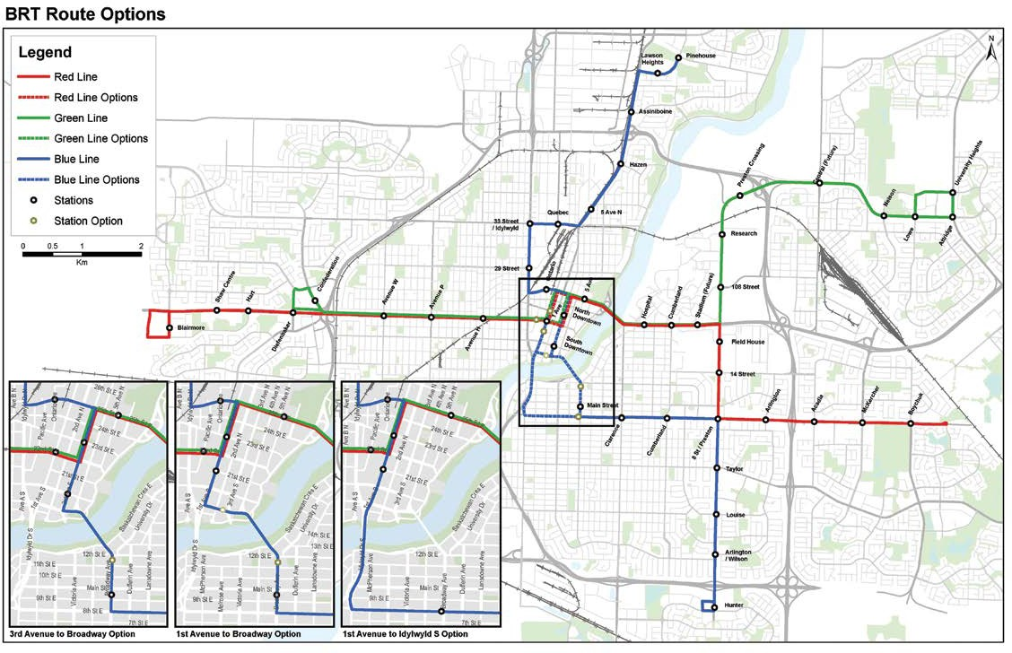
Bus Rapid Transit System with Downtown
to Nutana Routing Options, Sep 2018.

PLANNING & DEVELOPMENT, COMMUNITY SERVICES DEPARTMENT

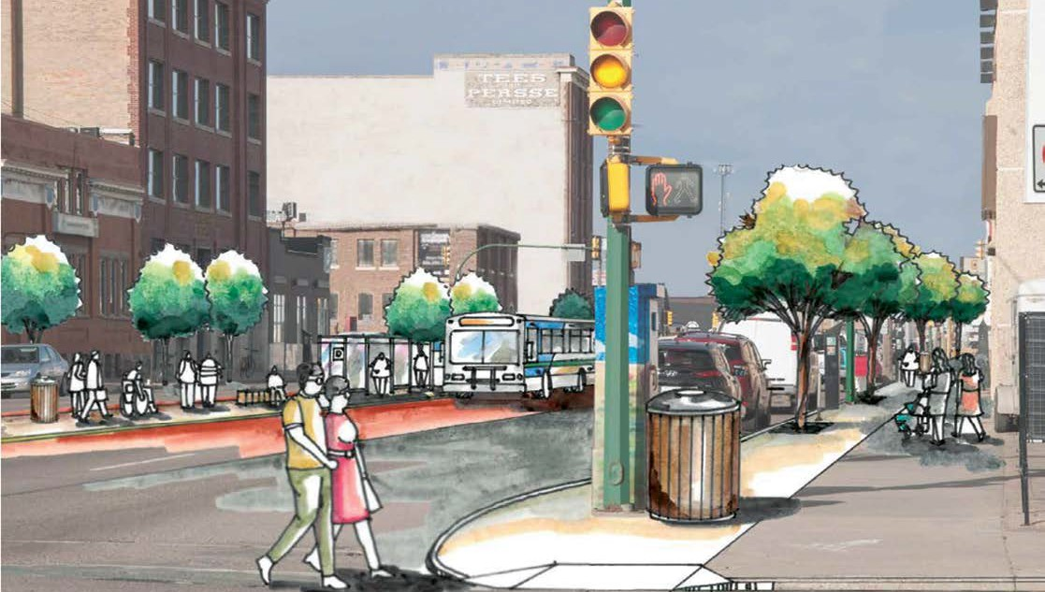
Illustration of the proposed Downtown
BRT station on 1st Avenue North and 23rd Street East, Nov 2018.

community. Comparatively, 1st Avenue (aside from Midtown Plaza), 19th Street and Idylwyld Drive station locations will require more work to integrate a BRT station into existing surroundings. For these alternate station locations, restructuring of the public realm and investment and construction of transit-oriented development will be required to achieve similar ends, as well as to establish feelings of safety and comfort in current and potential transit users.

In the coming months, city council will consider each of the potential routing options for the Blue Line before making a final decision.
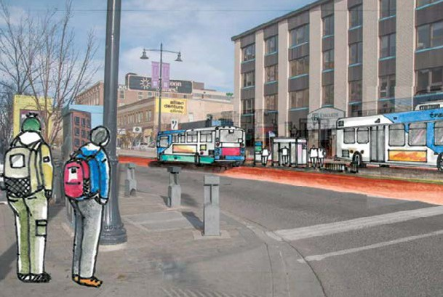
Illustration of the proposed Downtown BRT station on
3rd Avenue South and 20th Street East, Nov 2018.

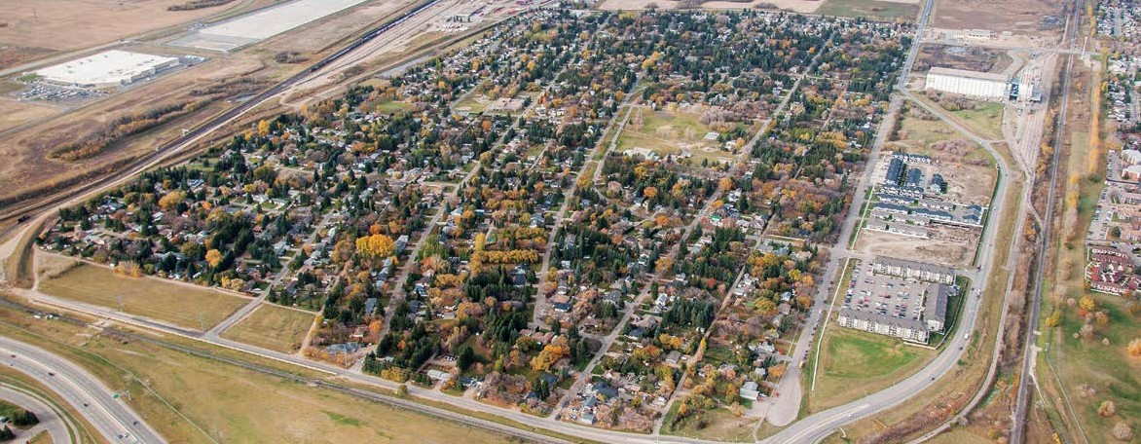
PLANNING + DESIGN SPRING/SUMMER 2019

NEIGHBOURHOOD PLANNING
Montgomery Place Local Area Plan
Mark Emmons, MCIP RPP, Senior Planner | 306-975-3464 | mark.emmons@saskatoon.ca

Local Area Planning is a community-based approach to developing comprehensive neighbourhood plans by enabling residents, business owners, property owners, community groups and other stakeholders direct input into determining the future of their community. It is a highly adaptable process that encourages stakeholders of an established neighbourhood to discuss issues of local importance.
PLANNING + DESIGN SPRING/SUMMER 2019

The Local Area Plan (LAP) program is administered by the Neighbourhood Planning Section, Planning and Development Division. Once completed, LAPs establish the vision and set goals to guide the renewal and growth of a neighbourhood. Each plan is submitted to city council for endorsement and identifies specific recommendations for local improvements. LAPs are long-term plans that may take many years to be fully implemented. The Montgomery Place LAP was adopted by city council in November 2018, becoming the 15th LAP completed since the program began in 1997.

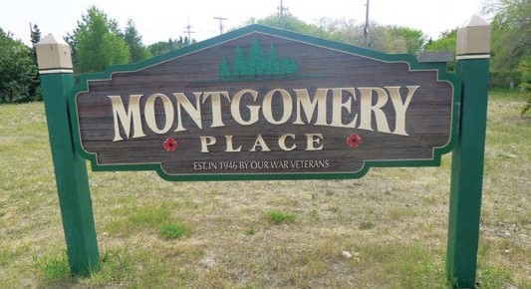
The neighbourhood of Montgomery Place is located in the southwest corner of Saskatoon. More than 200 neighbourhood residents and stakeholders participated in the creation of
the Montgomery Place LAP, which contains a total of 50 recommendations related to the following topics: land use, housing and infill; parks and open space; heritage and culture; drainage; property maintenance and nuisance abatement; sound mitigation; traffic and transit; and neighbourhood safety.
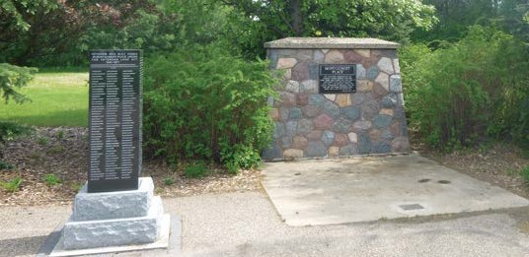

Key Montgomery Place LAP recommendations will result in: honouring thelegacyofthehistoricneighbourhood; improvements in Montgomery Park; and addressing safety concerns related to overgrown vegetation and other property maintenance issues.

In 2016, Montgomery Place received designation as a National Historic Site, due to the neighbourhood being originally developed as a Veterans’ Land Act settlement to support Second World War veterans transitioning to post-war life. The Montgomery Place LAP includes several recommendations related to heritage. Proposed improvements to Montgomery Park that incorporate historical design elements could result in the installation of permanent seating that can be used during major events like the neighbourhood’s annual Remembrance Day ceremony.

The Montgomery Place LAP (full report and summary report) is located online at saskatoon.ca/lap

LONG RANGE PLANNING
Come & Grow 2019

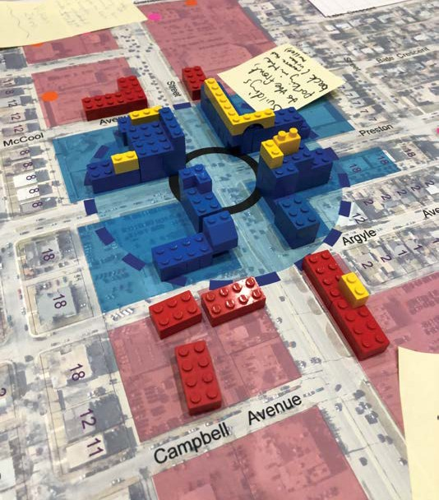
Come & Grow 2019, spearheaded by the Plan for Growth project team along with teams from the Official Community Plan and the University Sector plan, took place in January at the new Holiday Inn Express and Suites. With its sweeping views of the College Drive corridor and the University of Saskatchewan campus, this venue was a perfect location to showcase plans for future growth. Anchored by Corridor Planning and Transit Villages, displays led attendees through an overview of potential development. Feedback was gathered on a number of initiatives, from infill densities to urban design concepts for the public realm.
While long-term and visionary planning can be difficult to effectively communicate, the Planning & Development team, supported by Communications & Public Engagement, did an exceptional job of sharing and gathering feedback on prospective plans to support Saskatoon’s future growth. The response was overwhelmingly positive from the 177 attendees; they were particularly impressed by the creative presentations and the city staff’s ability to explain tough concepts and answer challenging questions in an understandable way. Using Lego as a visual aid was definitely a well-received strategy!

Engagement around corridor planning, transit villages and brownfield renewal are ongoing with continued stakeholder meetings, an online survey and Blue Line specific engagement to come in the near future.

Saskatoon’s Plan for Growth charts a course for growth and revitalization that balances and promotes quality of life, sustainability and economic development. Plan for Growth projects are funded in part under the Public Transit Infrastructure Fund (PTIF) from the Government of Canada.

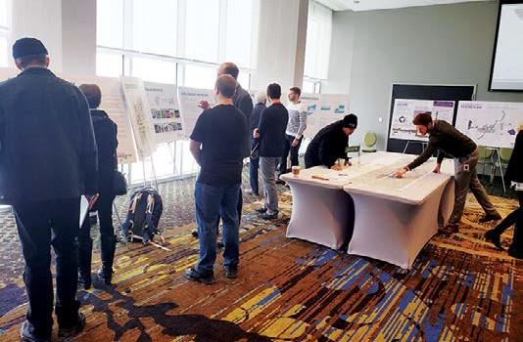

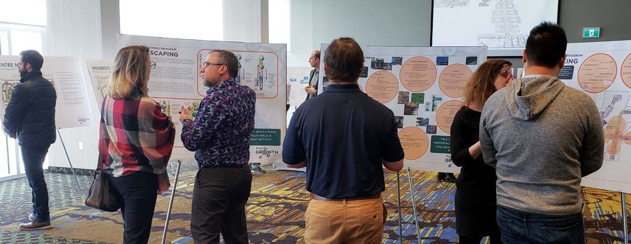– 11 –
PLANNING & DEVELOPMENT, COMMUNITY SERVICES DEPARTMENT
saskatoon.ca

COMMUNITY STANDARDS
Ride sharing through Transportation Network Companies
Mark Wilson, MCIP, RPP, Acting Licensing and Permitting Manager | 306-986-3148 | mark.wilson@saskatoon.ca

Transportation Network Companies (TNCs) are a new transportation option in Saskatoon. TNCs like Uber and Rel8well Travel are businesses that provide transportation services by connecting vehicles for hire with passengers through a mobile app. Unlike taxis, which are commercial vehicles (Class PT), TNC vehicles for hire are the light vehicle (Class LV) of the driver or company.
The current issue of Planning + Design is available for download at saskatoon.ca
The information contained in this publication is not copyright protected and may be used freely. The Community Services Department believes all information and sources in this publication to be correct, but cannot guarantee accuracy and assumes no responsibility for its use. Planning + Design is provided as an informational service to the general public and agencies who regularly do business with City Hall. Readers should not act upon the information contained in this publication without seeking professional advice.
City of Saskatoon
Planning & Development 222 – 3rd Avenue North Saskatoon, SK S7K 0J5 306-975-2645
city.planning@saskatoon.ca

On Dec. 14, 2018, the Province of Saskatchewan approved the Vehicles for Hire Act Regulations, which established the rules and regulations for ride sharing and TNCs in Saskatchewan, and allowed municipalities to adopt bylaws to license TNCs.

Saskatoon City Council adopted the Transportation Network Company Bylaw (No. 9548) on Dec. 17, 2018. This bylaw allows for TNCs to operate in Saskatoon, and sets out rules and regulations for licensing. The bylaw was developed and reported on by the city administration and standing policy committee on transportation for more than a year. It included consultation with representatives from the taxi industry, extensive data analysis on taxi wait time, needs during peak demand periods and research into practices adopted by other cities already licensing TNCs.

Ride sharing through a TNC may only be booked by using that company’s mobile app. Unlike taxis, services cannot be arranged by telephone or by a street hail, such as waiting at a taxi stand. Like taxi drivers, every TNC vehicle-for-hire driver must have a criminal record check and vulnerable sector check completed through the Saskatoon Police Service.
Under provincial regulation, vehicles for hire must display a decal of the TNC on two sides of the vehicle. When using a TNC, be sure to look for this identifying decal and verify that the license plate matches with the one on the app. Because TNCs may only be booked using an account on an app and cannot be used anonymously, vehicles for hire are not required to have in-car cameras like taxis are. For this reason, booking using the TNC’s app and verifying the vehicle are important steps passengers must take to protect their safety. Not only is it a bylaw violation for a vehicle for hire to provide transportation services without using the app, it puts the safety of the passenger and driver at risk, too.

While taxis and TNCs both have the same minimum fare of $3.75, the fare structures are otherwise different. Taxi fares are regulated through the Taxi Bylaw (No. 9070), and are calculated using a taxi metre. At the end of the trip the customer is charged a metre fare, which is determined based on the distance and time of the trip. The taxi fare is closely regulated and is the same price throughout the day, regardless of demand. Flat rate fares are also offered by some taxi companies for trips to and from the airport.

TNC fares however are determined at the start of the trip when the vehicle is booked. Unlike taxi fares, TNC fares are not regulated by the City and are at the discretion of each company to determine. An industry practice called surge-pricing is often used by TNCs to charge a higher fare during peak demand in order to motivate more vehicles for hire to pick up passengers.

Ride sharing through TNCs provide another transportation option to Saskatoon residents, adding to active transportation, transit, taxis, shuttles, car pooling and private passenger vehicles.

