A CITY OF SASKATOON SEMI-ANNUAL PUBLICATION FROM PLANNING & DEVELOPMENT FALL/WINTER 2020

Saskatoon Downtown Parcel YY Streetscaping New P4G Planning District
The Official Community Plan Parking Patios During Covid-19 New Attainable Housing Projects

Corridor Parking Standards Reduction Equity, Diversity & Inclusion Roadmap Development in Proximity to Rail Operations

We’ve been able to pivot to address COVID-19 impacts while keeping many other projects moving along in 2020.

Message from the Director

Well, 2020 has certainly been different than we all expected!

Looking back at my last message, it seems like so long ago. Pre-COVID
19. Issues and developments have not ceased as a result of COVID-19, but they sure have been dealt with differently.

In March of 2020, through a major effort by many in the City of Saskatoon, we moved almost all of our processes for Planning and Development online. This amazing shift allowed for online receipt and review of all applications, and our communications to occur virtually. Our standard response times stayed relatively stable, all things considered, and in general staff and our customers adjusted rapidly to the new way of doing business. We were even able to continue taking forward applications to Public Hearings of City Council. This began in March of 2020 and has continued every month since.

Conducting appropriate public engagement in a virtual environment has been the largest shift to many of our files. Our colleagues in Communications and Public Engagement are tasked with ensuring that the City’s approach meets the intent and principles approved by City Council as part of the City’s Public Engagement Policy. When COVID-19 arrived in Saskatoon, public engagement and many communication efforts were put on hold to allow community members to deal with the impacts of the pandemic and their own health and safety. This was an important step, and the team developed a phased approach to bring back appropriate public engagement as public health conditions changed. At the time of writing this letter (late August), we are still conducting online-only engagement.

Public engagement is a critical component in most of our efforts. Hearing from members of the community about concerns, impacts and benefits of new development helps inform our approach and our recommendations to City Council. Luckily, we had completed the engagement phase and a number of our projects were nearing completion and could be finished virtually. We were able to move forward on items that had been underway and wrap them up.

As mentioned in the last issue, we have spent a considerable amount of time creating an updated Official Community Plan, including public engagement opportunities and reporting to Council’s five advisory committees. The new Official Community Plan (OCP) was approved

by City Council on June 29, 2020 and provincial approval was received in late August. The OCP once again represents Saskatoon’s current direction and it will be maintained to ensure the policies in place reflect the direction received from City Council.

The new Saskatoon North Partnership for Growth District Official Community Plan was approved at a joint public hearing of all five Councils in September 2020, setting the stage for future collaborative planning for many years to come. The new OCP is built upon the 2017 Regional Plan which included extensive public engagement. Recent public engagement allowed residents in the region to provide valuable feedback during the plan’s final stages. The City is one of five partners in the Saskatoon North Partnership for Growth Regional Plan.

We’ve been able to pivot to address COVID-19 impacts while keeping many other projects moving along in 2020. The WintercityYXE Strategy team had a range of engagement events scheduled for March. In response to those event cancellations, the team will gather input during the implementation stage instead. Engagement on the Exhibition Local Area Plan (LAP) was also largely complete, but confirmation and review by City staff and community members was needed. This was completed virtually and the LAP moved to formal approval by Committee and Council in September.

These are just a few examples of the work underway in 2020. We’ve had many other projects moving forward this year as well, and I’m excited to see the project updates included in this issue of Planning + Design.

Lesley Anderson, RPP MCIP
Director of Planning and Development
306-975-2650 | lesley.anderson@saskatoon.ca

NEIGHBOURHOOD PLANNING

New Attainable Housing Projects to be Built in Saskatoon
Michael Kowalchuk, RPP MCIP, Housing Analyst | 306-986-3024 | michael.kowalchuk@saskatoon.ca

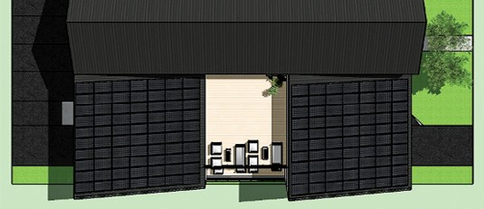Saskatoon has given the green light to three projects aimed to meet the growing demand for affordable housing. Even through uncertain times, community partners continue to create housing units that are more accessible than the traditional housing market. The three new projects will have a significant community impact, and are detailed below.
Fika House

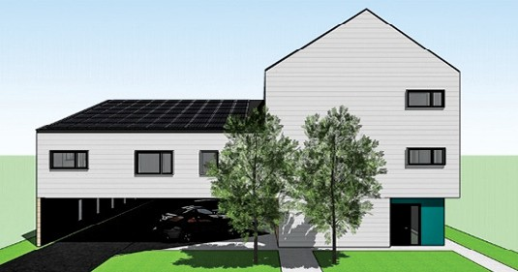Stewart Properties
Fika House

PLANNING & DEVELOPMENT, COMMUNITY SERVICES DEPARTMENT

Petrichor & Arlyn Developments – Fika House
Fika House will address the gap in affordable housing for LGBTQ2+ and seniors. It will include five market-priced units and seven affordable rental units targeted for low-income seniors. Design includes passive solar panels, a high-performance building envelope and high-efficiency HVAC systems allowing Fika House to be 55 per cent more energy efficient than the National Building Code. Tenants can expect a resulting 60 per cent energy savings on their utilities. The project will also allow residents to share an electric vehicle through their EV car-share service.
Stewart Properties have been approved for multiple projects including a Pleasant Hill 12-unit apartment building. This project will provide second stage affordable housing for residents who have been under the care of Sanctum Care Group. Supports will include assistance with money management, help accessing income assistance, food programs and mental health assistance.

Stewart Properties will also build an additional eight-unit affordable apartment. The site at 411 Avenue P South was rezoned on Feb. 25, 2020 to allow for a commercial component to add on- site offices for Parental Aide and Fetal Alcohol Spectrum Disorder Network of Saskatchewan.

The City of Saskatoon’s Attainable Housing program contributed to 82 affordable rental units in 2020; this will mark the City’s highest affordable rental contribution since 2012.

REGIONAL PLANNING

Equity, Diversity & Inclusion Roadmap
Jason Sick, RPP MCIP, Senior Planner | 306-986-3139 | jason.sick@saskatoon.ca

The Canadian Institute of Planners (CIP) released their Equity, Diversity & Inclusion Roadmap in June, 2020. The document sets out CIP’s commitment to creating a more accessible and inclusive profession and Institute. The Roadmap consists of four core areas to be implemented over the next five years: Leadership Commitment, Education & Communication, Systemic Changes and Sustainment.

Leadership Commitment
1
Engagement, sponsorship, and commitment to EDI from the CIP Board and CEO aligns stakeholders around the importance of EDI. It also informs planning and the allocation of resources required to sustain the e ort over time.

Education
& Communication
2
Increased knowledge of EDI, particularly for CIP leadership and industry change agents, raises awareness, and o ers valuable insight into building an inclusive culture. It builds capacity within the profession by creating a shared understanding and common language for safe and productive conversations about EDI.

Systemic Changes
Equipped with foundational EDI knowledge and commitment from CIP leadership and change agents in the profession, the organization is now ready to identify, design, and implement systems, policies, practices, and processes that support a more diverse, equitable, and inclusive culture. These systems begin the process of structurally embedding EDI, and the organization no longer relies solely on individuals to champion this change.
3

4Sustainment
Measuring the impact of change initiatives and continuously adapting and enhancing over time will position the organization as a leader in EDI in the planning profession.

This foundational document lends an opportunity to reflect on how we can incorporate these values into our daily work. While the following article will focus on the Education & Communication pillar, it is important to recognize how past planning decisions have had an impact on Indigenous people and people of colour. The resources are simply a starting point; however, they remind us to consider the roles planners have had on past communities and people, to learn from those experiences and create a better future for all.

In support of City Council’s commitment to respond to the Truth and Reconciliation Commission of Canada’s (TRC) Calls to Action, this article provides educational resources to assist in cultivating an understanding of our shared history and allows us to work towards decolonizing our planning processes.

University of Alberta – Indigenous Canada Course (Free!)
Indigenous Canada is a ‘Massive Open Online Course’ (MOOC) that explores Indigenous histories and contemporary issues in Canada. The course consists of twelve modules, each with a series of video lectures, a set of course notes and glossary, required and recommended readings.

This course explores key issues facing Indigenous peoples today from a historical and critical perspective, highlighting national and local Indigenous-settler relations.

Topics covered include:
- The fur trade and other exchange relationships;
- Land claims and environmental impacts;
- Legal systems and rights;
- Political conflicts and alliances;
- Indigenous political activism; and
- Contemporary Indigenous life, art and its expressions.

BeAConnectR – Reconciliation Saskatoon
Developed by Reconciliation Saskatoon, ConnectR evolved from a desire to share experiences through a city-wide conversation where Calls to Action are engaged and people may share beyond their own circle. ConnectR program participants will discover new ideas and many resources on how to follow on the path of Reconciliation, including opportunities to:
- Listen to each other and build new relationships;
- Learn from one another;
- Build a shared future; and
- Create change and live Reconciliation together.
The ConnectR program invites participants to share their journey on social media using the hashtag #BeAConnectR.

Indigenous Peoples Atlas of Canada
Enrich your travels with the Indigenous Peoples Atlas of Canada app. It uses your phone’s location to provide information on the closest Indigenous peoples including: treaty area, language, demographics, economy and culture. Important topics such as treaties and residential schools are covered in-depth, along with information about all Indigenous peoples, their oral traditions and land-based knowledge. The app can be found on the Google Play Store and the App Store.

To complement the Indigenous Peoples Atlas of Canada, the following timelines are great resources that can help us acknowledge and understand our true history:
  - Treaty Timeline – Office of the Treaty Commissioner (OTC)
  - Métis Timeline – Canadian Geographic

Wanuskewin Heritage Park
For an incredible in-person educational and cultural experience, book a physically distanced, guided or self-guided tour of Wanuskewin Heritage Park this fall. A global centre of excellence, Wanuskewin fosters education and respect for the land-based expressions of Indigenous culture, heritage and arts. The area contains some of the most exciting archaeological finds in North America, many of which pre-date the pyramids of Egypt, and is a remarkable resource for understanding Pre-Contact history of the Northern Plains Indigenous peoples.

Be sure to check out the recently reintroduced Plains bison herd, including two calves born in the park this spring. These were the first calves born in the area since before 1876. The award-winning park reopened to the public on Sept. 5, 2020 after having been closed due to the Covid-19 pandemic.

ayisiyiniwak: A Communications Guide
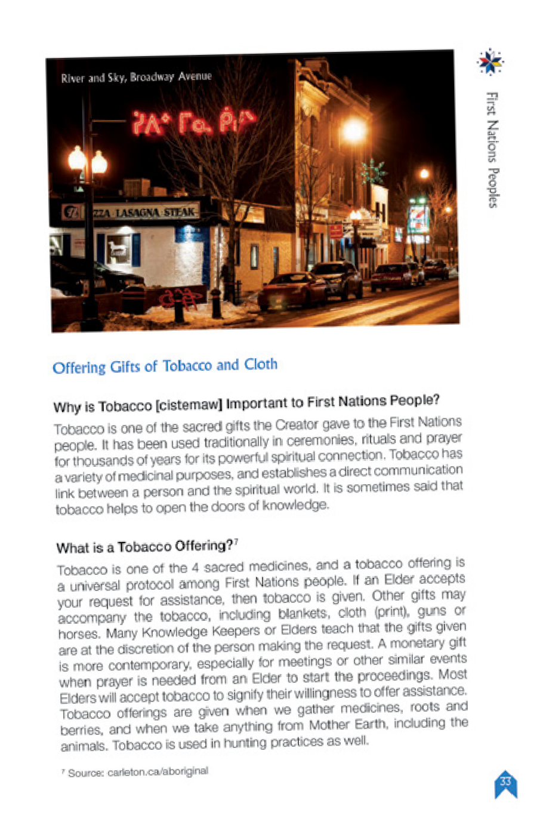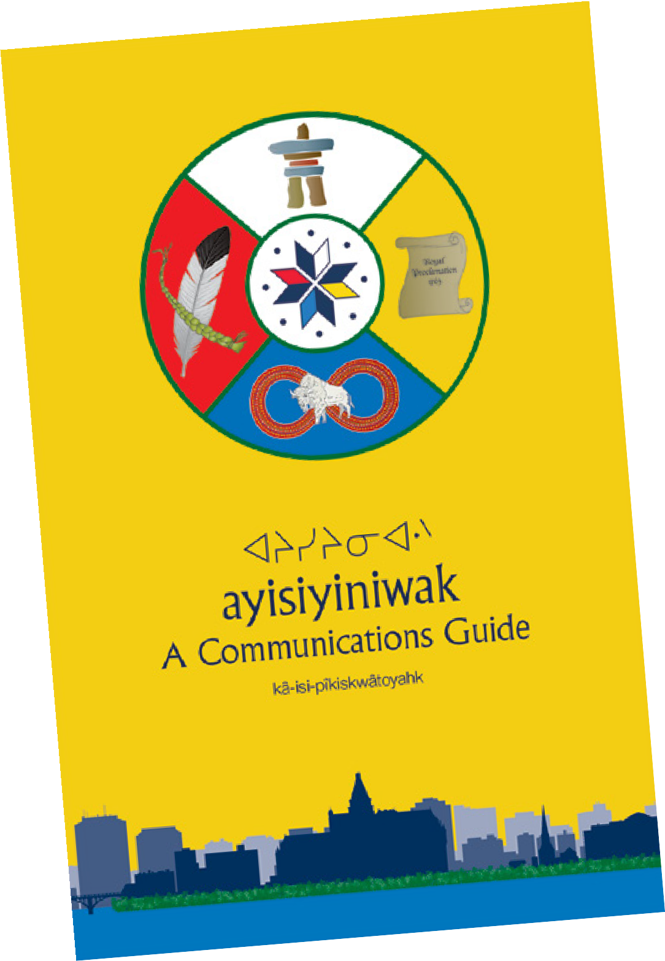This resource allows City employees to enhance their understanding of Indigenous culture and practices. Developed in partnership with the Saskatchewan Indigenous Cultural Centre and the Office of the Treaty Commissioner, it includes valuable information on First Nation meeting etiquette, protocols and ceremonial traditions.

PLANNING + DESIGN FALL/WINTER 2020
saskatoon.ca/downtown

Welcome to the Heart of our City
Those who live, work, play and do business in our City Centre know it as a vibrant, dynamic place that reflects who we are as a city.
#roomtobreathe
Even in the heart of our city, nature is never far away. The river that runs through Downtown and the green, publicly accessible corridor that flanks it are a source of great pride for our citizens.

After traveling for seven years and living in several cities, I came home to Saskatoon to take a breath to decide what to do next — and stayed. I appreciate the pace, the open spaces, and the support of a community that cares about me. It’s nice to not feel the hustle, the rush to the next thing that happens in bigger cities.
– Stephanie Yong, Design Thinking Consultant and Downtown Resident

I want to be close to work, and I didn’t want to have to buy a car in my first year in Canada. I was looking for more space, and loved the connection with nature you get in Saskatoon’s Downtown. I had an offer in Toronto as well, but I chose Saskatoon because of the lower cost of living and because Saskatoon is less crowded. I love the clean air here.
– Ruth Munoz, Developer at Vendasta, arrived from Buenos Aires with
her husband in January, 2020

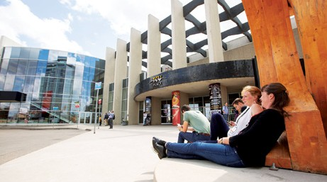#spacetogrow

We have bold plans for Downtown Saskatoon including new public transit corridors, an entertainment district and a new central library. Now is the time to invest in our future.

A Downtown event and entertainment district, centred on a new arena and convention centre, will catalyze new
development and help ensure that our Downtown remains the centre and heart of the financial, administrative, cultural and commercial activity of the city and region. This transformative project has the potential to create a well-
connected district within our Downtown that combines these anchor facilities with high quality public spaces and new opportunities for residential living, offices, dining and retail.
- Brent McAdam, City Centre Planner, City of Saskatoon
Bus Rapid Transit (BRT) will make downtown more accessible to residents, with more viable options to get to and from downtown. All the major BRT lines lead downtown. We will have high-frequency, highly reliable service, connecting corridors through the downtown and leading out to other areas in the city. BRT is a big part of the City’s overall growth plan. Across North America, evidence shows that when cities invest in high quality transit and support transit oriented development, private investment follows. We’ll be moving toward a new land use policy and developing zoning districts to allow more intensive development along the BRT corridors.
- Chris Schulz, Manager of Planning Project Services, BRT, City of Saskatoon

#placetobelong

Downtown is like any other Saskatoon neighbourhood—we get to know our neighbours. We look out for one another. It’s what makes this place feel like home.

There is a certain energy that comes with being located in a city centre and our downtown campus is right on that
pulse. Saskatchewan Indian Institute of Technologies (SIIT) is a major contributor to the culturally vibrant landscape of Saskatoon- with staff and students representing 74 First Nations, Metis, Inuit, and non-Indigenous people.
Our students are engaged in trades, industrial, business, IT, health, community studies, and adult basic education programs. They are accessing employment services at our
Career Centre. We look forward to a bright future downtown and the many opportunities that it offers our alumni.
- Riel Bellegarde, President & CEO, Saskatchewan Indian Institute of Technologies
Our mission is to serve local business— we’re fighting for the little guys. We serve and empower local businesses—which are the lifeblood of the economy and our communities—
to thrive in the digital economy. Staying downtown lets us embody our mission. Choosing downtown for our headquarters is also about our people. They want to live somewhere small enough to be able to afford to make a
home, but large enough to provide all the amenities. People from other countries come to Vendasta for their careers, but Saskatoon really seals the deal — to be able to live in vibrant place that is also safe and with a reasonable cost of living.
- Jacqueline Cook, Chief Strategy Officer, Vendasta Technologies

REGIONAL PLANNING

New P4G Planning District
The approved District OCP includes the following content:
- Part 1 - Partnership for Growth: provides the statement of intent for the District OCP and outlines the Vision, Principles and Strategic Directions used to develop and manage the District OCP.
- Part 2 - General Policies: outlines policies on economic development, Indigenous inclusion and natural resource management that apply to the whole Planning District.
- Part 3 - Land Use: outlines major land use and development policies related to designations on the District Land Use Map that is part of the District OCP.
- Part 4 – Servicing: outlines policies related to the construction and management of infrastructure and delivery of services throughout the Planning District and region.
- Part 5 – Implementation: describes the processes for administering and carrying out the District OCP.
- Maps – Includes a District Plan Area Map, a District Land Use Map and a Future Urban Growth Areas Map.
Sarah J. King, RPP MCIP, Senior Planner 306-975-2774 | sarah.king@saskatoon.ca

A District Official Community Plan (OCP) was passed unanimously by the five partner municipal councils of the Saskatoon North Partnership for Growth (P4G) after a live-streamed joint public hearing on Sept. 24, 2020. P4G member councils include the Cities of Saskatoon, Warman, Martensville, the Town of Osler and the Rural Municipality (RM) of Corman Park.

During this same meeting, a District Planning Agreement was adopted. This agreement will establish a new Partnership for Growth (P4G) District Planning Commission that will provide guidance to the partner councils on land use and development. The Commission will consist of 13 members, made up of representatives from each partner council, as well as others jointly appointed by the partners.

This progress is possible due to earlier work; In 2017, the partner Councils endorsed a Regional Plan in principle which included land-use policies, a Regional Land-Use Map, a Regional Servicing Strategy and a Regional Governance and Implementation Strategy.

The endorsed Regional Plan was used to draft a P4G District Official Community Plan bylaw (District OCP) to address future land-use development and servicing within the P4G Planning District, as well as provide a coordinated approach for growth among all P4G municipalities.

The Partnership for Growth will finalize the newly-drafted P4G District Zoning Bylaw before presenting it to the RM Council for consideration in early 2021. The RM will be sole adopters of this Bylaw as all of the land in the P4G Planning District is in the RM.

The P4G Planning District and the new District OCP and Zoning Bylaw are expected to take effect by mid-2021, following the completion and adoption of the P4G District Zoning Bylaw. The Ministry of Government Relations are also required to approve both the District OCP and Zoning Bylaw.

Once in place, the P4G Planning District will replace the Corman Park-Saskatoon Planning District and the corresponding District OCP and Zoning Bylaw will be repealed.

For more information on P4G, and to view the new P4G District OCP, please visit the website at partnershipforgrowth.ca.

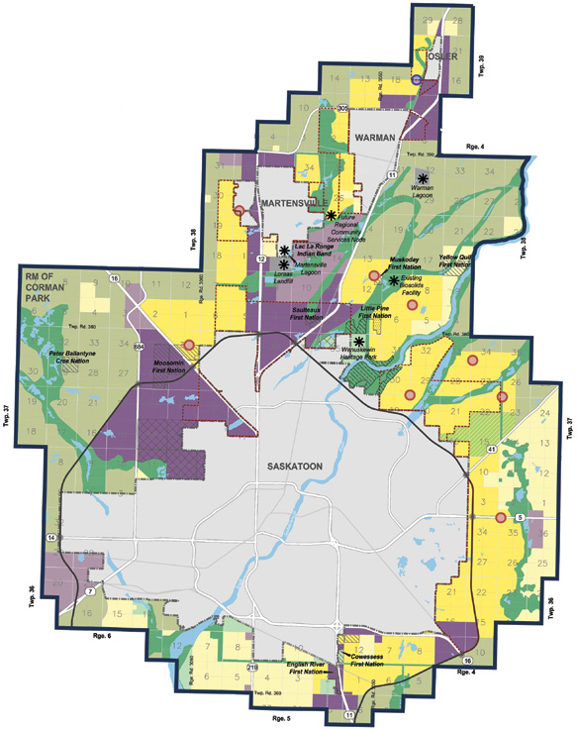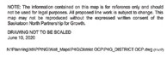LAND USE
Agriculture Agricultural Research Country Residential
Urban Residential Neighbourhood
Rural Commercial/Industrial Urban Commercial/Industrial Urban Mixed Use Node
Corman Park - Osler Agri- Food Node
Green Network Study Area Regional Infrastructure Regional Institutional Facilities Recreation, Parks and Culture Water
P4G District Boundary Existing Urban Municipality First Nations Land Holdings First Nations Reserves
Growth to 700,000
(Airport, Wanuskewin, etc.)
Wanuskewin Viewshed Major Roadways
Saskatoon Freeway Alignment Railway
Potential Interchanges Key Location
Potential Expansions
– 8 –

SCHEDULE B: DISTRICT LAND USE
FUTURE URBAN GROWTH AREAS

PLANNING PROJECT SERVICES

Corridor Parking Standards Reduction
Lee Smith, RPP MCIP, Senior Planner | 306-986-3668 | lee.smith@saskatoon.ca

Encouraging transit use and active transportation, less automobile dependence, greater housing diversity and reduced construction costs for multiple-unit dwellings (MUDs) are some of the drivers behind the recent off-street parking standards review. Identified as a priority for early implementation, the reduction to minimum parking requirements for MUDs along major transportation corridors ultimately resulted in a Zoning Bylaw amendment adopted by City Council on March 23, 2020.

Administration drove the change, based on strategic goals and supported by comments and discussions with members of the building and development industry. The work ultimately points towards Saskatoon’s Growth Plan to Half a Million that set a target for 15 per cent future population growth along major transportation corridors (the Bus Rapid Transit corridors). The Corridor Planning Program was established to begin implementing this directive in 2017, and in 2020 Council endorsed the Corridor Transformation Plan.

An approach to reducing the minimum parking for MUDs was developed through many internal stakeholder meetings and extensive background research. See the below table for a summary of these changes.

Typical Minimum Parking Requirement for MUDs on Transit Corridors  (Before Amendment) | New Minimum Parking Requirement for MUDs on Transit Corridors  (After Amendment)
- One space per unit 56 sq. m. or smaller  - 1.25 spaces per unit larger than 56 sq. m.  - 0.125 visitor spaces per unit | - 0.75 spaces per unit 56 sq. m. or smaller  - 0.9 spaces per unit larger than 56 sq. m.  - 0.125 visitor spaces per unit
Example: | Example:
An apartment with 12 units, each larger than 600 sq. ft., would have to provide a minimum of 15 resident parking spaces and two visitor spaces | An apartment with 12 units, each larger than 600 sq. ft., would have to provide a minimum of 11 resident parking spaces and two visitor spaces
The new minimum requirement applies only to MUDs that are next to the approved Bus Rapid Transit corridors; a total of 241 existing sites as of March 2020. The new minimum standards are based on the Institute of Transportation Engineers’ data on parking demand observed across North America.¹

¹ This data is available to the Planning & Development Division, both in printed format (ITE, Parking Generation Manual, 5th Edition) and online. Contact Lee Smith or Paula Kotasek-Toth for more information.
Some additional research findings include:
- Thirty per cent of residents within the Corridor Growth Area already commute using a method other than driving, compared to 20 per cent of Saskatoon residents as a whole. (The Corridor Growth Area is loosely defined by a short walking distance from the Bus Rapid Transit routes; see the Corridor Transformation Plan for more info.)
- Peak parking demand for North American MUDs ranges from
0.22 to 1.31 vehicles per dwelling unit, depending on urban setting, development density and proximity to rapid transit. The peak demand for mid-rise (three to 10 floors) MUDs in “dense multi-use urban” settings is 0.9 vehicles per dwelling unit, or
0.71 when in proximity to rapid transit. (ITE Parking Generation Manual, 2019)
- In Western Canada, construction of structured parking can cost up to $45,000 per parking space. It is expected that some of the costs saved by building less parking can be passed on to buyers or renters and ultimately have a positive impact on housing affordability.
- Eleven of the sites affected by this amendment are within Residential Parking Permit (RPP) zones. The Parking Services group was engaged throughout the project to ensure that residential parking permits would not be impacted by this amendment.

This amendment represented an early step toward the larger goals of the Growth Plan to Half a Million and the Corridor Transformation Plan. Future work under the Corridor Planning Program will include a more comprehensive review of parking standards including other land uses and locations. The Corridor Growth Area’s new land-use designations were recently adopted in the new Official Community Plan and will be the starting point for the development of new zoning standards for the corridors, parking included.

LONG RANGE PLANNING

The Official Community Plan
Tyson McShane, RPP MCIP, Long Range Planning Manager | 306-975-7946 | tyson.mcshane@saskatoon.ca

Saskatoon City Council unanimously approved The Official Community Plan Bylaw, (Bylaw No. 9700) on June 29, 2020. The Official Community Plan (OCP) is our collective long-term vision, guiding Saskatoon’s physical, environmental, economic, social and cultural development. It provides both inspiration and direction through a comprehensive policy framework to ensure the community’s vision for Saskatoon is integrated in all aspects of planning, decision-making and priority-setting.

The new OCP establishes and consolidates the direction set by a number of major initiatives over the last 10 years into one guiding document that sets the framework for city building. This marks the first significant update since 2009 and the first complete redesign since 1998. The new bylaw aligns the OCP with directions set out in the Plan for Growth, the City Centre Plan, the Culture Plan, the Heritage Plan, the Active Transportation Plan, the Recreation and Parks Master Plan, the Green Infrastructure Strategy, the Strategic Plan, Saskatoon Speaks and the Saskatoon North Partnership for Growth, amongst many other plans and initiatives.

As the updated OCP represents direction approved by City Council over more than a decade, the significance of this update extends beyond the policies that it contains. It marks a major change in how this information is presented and how it can be used. The redesigned OCP follows best practices set across Canada with a more visually-engaging layout and design than previous versions. With added images and wording to provide context on the policies, it is a colourful and dynamic document.

It was also reviewed to reflect an Indigenous lens, showing our commitment to the goal of enhancing and honouring relationships with the original stewards of this land. The table of contents is shown as a cycle (see page ii of the OCP). With people at the centre, it represents an equitable community with no one section more important than the other.

The updated OCP is intended to guide Saskatoon’s growth and development to a population of 500,000. This reflects the scope and horizon laid out in the Plan for Growth.
Highlights of new policy and added wording include:
- Recognition of the location, history and projected future of the city and region, including honouring our long Indigenous history and the City’s commitment to reconciliation and the Truth and Reconciliation Commission of Canada’s recommendations;
- The City’s seven Strategic Goals so as to align the OCP and the Strategic Plan;
- Supporting the Plan for Growth infill goal of accommodating 50 per cent of long-term growth as infill (25 per cent in Strategic Infill Areas, 15 per cent in Corridor Growth Areas, and 10 per cent in Neighbourhood Infill areas);
- Enhancing quality of life through the support and development of arts and culture throughout the city;
- Mitigating and adapting to climate change through the implementation and maintenance of a climate action plan to reduce corporate and community emissions;
- Integration and interconnection of all modes of transportation as part of the transportation network;
- Accessibility of existing or future streets and their integration with surrounding land uses;
- Coordinating with regional partners to enable cost-effective growth; and
- Coordinating and facilitating business growth and creation among regional partners.

To view the new OCP and see a more extensive list of policies, visit saskatoon.ca/OCP.

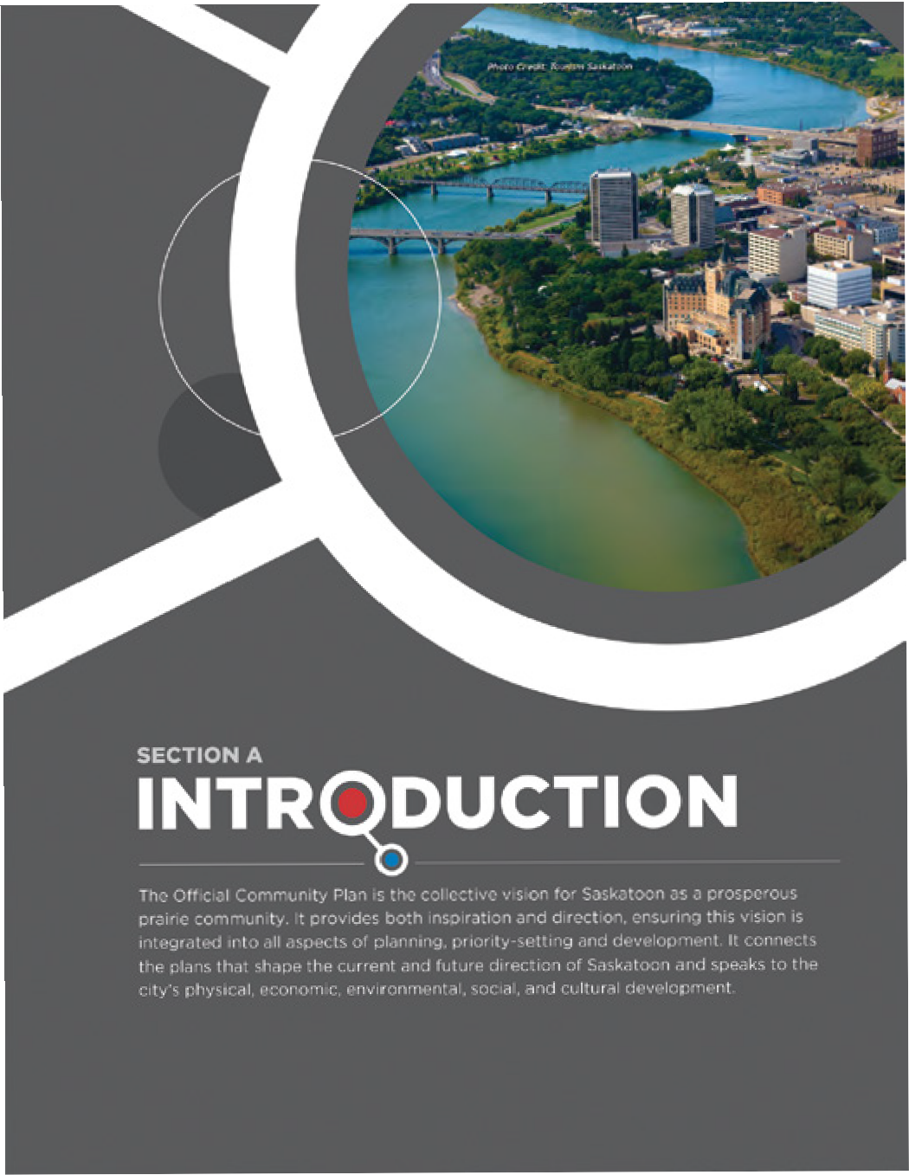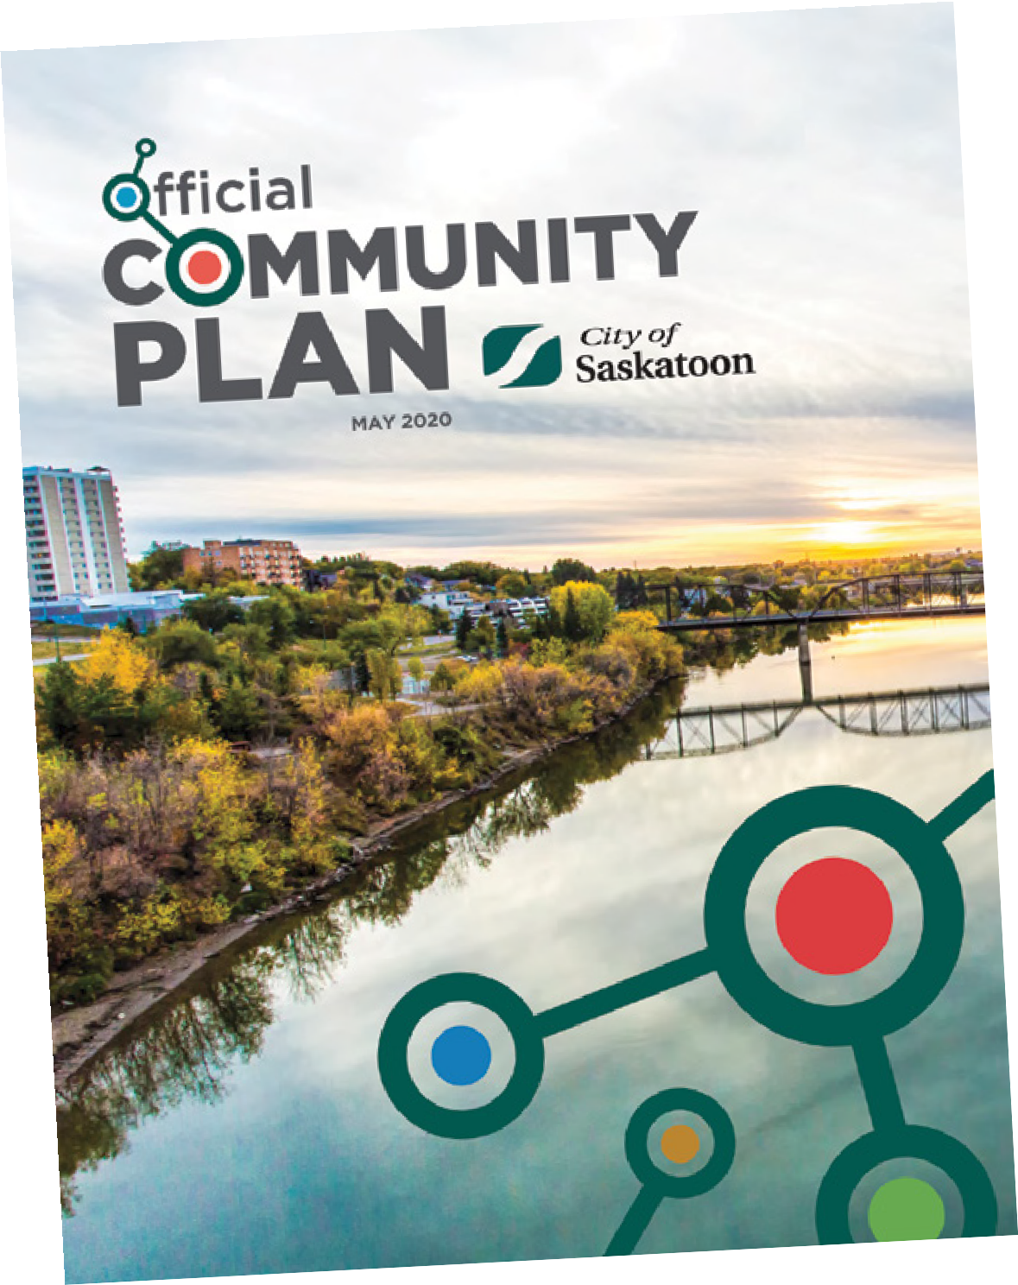

– 10 –

BUSINESS LICENSE PROGRAM

Parking Patios During Covid-19
Mike Ewen, Planner | 306-975-3470 | mike.ewen@saskatoon.ca

Despite a late start to patio season, 2020 saw more Saskatoon restauranteurs offering temporary outdoor dining than ever. Provincial health directives forced restaurants and bars to close for multiple months during the onset of the COVID-19 pandemic. Upon reopening in early summer, businesses were faced with economic difficulties while also navigating physical distancing requirements that limited seating capacity. With customers seeking outdoor dining options, many businesses viewed parking patios as a remedy to their problems. These patios allowed restaurants to partially offset reduced indoor capacity with new outdoor seating; ultimately leading to several new parking patio inquiries.

New motions were passed to make it easier for businesses to install parking patios at the Saskatoon City Council meeting on June 29. The approved changes were:
- Waiving all fees associated with parking patios until the end of 2021;
- Increasing the number of parking stalls per block-face that may be occupied by parking patios;
- Introducing a temporary Asphalt Patio License for summer 2020 to allow for simple patios placed directly on the parking surface; and
- Allowing parking patios to operate in winter months until the end of 2021.
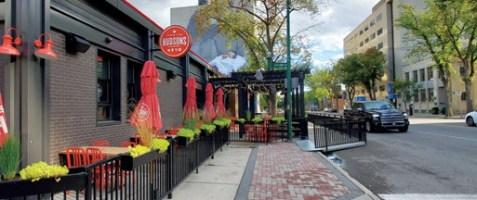
The Business License Program issued eight parking patio approvals this year (including one asphalt patio), surpassing the previous record of six approved patios in 2017. Five of the approvals this summer were for first time parking patios. Restaurants and bars have been allowed to temporarily convert on-street parking stalls into these outdoor dining areas since 2014.

We will be closely monitoring the operation of parking patios during the coming winter months. These patios will provide new opportunities for businesses to actively promote outdoor winter dining, in line with the City’s WintercityYXE Strategy. We expect substantial interest in parking patios during the summer of 2021, as businesses continue to look for ways to safely accommodate their patrons in an outdoor setting.
DEVELOPMENT REVIEW

Comprehensive Review of the Zoning Bylaw – Updates for Development in Proximity to Rail Operations
Christine Gutmann, RPP MCIP, Senior Project Planner 306-986-3096 | christine.gutmann@saskatoon.ca

The Federation of Canadian Municipalities (FCM) Guidelines for New Development in Proximity to Railway Operations provides a road map for managing potential conflicts between rail operations and new developments near railway corridors. Saskatoon’s ongoing, comprehensive Zoning Bylaw review project will develop changes to reflect the requirements of the guidelines.

The guidelines provide consistency in the approach to the design of buildings and their context to nearby railway corridors and insight into how these problems are dealt with across Canada. These guidelines were prepared for the Federation of Canadian Municipalities and the Railway Association of Canada and are found online at www.proximityissues.ca. Amendments to the Statements of Provincial Interest, which will take effect on Jan. 1, 2021, will require municipalities to consider setbacks, noise and vibration when planning development near railways.

The Official Community Plan, 2020, also states that “Development in proximity to rail yards or rail lines should be consistent with the Guidelines for New Development in Proximity to Railway Operations prepared for the Federation of Canadian Municipalities and the Railway Association of Canada.” Amendments to the Zoning Bylaw to reflect the requirements of these guidelines are forthcoming.

The Zoning Bylaw review began in 2019 and will include several updates, including a comprehensive review of the RMTN/ RMTN1 Districts, updates to the neighbourhood-level infill regulations, a review of landscaping requirements and other Zoning Bylaw updates. More information about the review can be found at saskatoon.ca/zoningbylawreview.
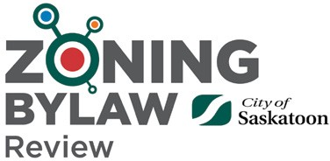

– 11 –
saskatoon.ca

NEIGHBOURHOOD PLANNING

Parcel YY Streetscaping ̶ a Collaborative Partnership Coming Out of the Ground
Jill Cope, River Landing Project Manager | 306-975-3461 | jill.cope@saskatoon.ca

What can hundreds of metres of concrete, electrical conduit, irrigation lines, paving stones, bollards, street lights, benches and trees build? These things build a great collaborative partnership…. and the City streetscaping around Parcel YY in the heart of River Landing!

The site footprint, now known as Parcel YY, is the amazing private development that reaches from 19th Street to Spadina Crescent and from 2nd to 3rd Avenue. It features five separate elements, all with different owners and management structures: Alt Hotel, No. 1 River Landing Condos, East Tower, Nutrien Tower and the K.W. Nasser Plaza.

Parcel YY was created as a result of River Landing’s original construction, including the extension of 2nd Avenue all the way to Spadina Crescent. At the time, civic streetscape work like sidewalks, amenity strips, trees and streetlights weren’t built, as we were waiting for future site development to go in first.

So, in 2018 when construction began on Parcel YY, River Landing first partnered with hotel and condo developers. Their contractor built their site and constructed our streetscape elements at the same time. This partnership happened thanks to a fantastic team of interdivisional colleagues from Urban Design, Development Review, Construction & Design, Transportation and Saskatoon Light & Power.
It was a very innovative and beneficial partnership ̶ the City was able to mitigate its risk around schedule, site coordination and contractor continuity while saving costs and increasing efficiencies. The City team worked closely with the developer and their contractor, sub-trades, engineers and architects on creative problem solving to ensure things went well on the construction. When everything opened up in early 2019, it looked great.

It worked so well that we did it again during the summer of 2019. We partnered with the East Tower and K.W. Nasser Plaza developers for the civic streetscape work along Spadina Crescent and the intersection of 3rd Avenue and 19th Street. The Tower opened in 2019, with the Plaza set to be finished in 2020 or 2021.

And, in 2020, we continued the collaboration on both of those sites, as well as the reconstruction of Mews Road on 2nd Avenue. 2021 will see completion of 19th Street work, the remaining civic streetscape work along 2nd Avenue and the opening of Nutrien Tower.

Parcel YY will be an incredible site when it is finished. It has already changed Saskatoon’s skyline, and its intentional people- centric design will entice more people to live, work and visit this vibrant area!

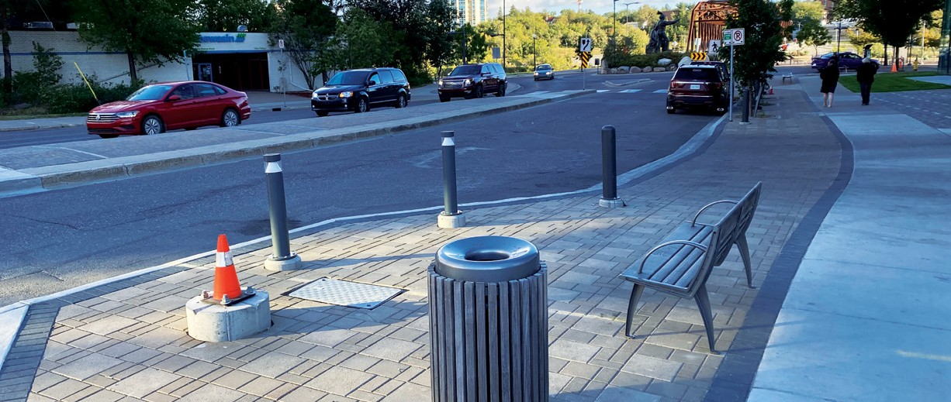
The current issue of Planning + Design is available for download at saskatoon.ca
The information contained in this publication is not copyright protected and may be used freely. The Community Services Department believes all information and sources in this publication to be correct, but cannot guarantee accuracy and assumes no responsibility for its use. Planning + Design is provided as an informational service to the general public and agencies who regularly do business with City Hall. Readers should not act upon the information contained in this publication without seeking professional advice.
City of Saskatoon Planning & Development 222 – 3rd Avenue North Saskatoon, SK S7K 0J5 306-975-2645
city.planning@saskatoon.ca

