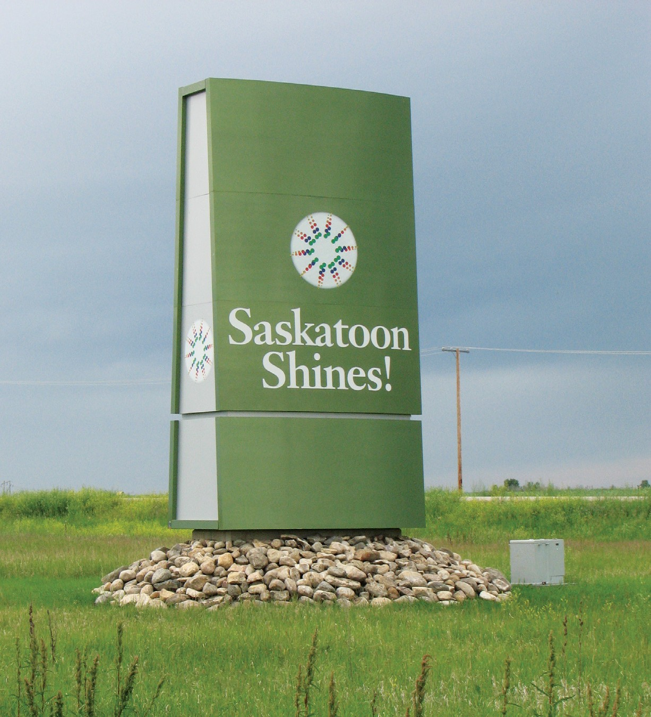

A CITY OF SASKATOON SEMI-ANNUAL PUBLICATION FROM PLANNING & DEVELOPMENT SPRING/SUMMER 2020

2nd Edition of ayisiyiniwak released | The City of Saskatoon’s Growth Monitoring Report University Sector Plan | Local Area Planning Tools and Approaches to Engagement Kahkewistahaw Signing Ceremony | Interim Exemption of Offsite Levies for Infill Development Strategic Infill | Pleasant Hill Village - Parcel F Sold for Development of CUMFI Elders Lodge Hyde Park Outdoor Sculptures Project

Message from the Director

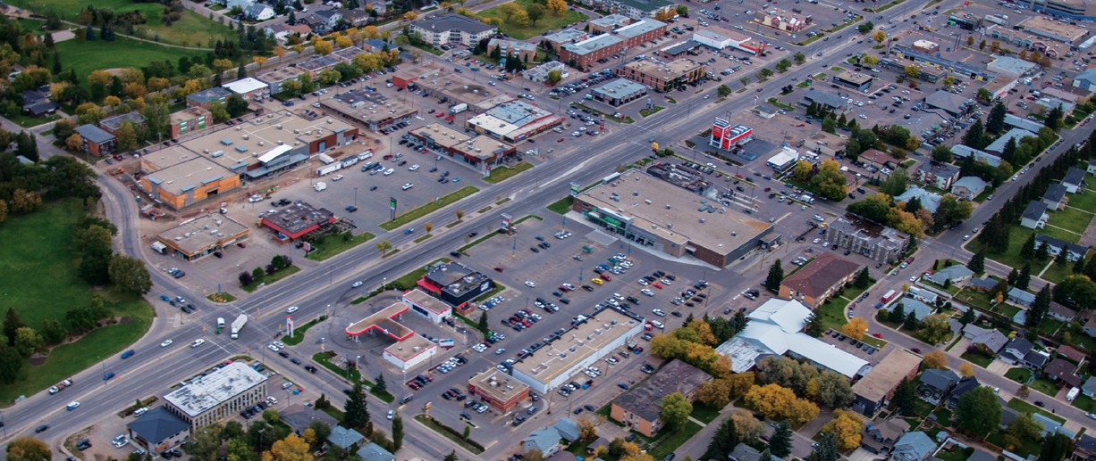We made several significant steps to align the city’s policy framework with the overall goals of the Plan for Growth in early 2020. Work to prepare and present the redesigned Official Community Plan (OCP) to the Advisory Committees of City Council and the Governance and Priorities Committee moved forward. In addition, the Corridor Transformation Plan, which will provide high-level guidance for land use planning along our major corridors, was also endorsed in January by City Council.
PLANNING + DESIGN SPRING/SUMMER 2020

Saskatoon’s current OCP was approved in 1998 and updated in 2009. Over the last ten years, the city has undertaken a number of significant initiatives that have helped shape a new vision for our city. They include the Saskatoon Speaks Community Visioning process, the Plan for Growth and the Strategic Plan. Each of these initiatives have included extensive public consultation and have been endorsed by City Council. However, the formal step of embedding these directions in the OCP did not occur until now.

As our collective long-term vision for Saskatoon, the OCP provides both inspiration and direction through a comprehensive policy framework. It ensures that the community’s vision for Saskatoon is integrated into all aspects of planning, decision-making and priority-setting.

Topic reports were presented to each of the five Advisory Committees of City Council to identify items of interest and relevance for those committees. An introduction report was presented to Governance and Priorities Committee while the Municipal Planning Commission was kept busy from December to March with reports outlining each new section of the OCP.

When the redesigned OCP has been considered by council later this spring, it will once again represent the current direction of the city. Moving forward the OCP will be maintained to ensure the policies in place for Saskatoon reflect the directions received from City Council.
The Corridor Transformation Plan is a key element of the Growth Plan, and it was endorsed by City Council in January. Developed in 2018 and 2019, it is intended to provide the long-term vision, principles and guidelines for the Corridor Planning Program and Transit Villages project. The overall goal is to ensure alignment with the Corridor Growth Initiative of the Growth Plan.

These long-term directions for corridor growth will enable the Corridor Planning Program to remain responsive to changing real estate market conditions, new and emerging building technologies and sustainability and energy efficiency initiatives while meeting the needs of current and future residents.

An implementation priority of the Corridor Transformation Plan included a review of off-street parking standards along high-frequency transit corridors. This work represents an early step toward encouraging transit-oriented development in areas near rapid transit. More work will come, in order to consider other changes necessary to encourage new forms of transit- oriented development.

These are just a few of the activities underway that will help shape the future of the city. I hope the articles in this edition of Planning + Design will show you how our work is responding and contributing to the changes in Saskatoon.

Lesley Anderson, MCIP, RPP
Director of Planning and Development
306-975-2650 | lesley.anderson@saskatoon.ca

REGIONAL PLANNING
Kahkewistahaw Signing Ceremony
Jason Sick, MCIP RPP, Senior Planner | 306-986-3139 | jason.sick@saskatoon.ca

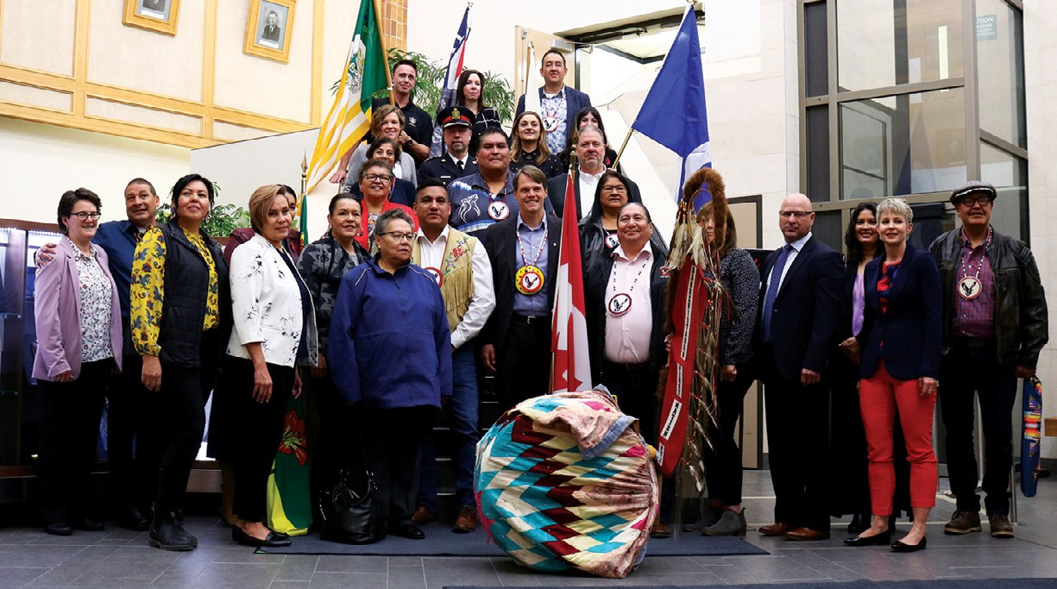The City of Saskatoon and Kahkewistahaw [kak-uh-WISH’-tuh- how] First Nation came together to celebrate their partnership in October, 2019. The municipal component of urban reserve creation process was concluded for the First Nation’s land at 1215 Claypool Drive within the Hampton Village Business Park.
PLANNING & DEVELOPMENT, COMMUNITY SERVICES DEPARTMENT

Mayor Charlie Clark, Chief Evan Taypotat, the Council of Kahkewistahaw First Nation and Saskatoon Board of Police Commissioners’ Chair Darlene Brander signed a Municipal Services and Compatibility Agreement and a Police Services Agreement during a special signing ceremony.

The agreements address:
- municipal and police services the city will provide;
- service fees Kahkewistahaw First Nation will pay the city in lieu of property taxes; and,
- compatible land use and development standards.

These agreements fulfill the municipal requirements for urban reserve designation.

Reserve designation decisions are made by the federal government. Once designated, it will become Saskatoon’s eighth urban reserve.
When a property transfers to reserve status, it is no longer under city jurisdiction.

Kahkewistahaw First Nation is a member of the Yorkton Tribal Council whose home reserve is located about 15 km north of Broadview, Saskatchewan. A signatory of Treaty No. 4, Kahkewistahaw First Nation has 2,020 members. About 670 members reside on the home reserve and 1,350 members live in other communities throughout the province.

For more information about Kahkewistahaw First Nation and urban reserve creation, please visit saskatoon.ca/urbanreserves.
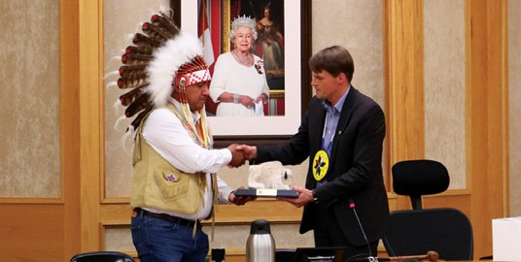

LONG RANGE PLANNING
Interim Exemption of Offsite Levies for Infill Development
Brent McAdam, MCIP, RPP, City Centre Planner | 306-986-3688 | brent.mcadam@saskatoon.ca

Qualifying infill properties are now exempt from offsite levies, on an interim basis, by City Council to encourage infill development in Saskatoon’s established neighbourhoods.

Offsite levies on new developments reflect the capital costs of increasing infrastructure (water, wastewater and storm sewer) capacity. While they are most commonly collected on new infrastructure in greenfield development areas, they can also be payable for infill development. The development industry has cited offsite levies as a barrier to infill development, specifically during the Mayor’s Infill Roundtable in 2017.

In November 2019, City Council resolved to exempt offsite levies for development on certain properties within the established neighbourhoods (excluding University of Saskatchewan land) on an interim basis. Please see map below. The exemption targets zones that assist with meeting the Growth Plan’s targets for infill
growth by providing for multiple-unit residential and mixed- use development in a variety of densities. The end date of this exemption is unknown, but it is intended that it will remain in place until a new development levy policy framework is implemented. Exemption impacts will be monitored by City Administration with future reporting to City Council will be required.

This new incentive follows a 2018 City Council decision that waived offsite levies for all downtown properties. Increasing infill development as a share of the city’s growth is a strategic objective of the City of Saskatoon, per the Growth Plan, Strategic Plan and City Centre Plan.

To confirm exemption eligibility, contact Brent at brent.mcadam@saskatoon.ca.

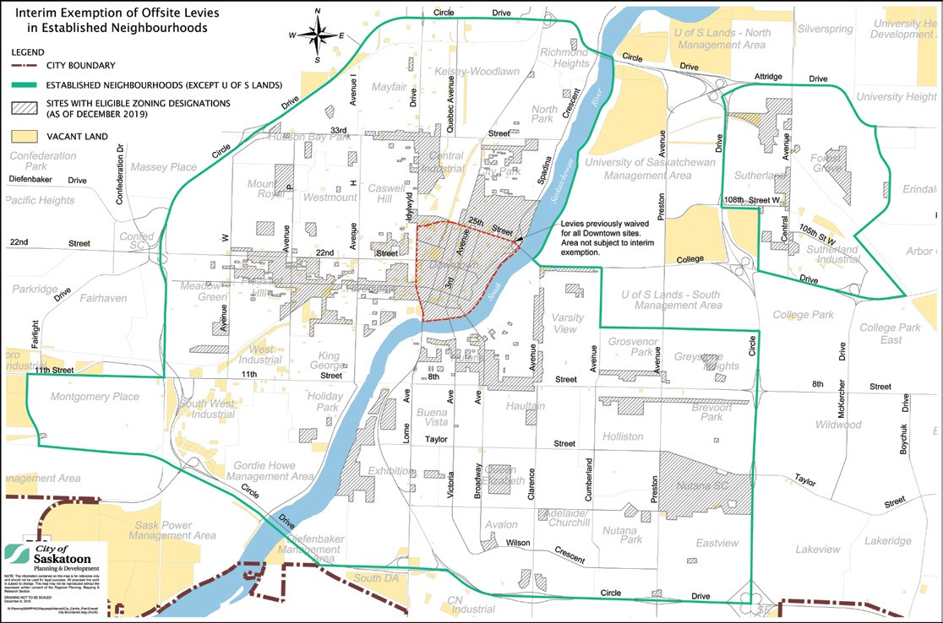

LONG RANGE PLANNING
University Sector Plan
Ian Williamson, MCIP RPP, Senior Planner | 306-657-8640 | ian.williamson@saskatoon.ca

The city’s Strategic Plan includes a long-term strategy to increase and encourage infill development. The Plan for Growth identifies strategic infill areas, including the University of Saskatchewan (USask) endowment lands, as a key part of Saskatoon’s plans for future growth. Of USask’s total inner-city land holdings of 755 hectares (7.55 km sq), 401 hectares (4 km sq) of land are recommended for potential development.

The 2009 study, Vision 2057: University Land Use Planning, outlines a range of possible uses for university endowment lands. However, the City and USask must still consider how these areas will be incorporated into the urban framework of Saskatoon, given their unique ownership, authority and central location. Plans around land use, servicing, transportation and development phasing is needed.

As a mutually beneficial and strategic endeavour, the city and USask partnered to develop the USask Strategic Infill Sector Plan to define the structure of lands.

The vision for the Plan will be achieved throughout the embodiment of the following land use planning principles:

- Recognize USask’s lands are a long-term strategic and economic asset to be retained and leveraged to support USask’s mission.

- Promote an inclusive process that supports design excellence and reflects Indigenous places and spaces.

- Embody environmental sustainability in land infrastructure, open space and building development.

- Support sustainable community development including mixed use, transit supportive development.

The plan will provide a broad framework for this future development area. It will outline a number of new neighbouhoods and their possible residential capacity. The plan will outline the basis for complete, vibrant, distinct urban communities that harmonize and integrate with existing surrounding communities.
The plan will include:
- a transportation strategy to outline the needs and infrastructure, based on the location to major employment areas, amenities and the future Bus Rapid Transit System;

- a servicing strategy to outline the major infrastructure needed for the plan’s development goals, and how to efficiently use existing city services and infrastructure;

- an open space and natural area strategy outlining natural areas and heritage resources that shall be preserved and integrated within the community design;
- a land use strategy that will outline residential, employment, mixed-use areas, schools and other community facilities.

Sector Plans are future oriented with no specific development timeline. A Sector Plan is the first step in an important process needed before land is prepared for development. Once the plan is approved by City Council, further detailed planning can begin on an area Concept Plan of a specific neighbourhood or other development within the area.

Consultation and communication with the public, the USask community and identified stakeholders will occur throughout the project. The plan will be drafted and refined based on the information shared during the public engagement phase. The final plan requires approval by both the USask Board of Governors and Saskatoon City Council.

For more information regarding the University Sector Plan, please visit saskatoon.ca/sectorplans.
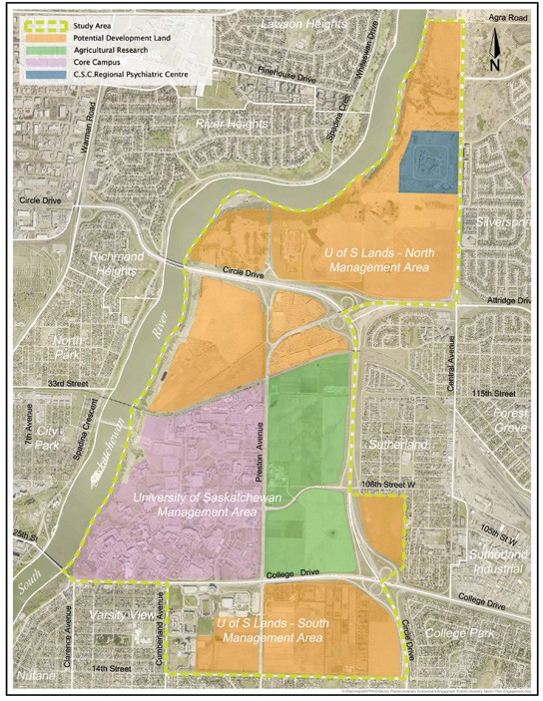

NEIGHBOURHOOD PLANNING
Local Area Planning Tools and Approaches to Engagement
Keith Folkersen, MCIP, Senior Planner | 306-986-1690 | keith.folkersen@saskatoon.ca

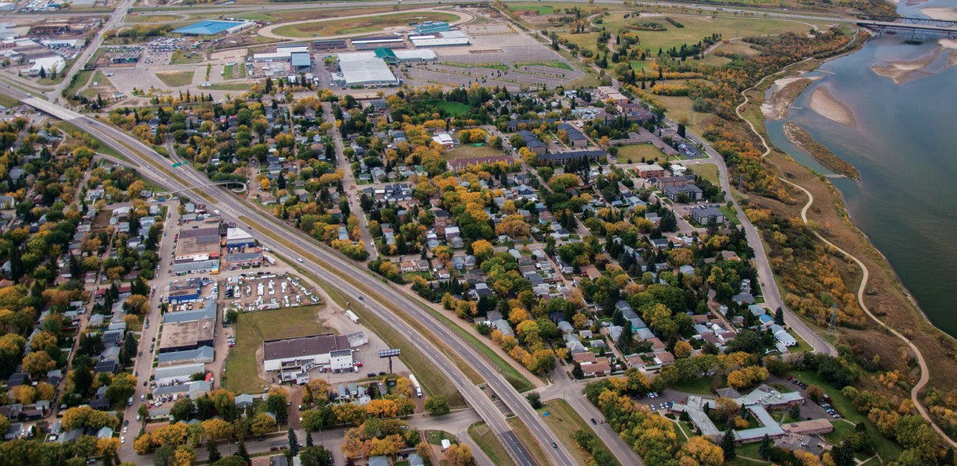
– 6 –
Through creatively using new and existing technology, the LAP team continues to enhance community engagement and encourage citizen participation in projects that impact Saskatoon.

Online photo submission, digital data collection and a new style of sharing public engagement outcomes were just some of the initiatives used during the Local Area Planning (LAP) Program for the Exhibition neigbourhood. Tools and approaches used to engage with the public are always evolving; we aim to get the most out of public participation and encourage stakeholder involvement.

Public engagement is a cornerstone of the LAP process as it gives residents, business owners, property owners and community groups an active role in determining the future of their neighbourhood. Together with the city, they develop goals and strategies aimed at improving the long-term success of their community. These plans identify action items for improvements and enhancements that are implemented with the support of various city departments over the short, medium and long-term.

Photo Submission Tool
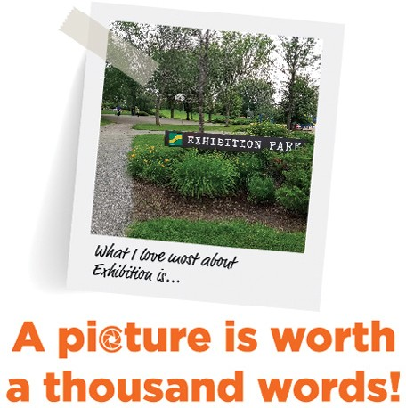
To kick-start the Exhibition LAP process and get stakeholders thinking about what they valued most in the area, stakeholders were asked to share photos of their favourite place, community event or neighbourhood feature. An online tool was developed for the project’s webpage allowing participants to upload and share photos. This tool can be used for future photo submission activities on other projects.

Digital Data Collection Application
A digital form was piloted; participants were able to record observations linked to GPS coordinates during safety audit assessments of locations in the Exhibition LAP study area. Safety audits are perception based and involve exploring an area with people who typically use the area. The safety audit assessment helps identify specific features that may impact feelings of safety.

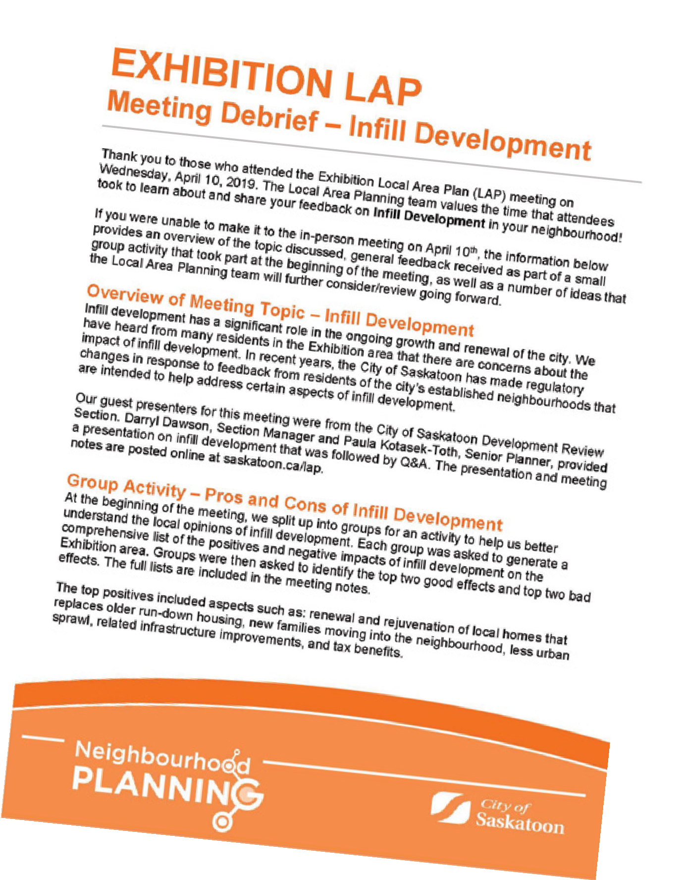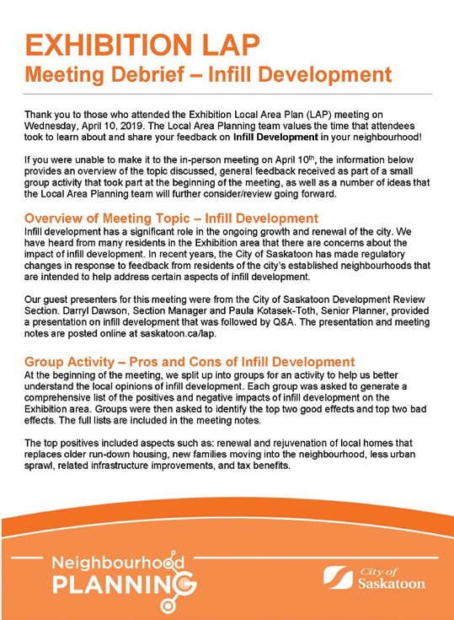The Fulcrum App, developed by Spatial Networks, allowed the neighbourhood safety team to create a digital version of the safety audit assessment booklet. It also allowed the team to review observations linked to GPS coordinates, documented locations of concern, geo-tagged photographs, video and audio. Collected information, including mapped locations of interest, were used to help identify action items to improve safety perceptions for specific areas. This digital tool allowed for much more specific safety audit observations and a new way of displaying perceptions of safety through maps.

Public Engagement Session Summary
During the Exhibition LAP process, meeting debriefs were circulated to stakeholders following public meetings that focused on topics identified by area stakeholders. These debriefs summarize the most important parts of the meeting discussions and the proposed next steps. They are great for people who could not attend meetings or preferred to review highlights online without having to read through the entire meeting notes. As well, detailed notes are recorded at LAP meetings and are also circulated to stakeholders.

Through creatively using new and existing technology, the LAP team continues to enhance community engagement and encourage citizen participation in projects that impact Saskatoon.

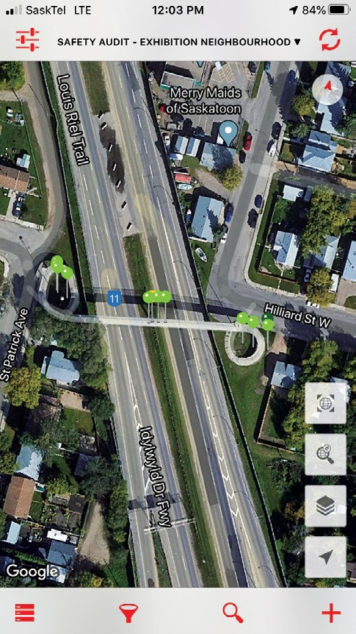

BUSINESS LICENSE PROGRAM
The City of Saskatoon Business License Program licenses all businesses operating from a fixed address within Saskatoon. This includes home-based businesses and those operating from commercial and industrial locations.

At the end of 2019, there were 11,743 businesses licensed by the program. Total Businesses graph illustrates Saskatoon’s overall business growth and identifies the total number of home- based and commercial/industrial business licensed from 2015 to 2019. New Businesses graph illustrates the number of new business licenses issued from 2015 to 2019. The number of new home-based businesses continues to exceed the number of new

2nd Edition o ayisiyiniwak released!
Jason Sick, MCIP RPP, Senior Planner
REGIONAL PLANNING
f
306-986-3139
jason.sick@saskatoon.ca

“ayisiyiniwak [a/yi/see/ni/wak,

Cree for ‘the people’]: A

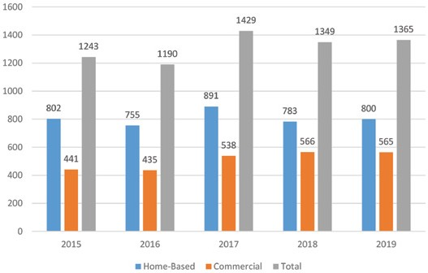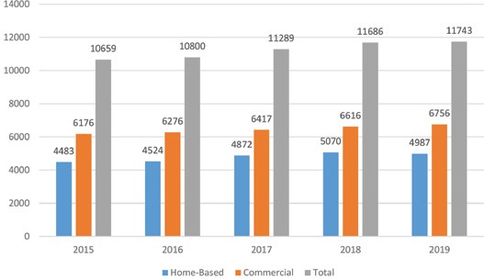commercial/industrial businesses.
For more business license statistics or to view the Business Profile 2019 Annual Report, please visit saskatoon.ca/businesslicense.

Total Businesses (2015-2019)

New Businesses (2015-2019)

Community Standards
222–3rd Avenue North, Saskatoon, SK S7K 0J5.
Tel: 306-975-2760
Fax: 306-975-7712
Email: business.license@saskatoon.ca
Communications Guide” (ayisiyiniwak) was published in August, 2019 by the City, the Saskatchewan Indigenous Cultural Centre (SICC) and the Office of the Treaty Commissioner (OTC). Originally developed in 2017 as an educational resource for city employees to enhance their understanding of Indigenous cultures and practices, copies of the guide have since been requested by many organizations across Canada.

The city team was led by Regional Planning department and included staff from Indigenous Initiatives and Communications and Marketing.

Enhancements to ayisiyiniwak (2nd edition) include the following:
- a chapter devoted to Métis culture and local history;
- a new Inuit chapter;
- revised Cree translations; and

- new sections on topics including the 60s Scoop, Elder’s Helper, Syllabics, Flag Etiquette, Anthems/Honour Songs, The Grand Entry, Blanketing and Two-Spirit People.

ayisiyiniwak is part of Saskatoon’s commitment to respond to the Truth and Reconciliation of Canada’s Call to Action #57, which specifically calls upon governments to: “provide education to public servants on the history of Aboriginal peoples, including the history and legacy of residential schools, the United Nations Declaration on the Rights of Indigenous Peoples, Treaties and Aboriginal rights, Indigenous law, and Aboriginal-Crown relations.”

The first edition of the guide received a National Planning Excellence Award of Merit from the Canadian Institute of Planners in the category of Planning for Reconciliation in 2019. For more information and to download a digital copy of ayisiyiniwak, visit saskatoon.ca/ayisiyiniwak

Printed copies are available for purchase. Contact regional.planning@saskatoon.ca for more information.

NEIGHBOURHOOD PLANNING
Pleasant Hill Village
Parcel F Sold for Development of CUMFI Elders Lodge
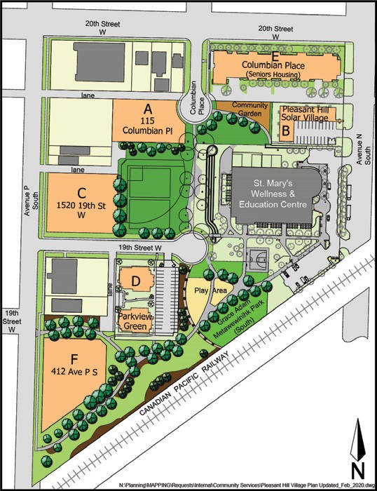
Blaire Prima, MCIP, Senior Planner | 306-687-8681 | blaire.prima@saskatoon.ca
Since its inception in 2006, the Pleasant Hill Village Revitalization Project has brought together people and organizations who want to see
a safe and thriving Pleasant Hill neighbourhood.

The Central Urban Métis Federation Inc (CUMFI) plans to construct an Elders Lodge on land purchased in December, 2019. The 32- unit, three-storey residential development will be centered around a gathering space. The sale of Parcel F (412 Avenue P South) in Pleasant Hill Village was approved by the Standing Policy Committee on Finance.

Previously an industrial site, it required clean up and soil remediation by the City in order to ensure the parcel was suitable and safe for residential use. The proposed Elders Lodge has community support and will be a welcome addition to the area. Construction of the Elders Lodge is anticipated to begin in 2020.

There are two remaining development parcels (A and C) within Pleasant Hill Village owned by the City of Saskatoon. The goal for these sites is affordable home ownership options for low- income renters who live in neighbouring areas. Administration is working with a local non-profit developer on conceptual plans for these sites.

Since its inception in 2006, the Pleasant Hill Village Revitalization Project has brought together people and organizations who want to see a safe and thriving Pleasant Hill neighbourhood. The City has led the project in partnership with the community, other levels of government, non-profit and institutional organizations, and members of the development community.

The project includes the following revitalization highlights:
- St. Mary’s Wellness & Education Centre replaced the aging St. Mary’s School;

- New community garden, improved park space and play areas in Grace Adam Metawewinihk Park;

- City investment in new infrastructure and environmental remediation to facilitate development;

- Creation of 36 new ground-oriented residential townhouse units in Pleasant Hill Solar Village (Parcel B) and Parkview Green (Pacel D); and,

- Construction of Columbian Place, a 75-unit seniors’ rental apartment building on Parcel E.

For additional information regarding Pleasant Hill Village, please visit saskatoon.ca/pleasanthillvillage.

LONG RANGE PLANNING
Strategic Infill
Ian Williamson, MCIP RPP, Senior Planner | 306-657-8640 | ian.williamson@saskatoon.ca

The Growth Plan to Half a Million (Growth Plan) lays out a framework for managing city growth by balancing greenfield development with infill development. It also identifies the University of Saskatchewan’s land holdings, Saskatoon’s Downtown and North Downtown as strategic infill areas that have the potential to accommodate significant growth.

The Strategic Infill Areas have the potential to accommodate about 74,000 people. This would account for 25 per cent of expected new residential development as Saskatoon grows to a population of 500,000. Therefore, these areas are a significant component in the city’s future growth. Development of these areas provides opportunities for the city in the following ways:
Opportunity and choice – Identified areas exist in locations that are strategically located and provide good access to major activity centres. Creating higher density developments throughout the existing urban area creates new living options with a range of housing, shopping, employment and community amenities. Increasing resident population in these areas also reinforces the viability of services and amenities and creates new opportunities for business.

Access to employment areas – The vast majority of Saskatoon’s employment is located within the Downtown, University of Saskatchewan and the North Industrial area. While the city is considering opportunities to diversify the location and types of

Continued on page 11
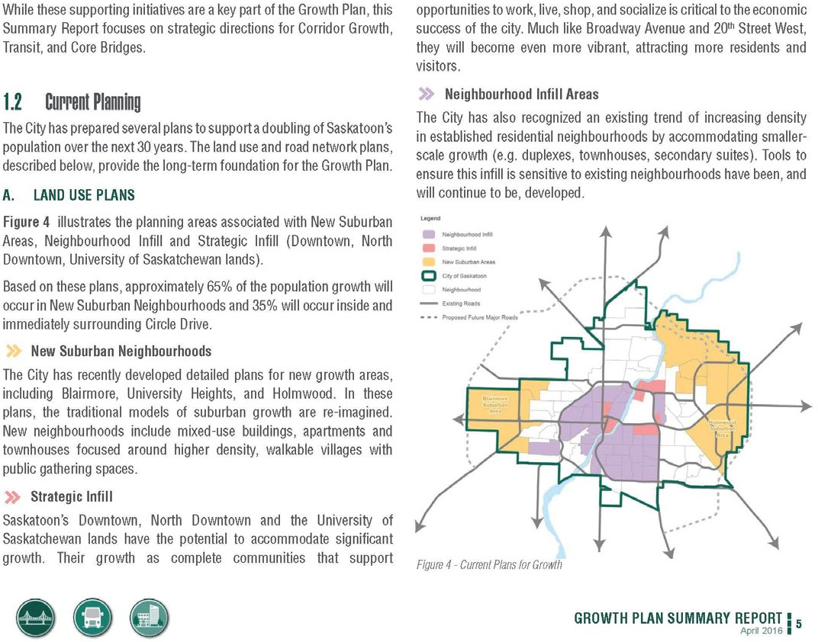

Continued from page 10

employment opportunities, the Strategic Infill Areas are located near to existing major employment nodes.

Transportation options – Strategic Infill Areas will enable more people to live in areas well served by public transit and active transportation (cycling and walking) infrastructure. Being near the future Bus Rapid Transit Network and major activity and employment hubs will allow a more integrated transportation network and enhanced connectivity for all modes of transportation.

Supportive land uses along bus rapid transit routes – Large population concentrations near transit will ensure that ridership is maximized and high-frequency, usable transit services are possible. These areas are ideally located to allow purpose- built developments which integrate with Saskatoon’s planned high-frequency transit services. Access to desirable, high-frequency transit is an incentive for developers and reenforces the value of strategic infill growth.

Efficient use of city services and infrastructure – Cities with a smaller overall footprint have less linear infrastructure per capita. This equals significant long- term savings for operations, maintenance and replacement. Strategic Infill Area growth allows the city to maximize investment in existing city services and infrastructure. It can also minimize long- term liability associated with the servicing and infrastructure expansion required for outward growth.

Higher density land uses in appropriate locations – Saskatoon regularly sees applications for new, high-density development in existing areas. This shows a demand for new development in existing areas, however these applications are not always appropriate for the proposed area. Strategic infill areas are natural locations for new higher density land uses. Planning for infill development in these areas helps preserve the character of existing neighbourhoods by focusing where new infill development occurs. In short; higher density use is hugely beneficial, as long as it follows guidelines set out in the Strategic Infill Area plans.
LONG RANGE PLANNING

The City of Saskatoon’s Growth Monitoring Report
Lars Ketilson, RPP, MCIP, Senior Planner | 306.975.7640 | lars.ketilson@saskatoon.ca

As the future of development shifts away from primarily suburban expansion to a more balanced mix of infill and suburban development, a new tool is needed to monitor how and where growth is planned. The new Growth Monitoring Report will fill this need.

Beginning in 2019, the report will provide a summary of growth and related indicators to help provide a comprehensive overview of how Saskatoon is changing. The report will continue to provide much of the Three Year Land Development Report content, but will also include additional information.

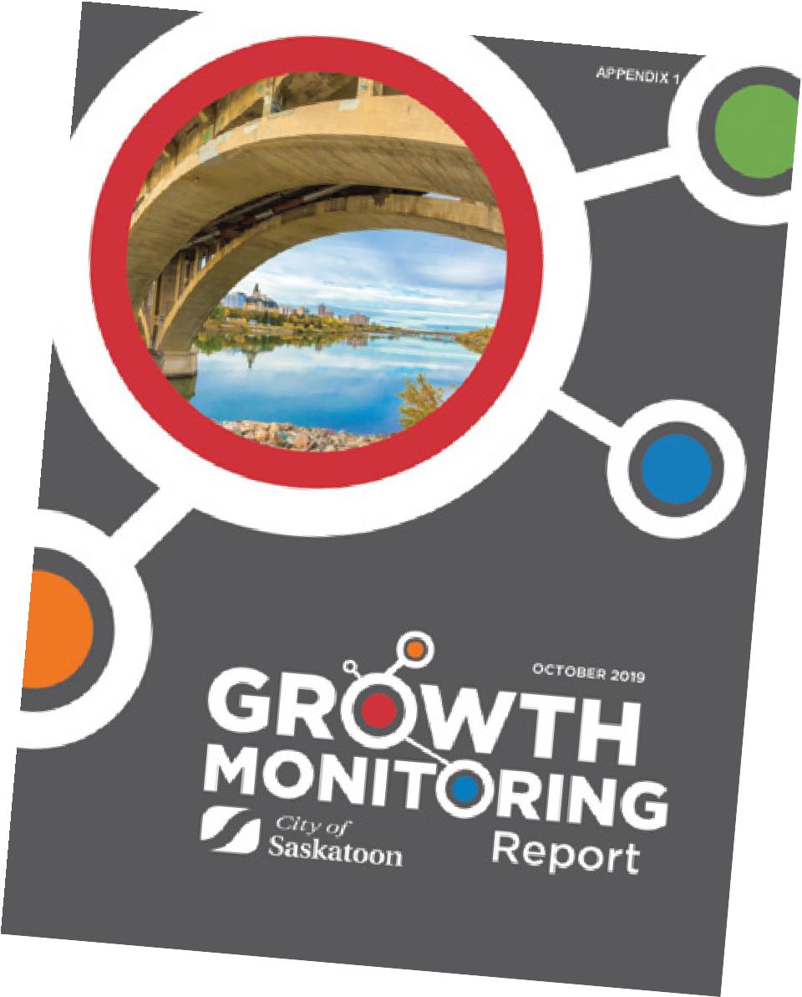
The new Growth Monitoring Report will cover the entire city and include more general indicators summarizing changes to the city. This annual analysis will help monitor how Saskatoon progresses towards its long term development targets and objectives, providing valuable information to help shape future policy, programs and council decisions.

Included from the Three Year Land Development Report will be: expected new development and associated servicing needs; information on development plans; and a range of information to fully inform city council when considering the proposed land development expenses.

This included:

- Key market indicators such as projected population growth, levels of employment and an analysis of housing starts;

- A market demand profile with projected demand for residential and non- residential lands;

- An inventory of land holdings by Saskatoon land, private home builders and developers;
- A market absorption analysis; and,
Projected build-out time frames of neighbourhoods currently under construction.
The Growth Monitoring Report is available on the City of Saskatoon website at saskatoon.ca/business-development/planning/planning-publications.

– 11 –
saskatoon.ca

COMMUNITY DEVELOPMENT AND PARKS
Hyde Park Outdoor Sculptures Project

Hyde Park is a large district/multi-district park that was developed in collaboration with Ducks Unlimited Canada. The park includes sports fields and an off leash recreation area. Much of Hyde Park is a naturalized representative of the prairie landscape and includes wetlands and riparian areas, wildflower beds, native prairie grasses, interpretive signage and many bird species. The park includes Rosewood Ponds that receive storm water from the surrounding neighbourhoods.

The Hyde Park Phase 2, Stage 2 includes outdoor sculptures installed in 2019. The outdoor sculptures are created by Canadian artists Peter Hide and Douglas Bentham.

In the 1960s a number of artists in Britain, the United States and Canada revolutionized the medium of sculpture by moving away from modelled, figurative works cast in bronze or carved in marble. Artists instead created large, abstract sculptures made of prefabricated steel and aluminum. British sculptor Anthony Caro (1924-2013) was the innovator in this way of working. Caro’s influence was strongly felt in Canada, especially on the Prairies, where his approach to sculpture was popular with young artists who saw potential in rusty old equipment found in farmers’ fields.

The Remai Modern Art Gallery collection contains a number of excellent examples of modernist sculptures by Canadian and international artists. Thanks to a partnership between the Remai
Modern, the Public Art Advisory Committee, the City’s Recreation and Community Development Division and Parks Division, four outdoor sculptures (three by Edmonton artist Peter Hide and one by Saskatoon artist Douglas Bentham) are now on exhibit in the western portion of Hyde Park in the Lakewood Suburban Centre.

The sculptures will be on exhibit until September 2024.

Further information on the development of Hyde Park is available at saskatoon.ca/engage/hyde-park-phase-2-open-house
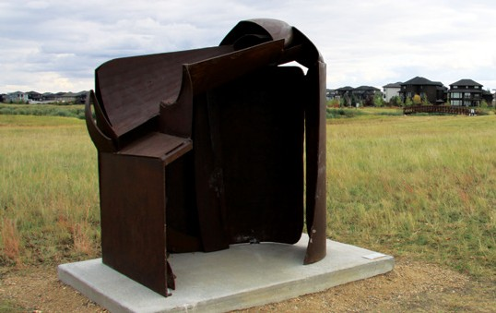

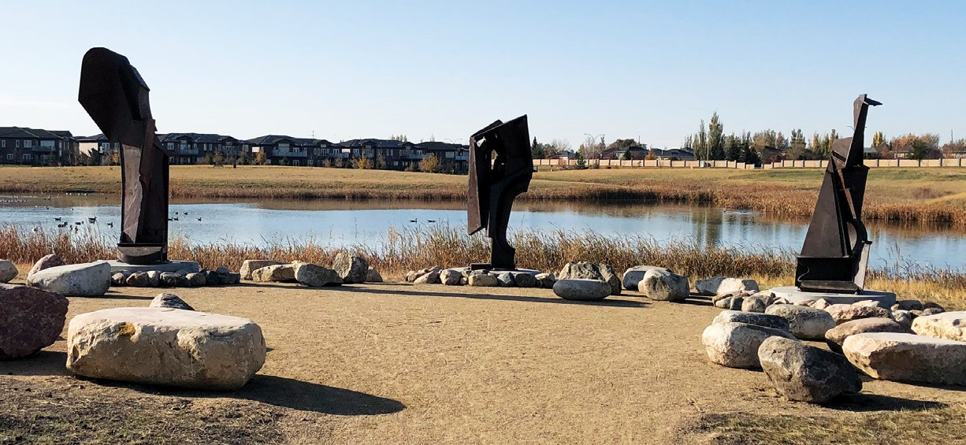
The current issue of Planning + Design is available for download at saskatoon.ca
The information contained in this publication is not copyright protected and may be used freely. The Community Services Department believes all information and sources in this publication to be correct, but cannot guarantee accuracy and assumes no responsibility for its use. Planning + Design is provided as an informational service to the general public and agencies who regularly do business with City Hall. Readers should not act upon the information contained in this publication without seeking professional advice.
City of Saskatoon Planning & Development 222 – 3rd Avenue North Saskatoon, SK S7K 0J5 306-975-2645
city.planning@saskatoon.ca

