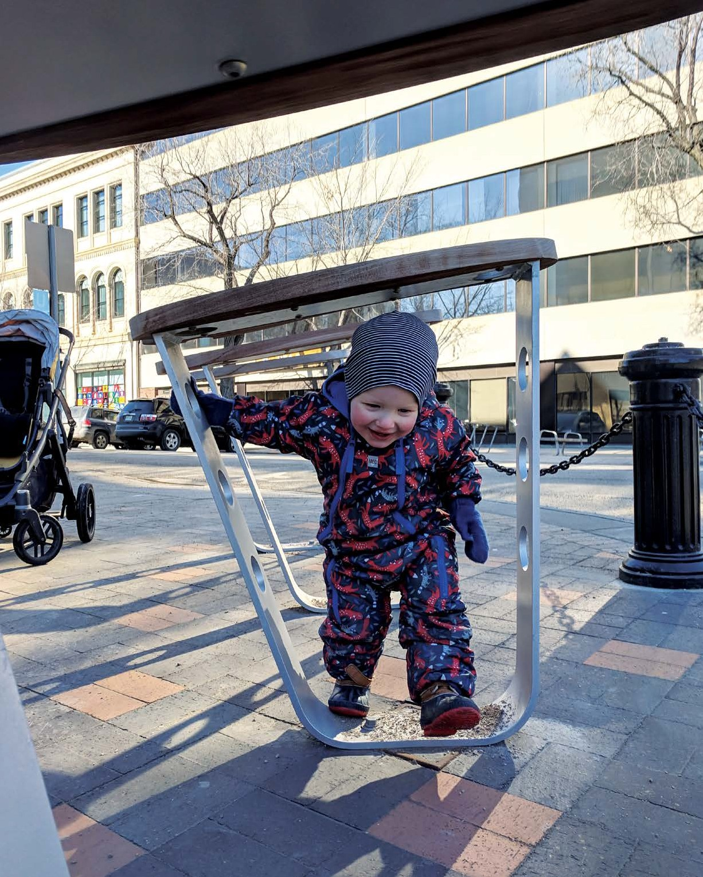

A CITY OF SASKATOON SEMI-ANNUAL PUBLICATION FROM PLANNING & DEVELOPMENT FALL/WINTER 2019

Canopy Assessment
History on 21st Street 20th Street Bike Corral Bus Rapid Transit update
The Future of Winter in Saskatoon Zoning Bylaw Comprehensive Review Changes to the Mobile Food Truck Policy
Heritage Reimagined: The Bunkhouse Project WintercityYXE, Saskatoon’s Winter City Strategy Measuring Perceptions of Safety in Downtown Saskatoon
Does Rental Affordability Improve with High Vacancy Rates?

NEIGHBOURHOOD PLANNING
20th Street Bike Corral
Danae C. Balogun, MCIP RPP, Active Transportation Program Manager | 306-986-0834 | danae.balogun@saskatoon.ca

Earlier this year, 9 Mile Legacy Brewing approached the City of Saskatoon about installing an on-street bicycle corral in front of their business at 229 20th Street West. Corrals can act as destination attractors for local businesses and encourage people to take their local trips by bike. They are also a great way to provide additional bike parking in places where amenity space is tight, such as 20th Street West.

PLANNING + DESIGN FALL/WINTER 2019

Message from the Director
In the last edition of Planning + Design, I laid out a variety of projects we have underway to move us towards a new level of customer service. These projects will provide clearer requirements, more timely responses on requests and more information overall to help streamline development processes. With the number of projects we have underway, some days it feels like we’re trying to move a mountain all at once. And I know we have some community partners who are anxiously waiting for us to move the mountain.

I can promise that there is going to be a shift in the near future. We’re advancing towards some long-overdue technology improvements and we’re bringing forward fee changes to help recover the costs of operations. These changes are absolutely essential to increase our levels of customer service and provide timely application reviews. Working with our colleagues in other divisions, we’re looking at many options to improve services.

These actions will also be supported by the clearer requirements and information that I mentioned last time. This will also mean changes in what we expect from applicants. As an example, through thoughtful collaboration with members of the development industry, our colleagues in Building Standards have laid out new minimum requirements for complete applications. This helps ensure that incomplete applications don’t bog down the system and hold up other applications. It also reduces the amount of follow-up time that staff spend tracking down missing information from applicants.

Residents, businesses and the development industry want and need better and faster service. We recognize that. We’re going to move the mountain to get there.

Lesley Anderson, MCIP, RPP
Director of Planning and Development
306-975-2650 | lesley.anderson@saskatoon.ca
An on-street bicycle corral is a temporary structure placed in an on-street parking space. It is similar to a parking patio, but instead of providing an area for people to sit, it provides a place to park bicycles.

9 Mile, in conjunction with Spoke N Sport and Bldg Studio Inc, led the design of the bike corral. The wood and metal structure provides parking for about 12 bicycles. Additional features include planter boxes, benches, a lighted pergola that illuminates the corral and a feature panel with the call to action “Bike Your City.”

Transportation and Urban Design, with the support of other civic departments and the Riversdale BID, worked closely with 9 Mile on this exciting project. Using the Parking Patio Guidelines as a framework, the project is being piloted for two years to allow for flexibility and to allow for any needed adjustments to the installation. The pilot is intended to operate year-round and will be evaluated annually.
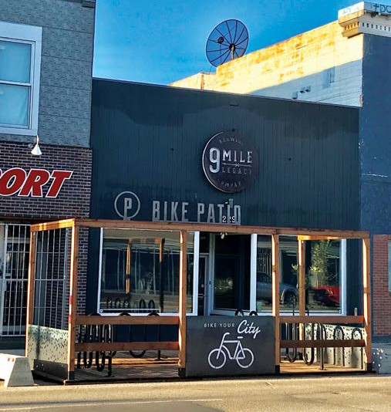

NEIGHBOURHOOD PLANNING
History on 21st Street
Ellen Wardell SAA, LEED AP B+D, Urban Design Manager | 306-986-3686 | ellen.wardell@saskatoon.ca

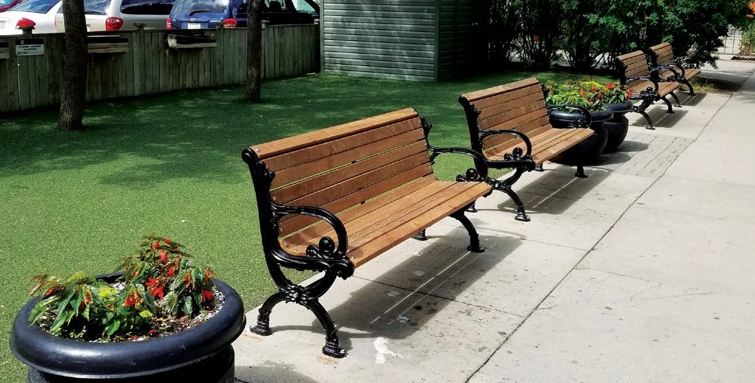Twenty-first Street is one of Saskatoon’s most significant locations, with 13 Registered Historic Places fronting its four-block length. The City of Saskatoon Urban Design Team has undertaken two projects to reinforce and renew 21st Street’s historic character and to celebrate Saskatoon’s rich Indigenous history.
PLANNING & DEVELOPMENT, COMMUNITY SERVICES DEPARTMENT

The original benches have been carefully repaired. Freshly powder coated and reassembled with new hardwood, they are ready for many more decades of life on Saskatoon’s iconic street. The refurbishment has met both aesthetic and cost-saving goals. The modern furniture that has filled the gap for the last few years will be relocated to 2nd Avenue.

The second project is the installation of bicycle racks that display Treaty Six and Homeland of the Métis medallions. Urban Design has consulted members of the Indigenous community and received support and enthusiasm for this effort to continue the recognition of our collective heritage. Gilles Dorval, City of Saskatoon’s Indigenous Initiatives Director, and the Downtown Business Improvement District helped in this process.

The Treaty Six medallion is based on the Chief Medal that was presented to signatories of the Treaty in the 1800s. It was designed to acknowledge growing relationships between Indigenous and non-Indigenous people.

The Homeland of the Métis medallion represents the important contributions of the Métis to the Saskatoon area. It was specially commissioned through a partnership between the Gabriel Dumont
Institute, Senator and Métis Elder Nora Cummings and the North Commuter Parkway Bridge Naming Steering Committee. The Steering Committee was tasked to help establish a name for the bridge now known as Chief Mistawasis Bridge.

Both medallions are featured on the banners installed along the Chief Mistawasis Bridge and as decals on all Saskatoon Transit buses.

“This crucial foundation cannot be forgotten; it is through this visual reminder of the relationship and its significance that this message will be conveyed,” - Treaty Commissioner Mary Culbertson regarding installation of Treaty Six medallion at École St. Paul School.

NEIGHBOURHOOD PLANNING
Does Rental Affordability Improve with High Vacancy Rates?
Michael Kowalchuk, MCIP, RPP Housing Analyst | 306-986-3024 | michael.kowalchuk@saskatoon.ca

Traditional economic and housing market analysis show that fluctuations in apartment rents are driven by an unbalanced market. The demand for rental stock is assumed to depend upon a number of variables including: demographics, disposable income, rental accommodation price and the cost of mortgage credit. These demand-and-supply variables interact to determine the level of rent and the stock of vacant rental units.

A residential vacancy rate of 3 per cent is considered balanced; where tenants have a reasonable amount of choice and supply is adequately meeting demand. Excess rental supply, determined by vacancy rates above 3 per cent, should ultimately put downward pressure on rents. Saskatoon is experiencing a higher than normal vacancy rate of 8.3 per cent which has been elevated since the economic downturn in 2015, as shown in Figure 1.

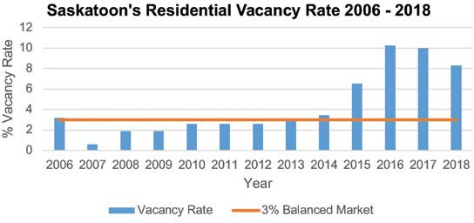
Figure 1: Saskatoon’s Residential Vacancy Rates from 2006 - 2018

With the vacancy rates being relatively high in recent years, Saskatoon should be seeing a significant reduction in rental rates. However, despite a small blip in 2017, rates in Saskatoon have remained relatively steady, as shown in Figure 2.
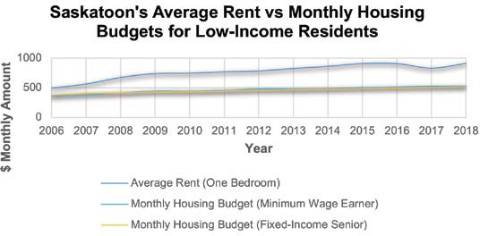
Figure 2: Low Income Monthly Housing Budget vs One Bedroom Rental Rate Average

With rental rates remaining steady, even with a high vacancy rate, affordability continues to erode with low-income earners being hit the hardest. Many low-income earners would find themselves in core housing need and unable to afford an average one-bedroom apartment in the city. This is based on the core housing need definition of monthly pre-tax household income spent on housing not to exceed 30 per cent.

So why haven’t we seen a more significant decrease in rental rates leading to greater affordability?

One possible explanation is that there is a complex lag process that is occurring in Saskatoon’s real estate market. Research identifies three construction lag indicators; the occupiers’ response to change in rents, the developers’ response to changes in demand through the rent adjustment process and the construction delay between starts and completions. Examples of these lags could be renters not negotiating for lower rental prices, landlords’ willingness to hold vacant units and overbuilding in the residential market. All of these elements create lags that lead to unexpected market conditions that can last longer than anticipated.

Another possibility is that Saskatoon has a higher-than-normal natural vacancy rate (i.e. above the 3 per cent balanced market). Some supply side studies have shown that in an environment where building is less constrained and land is abundant, these markets have higher-than-balanced vacancy rates. The barriers to entry for developers in these markets are less, and therefore the costs to build and hold may be less, leading to higher-than- balanced vacancy rates.

Ultimately, the current data in Saskatoon is showing that higher vacancy rates are not leading to better affordability. Rental rates remain elevated and this continues to hit those with the lowest incomes the hardest. Work remains to ensure that more people do not end up in core housing need in the city.

LONG RANGE PLANNING
Bus Rapid Transit update
Rob Dudiak, P. Eng., Special Projects Manager | 306-975-2475 | rob.dudiak@saskatoon.ca

The planned date for the switch from regular transit service to BRT is June 1, 2025.
At the April 2019 City Council meeting, decisions were made about the routes for the new Bus Rapid Transit (BRT) and system components. It will be nearly six years before the full BRT system becomes a reality, and the project team has been focused on routing from mid-2018 to mid-2019. Detailed design of the system is expected to continue until the end of 2019, while aspects of specific stations that require input from local stakeholders will remain open into 2021.

Moving toward implementation, stakeholder teams will be formed to focus on the more complicated geographic sections of the BRT
network. These teams will have a direct voice in BRT planning in these locations. They will provide feedback, share their insights and help communicate to the wider community what is happening with BRT and why. We believe using this team-based approach will help us chart a successful transition from today’s transit service to BRT.

The Crime Prevention Through Environmental Design (CPTED) review of the BRT project is ongoing. Project planning, including project team development for the implementation phase, is underway. Schedule creation, funding planning, strategic communication planning and engagement planning are also being completed. Collaboration with the Corridor Planning Project, Transportation Division initiatives and upcoming civic construction projects managed by the Construction and Design Division are ongoing.

The planned date for the switch from regular transit service to BRT is June 1, 2025.

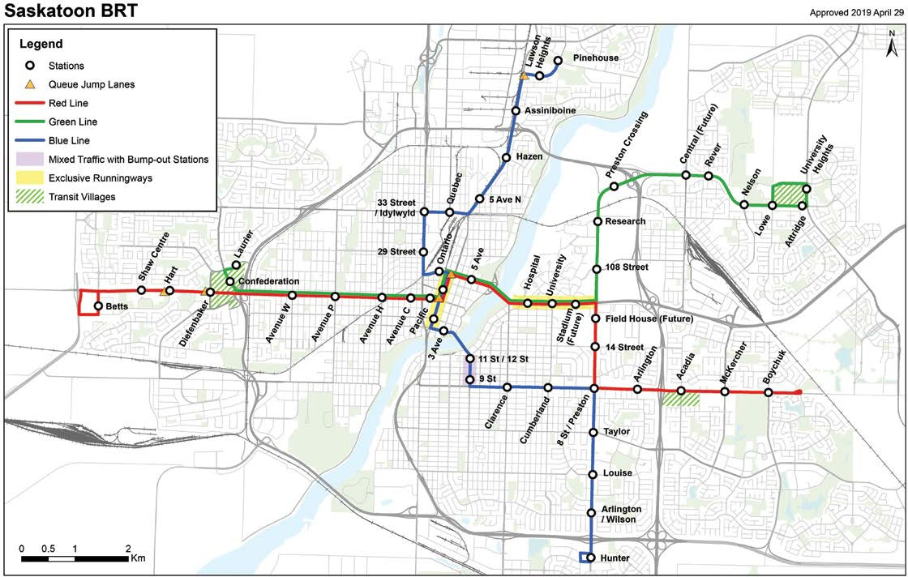

NEIGHBOURHOOD PLANNING
Measuring Perceptions of Safety in Downtown Saskatoon
Mateja Mihinjac, Criminologist | mateja.mihinjac@gmail.com

This summer, a team of eight city planners and I set out to explore how the physical and social environment in Downtown Saskatoon influences perceptions of personal safety.

Perceptions of safety have been understudied in the field of criminology, despite knowing they may affect people’s use of the public realm more than actual crime. Moreover, from Crime Prevention Through Environmental Design (CPTED) we know that particular socio-physical features in the immediate environment may promote or reduce anxieties and fear associated with using that environment. Yet, we rarely measure this association.

As a Criminologist specializing in CPTED, the City of Saskatoon hired me for the summer of 2019 to develop and pilot this Downtown project. The first step included the development of the field data collection survey; a shortened and modified version of the Neighbourhood Safety Audit that incorporates the principles of CPTED. The survey was then digitized in a location- based data collection platform called Fulcrum, which allowed us

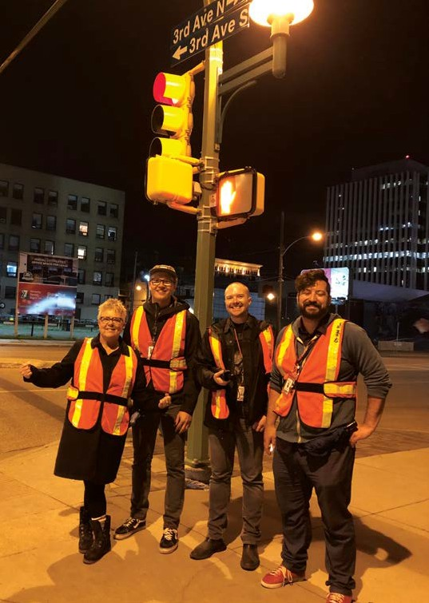
The Green Team
to capture and record data with our mobile devices for use in subsequent analysis.

The next step was data collection. We formed two CPTED teams of four participants from the Planning & Development Division. Each participant had previously undergone CPTED/SafeGrowth training. The teams collected data within the study area over 13 days that included daytime and nighttime fieldwork. Each day and night of fieldwork included intercept surveys with the public and a technical assessment of the area by the CPTED team.

The study area encompassed the blocks and laneways between 1st and 4th Avenues and 20th and 22nd Streets. We conducted the surveys and observations from micro-spatial locations within a radius of 30 metres (100 feet); a total of 108 locations repeated day and night and 596 intercept surveys with members of the public. Despite laborious work, we have gained invaluable insights from both interacting with the public and systematic assessment of the study area.

The purpose of this project was to identify micro-scale environmental features (physical and social) in public space that induce fear and anxiety or, conversely, provide comfort and reassurance. The project’s final step included reviewing collected information and analyzing it in conjunction with aspects of the local environment such as lighting, land use and design features, shop vacancy, crime events and calls for service. Some preliminary findings include:

- The social environment appeared to influence the perceptions much more than the physical environment. This was especially evident in our surveys with the public. While respondents often couldn’t point to particular land use or design feature impacting their perception of safety, they typically were able to note the types of people that increased their comfort levels
when walking down the block. These included local employees, shoppers and people running errands. Conversely, erratic and unpredictable behaviour by some individuals, especially when concentrated to specific areas or locations, often increased their anxieties and discomfort. Lack of activity in particular blocks lessened street activity that could provide more eyes
on the street, a sense of reassurance and dilute the visibility of anxiety-provoking behaviours. This lack of activity was due to uniform or under-active land uses and the 29 vacant storefronts identified in our study area.

- Night-time perceptions of public space did not appear as negative as we might have expected, considering limited after- hours land uses in the larger part of our study area. In fact, some parts were so inactive between 10 p.m. and midnight that we often had very few interview responses from the public and no intercept survey responses for particular locations.
The CPTED team, however, would frequently assess these

under-active areas and locations as anxiety provoking. This was especially true when the prospects of finding emergency assistance were far away, when the audit area was in or near a laneway or when the lighting was poor. On some nights and weeks, late-night social events and festivals (e.g. Jazz Festival, Taste of Saskatchewan, and conferences) activated the area and positively influenced the perceptions of our interviews as well as the CPTED team. Another contributing factor to fairly positive perceptions of safety at
night could be the self-selection of these night dwellers. We heard several times from the daytime respondents, “I would never come down here at night.” This means our night-time sample might have been biased towards the attitudes of groups likely to feel more comfortable and confident walking around the Downtown in the late evening hours, like young males and couples.

Apart from increased street activity, both the public participants and the CPTED team appeared reassured by uniformed presence. They particularly praised the City of Saskatoon Community Support Program for its contribution to increasing feelings of safety in the Downtown. There were many calls for expanding the Program and to extend its evening hours. While several respondents also identified police on bikes or foot as reassuring, many understood that the concerns that influenced their perceptions the most: panhandling, mental illness and drug-induced erratic behaviours were not necessarily a criminal justice issue demanding police response, but rather health and social concerns.

This project has shown us the critical importance of the interplay of both the physical and social environments on perceptions of safety and use of public space. As criminologists we rarely get an opportunity to truly understand this interplay through collecting our own field data. I am fortunate that this project has provided this opportunity for my planning colleagues and I, while also collecting detailed data that can be used to further improve perceptions of safety in Saskatoon’s Downtown area.

Daytime perceptions of safety (Public)
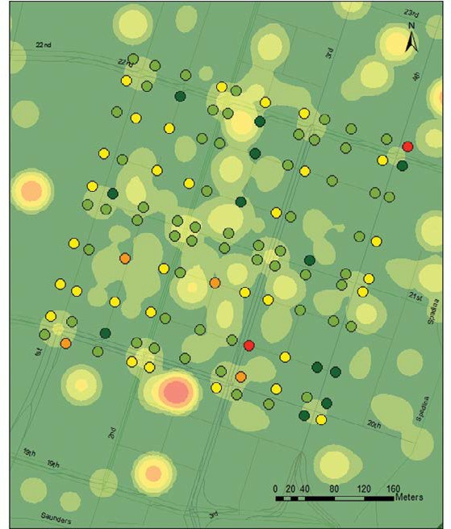
Very safe Safe
Mostly safe, occassionaly risky
Unsafe Very unsafe

Crime incidents 2012 - June 2019
Low density

High density

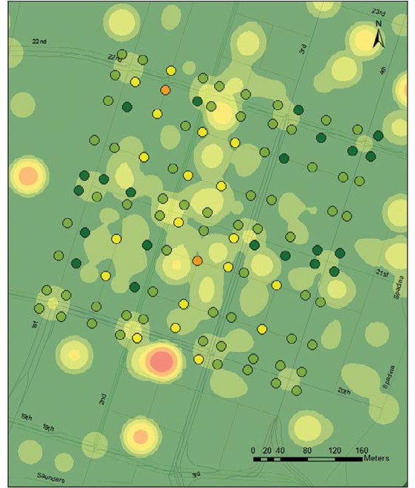
Daytime perceptions of safety
(CPTED team) Very safe Safe
Mostly safe, occassionaly risky
Unsafe Very unsafe

Crime incidents 2012 - June 2019
Low density

High density

LONG RANGE PLANNING
Canopy Assessment
Genevieve Russell, SALA, CSLA, Green Infrastructure Strategy Special Projects Manager 306-986-3650 | genevieve.russell@saskatoon.ca

Trees are living assets that provide many social, environmental and economic benefits to our city. They provide shade, support wildlife habitat, regulate climate, mitigate storm water and beautify our community. Saskatoon’s urban forest is changing due to urban growth, redevelopment in established areas and impacts from invasive pests, diseases and weather events. Protecting and growing the Urban Forest is a key part of the City’s Green Infrastructure Strategy. In order to adapt to the changes and feel confident in our future investments, a plan is needed to manage the City’s green infrastructure.

The Parks and Sustainability Divisions are collaboratively working on the Urban Forest Management Plan. As part of the plan development, Diamond Head Consulting was contracted to complete a canopy assessment. Early results show:
- an average canopy cover of 9 per cent;

- The urban forest canopy is distributed unevenly throughout the city, ranging from 2 to 39 per cent across neighbourhoods (see canopy map below);

- The city manages over 110,000 trees in our parks and on our boulevards; and
- The majority of our trees are elm, ash and spruce. Results of the canopy assessment will help:
- identify strategic planting areas to increase the urban forest;
- improve planting practices to diversify the canopy; and

- understand how the urban forest is changing to better manage it.

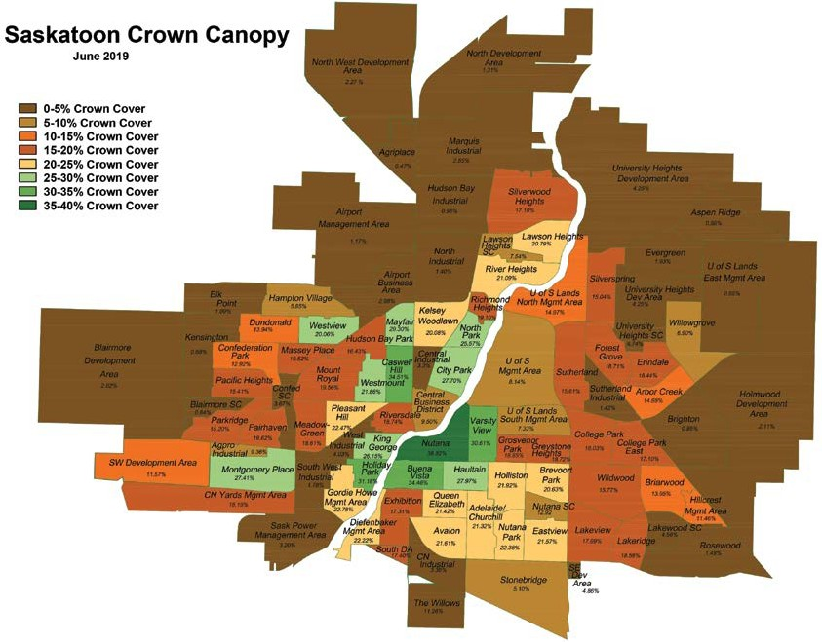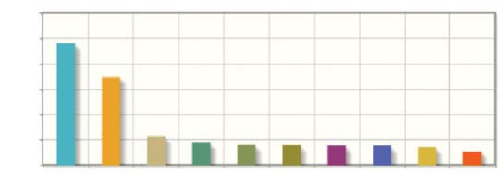
Most Common Species
30K
25K
20K
15K
10K
5K
0
Saskatoon Crown Canopy
June 2019
0-5% Crown Cover
5-10% Crown Cover
10-15% Crown Cover
15-20% Crown Cover
20-25% Crown Cover
25-30% Crown Cover
30-35% Crown Cover
35-40% Crown Cover
– 8 –
American
Elm

Green Ash

Colorado Blue Spruce
Black Ash
Scots Pine

American Basswood
Poplar
White Spruce
Manitoba Maple
Littleleaf Linden

COMMUNITY STANDARDS
Changes to the Mobile Food Truck Policy
Chantel Riou, Planner | 306-986-0866 | chantel.riou@saskatoon.ca

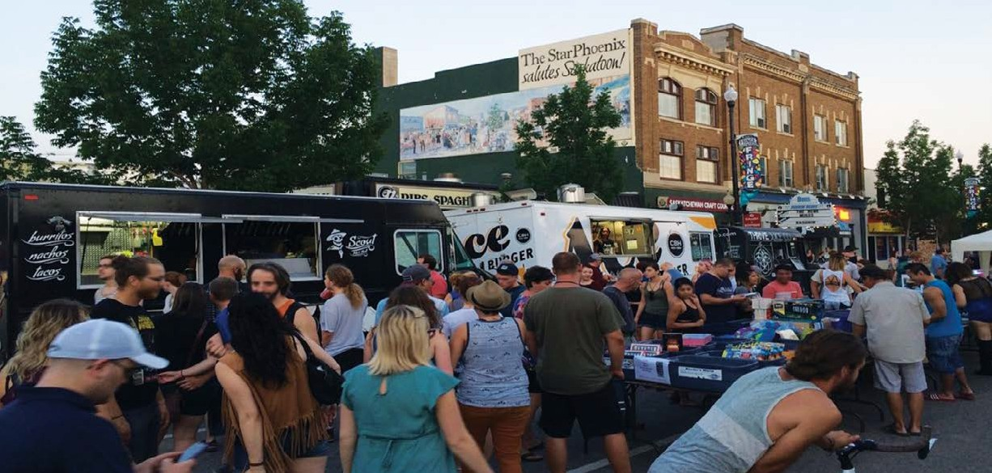The summer of 2019 marks the seventh season of mobile food trucks and trailers operating in the City of Saskatoon. In 2013, City Council adopted the Mobile Food Truck Policy to enhance the overall image, economic vitality and promotion of street life in the downtown and commercial areas through street food vending. Food trucks provide a unique alternative dining choice to consumers. Since their introduction to Saskatoon, there has been a dramatic increase in street use activity through street food vending.
PLANNING & DEVELOPMENT, COMMUNITY SERVICES DEPARTMENT

The policy aligns with the key strategies of the 2013 City Centre Plan in recognizing Saskatoon’s outdoor street environment as an asset the City promotes. City Council’s support of these non- traditional business models helps to create a business-friendly environment while reinforcing the City Centre as a vibrant cultural and entertainment district.

Until 2019, a Food Truck License was required for any mobile vendor operating on-street on the public right of way and off-street on private property. Vendors who chose to solely operate at special events and festivals were exempt from the policy and were not required to hold a license. However, the administration’s position was that all food trucks and trailers operating in Saskatoon should be licensed under the Mobile Food Truck Policy. This provides assurance that health and safety considerations are met through required vehicle inspections. In 2018, there were an estimated 13 unlicensed mobile vendors who operated only at special events and festivals. In contrast, there were 15 licensed food vendors who operated on and off-street.
The policy lays out a regulatory framework specifying how mobile food trucks and trailers operate in Saskatoon. Licensing requirements are in place to ensure fair competition, public health and safety to citizens, and to mitigate any nuisance through awareness. Licensed food trucks and trailers must undergo government inspections from the Saskatchewan Health Authority and Saskatoon Fire to ensure their equipment meets health and safety standards. If the vehicle has natural gas or propane equipment, a gas inspection is required from SaskPower.

In April 2019, City Council adopted amendments to the policy which expanded the scope to apply to all mobile food trucks and trailers operating in the city, including those solely operating at special events and festivals. Every vendor operating in Saskatoon would be required to obtain a license.

Stakeholder engagement was a key factor in expanding the policy; the administration consulted the Saskatchewan Health Authority, Saskatoon Fire, SaskPower, the Business Improvement Districts (BIDs), special event coordinators, mobile food truck and trailer operators and the Saskatoon Food Truck Association (SFTA). Representatives from SaskPower, Fire and Health all agreed with this licensing change as it minimizes the risk of mobile vendors operating at events without health and safety approvals.

The implementation of this policy change has been a great success in the 2019 season. The number of licensed vendors has nearly doubled; in 2018 there were 15 licensed mobile vendors and in 2019 that number jumped to 29. The administration is continuously looking at ways to improve the program and will be holding an end-of-season meeting with operators this fall.

LONG RANGE PLANNING

WintercityYXE, Saskatoon’s Winter City Strategy
Christine Gutmann, RPP, MCIP, Senior Project Planner 306-986-3096 | christine.gutmann@saskatoon.ca

WintercityYXE is a strategy aimed at making Saskatoon’s winter more inviting, vibrant and popular. Through WintercityYXE, residents, businesses and visitors are encouraged to embrace winter with as much enthusiasm as is had in summer months.

The concept of a Winter City capitalizes on opportunities to relieve the real and perceived negative effects of the winter season and reinforce positive ones. The outcome can be a more vibrant, sustainable, prosperous and livable community.

WintercityYXE intends to improve community accessibility, inclusion, activity and energy leading to greater economic strength as the opportunities of winter are recognized and challenges diminished. This will be especially true within service and retail sectors. The intent is to be broad and respond to possibilities associated with winter, while generating a positive winter culture by addressing perceptions, attitudes and behaviours of citizens.

What’s happening in Saskatoon this winter?
There is already so much to do in Saskatoon in the winter! Outdoor winter activities include skating at our amazing outdoor rinks, exploring the dog parks with your furry friends and taking adventurous treks by cross country skiing, snow biking and tobogganing.

The WintercityYXE Grant Program provides a total of $25,000 to non-profit organizations, ad hoc groups, businesses or for-profit organizations who are implementing initiatives that support the WintercityYXE goals and objectives.
The winter 2019-2020 grant recipients are:

- City Park Community Association - City Park Winter Festival
- Friends of the Broadway Theatre - Winterruption Outdoor
- Global Gathering Place - Learn to Skate
- Greystone Community Association - Winter Fun Day
- Lawson Heights Community Association - LHCA Winterfest
- Riversdale BID - Ice Castle - Bing Chengbao
- Saskatoon Nordic Ski Club - Holiday Park Ski Trail Upgrade Estimates
- The Neighbourhood Church - Winter Family Day Carnival
- Saskatoon Open Door Society - Yay! It’s Winter
- Wanuskewin Heritage Park - Kona Winter Festival

If you are interested in getting out this winter and enjoying the many activities and events, or to promote your activity or event on the WintercityYXE events page, visit saskatoon.ca/WintercityYXE.

The Future of Winter in Saskatoon
Kristin Bruce, MPP, CAPM, Special Projects Manager | 306-975-2821 | kristin.bruce@saskatoon.ca

Climate change is impacting weather patterns and conditions in each of our four seasons. A recent report called Canada’s Changing Climate outlined that Canada is warming at double the global rate.

In Saskatoon, the same trend holds true. The average annual temperature has increased more than 1 C since 1902. Meanwhile, seasonal warming trends have even higher rates of change. Warming conditions like these create a cascade of climatic changes, such as shifting precipitation trends and increasing variability during seasonal transition months.

Local Actions: The City of Saskatoon’s Adaptation Strategy, as part of the City of Saskatoon’s Climate Action Plan, outlined climate projections for Saskatoon for the 2021-2050 time period. Climate models of a status quo or business-as-planned emissions rate project the following changes to Saskatoon’s winter season:
- Average winter temperatures are likely to warm by approximately 3 C;
- The frequency of days with temperatures below -30 C is set to fall from an average of 13 per year to around four per year;
- The length of the frost-free season could increase by 20 to 35 days;
- The number of freeze-thaw cycles occurring per year will be highly variable; and
- Winter precipitation rates will be highly variable due in part to changing temperature trends increasing the risk of severe winter storms.

– 10 –
Continued on page 11

PLANNING & DEVELOPMENT, COMMUNITY SERVICES DEPARTMENT

Continued from page 10

WORDS FROM THE INTERNS

Civic winter mobility maintenance services and traditional outdoor recreation offerings like cross-country skiing and ice skating are highly dependent on temperature and precipitation rates. Designing winter infrastructure that can support a sense of place and draw citizens out to experience urban landscapes in winter will increasingly need to consider highly variable snow and rain, stronger winds and warming average temperatures to ensure reliable investment returns, continued usability and value to the community.

In order to contribute to global climate action, the Low Emissions Community Plan sets out a roadmap of 40 actions to guide work on reducing Saskatoon’s greenhouse gas emissions to 80 per cent of the 2014 baseline by 2050. A typical winter season as described above would result from global heating impacts projected under the business-as-planned scenario. Even with major reductions in global greenhouse gas emissions, climate modelling predicts some temperature increases, precipitation changes and an increased likelihood of extreme weather events, albeit at a lower rate than the business-as-planned modelling.

In considering climate projection data, it is important to remember that uncertainty exists in climate projections. As a result, we will not always experience all projected conditions exactly as projected due to natural and unknown variability patterns.

DEVELOPMENT REVIEW

Zoning Bylaw Comprehensive Review
Christine Gutmann, RPP, MCIP, Senior Project Planner 306-986-3096 | christine.gutmann@saskatoon.ca

The City of Saskatoon is undertaking a comprehensive review of the Zoning Bylaw which was last reviewed from 2007 to 2009. To align with identified strategic priorities and current trends, a range of amendments will be considered. These include alignment with City initiatives, business-friendly and economic- development initiatives, environmental initiatives and other current trends in planning.

The review of the Zoning Bylaw will ensure that it meets current and desired trends in commercial, residential and community developments. The review will also include the development of a digital platform for the Zoning Bylaw.

The Zoning Bylaw is a regulatory document that facilitates implementation of the City of Saskatoon’s Official Community Plan. All City of Saskatoon land is assigned a zoning district and is subject to its development standards. Parking, permitted uses and setbacks are included in these regulations.

For more information or to receive updates on the Zoning Bylaw Review project, please visit saskatoon.ca/zoningbylaw.
Dallen Osachuk, Business Licensing
I was very fortunate to return to the City this year as a summer student in the Business License Program. While different than my time in Neighbourhood Planning last summer, the experience has been invaluable just the same.

I was able to familiarize myself with how businesses are licensed in Saskatoon, including the ins and outs of regulations and what they seek to accomplish. I had the opportunity to work on a research project on how urban agriculture might be regulated as a home-based business in Saskatoon. Considering my foray into countless zoning and licensing bylaws, food strategies and community plans, I now feel more comfortable with the regulatory environment in planning and am (slightly) less intimidated by Saskatoon’s zoning bylaw. Seeing the other side of what planners do here has given me a new appreciation for the behind-the-scenes business at City Hall.

Whether learning about interesting businesses through reviewing licenses, exploring Saskatoon’s history through a heritage photo project or examining how regulations could enable a new industry, this experience has been instrumental in building upon my knowledge and confirming planning as the right profession for me. The warm welcome and continual guidance from everyone is greatly appreciated and cemented this summer as another for the books!

Nicole Levine, Bylaw Compliance
For my summer planning internship, I was placed in the Bylaw Compliance Section. I was nervous and had no idea what to expect on the first day, but I was pleased to find that the office was quick to welcome me and valued my input. Over the past three months, my work as a bylaw inspector involved visiting residential, commercial and industrial sites to ensure that parking and landscaping requirements conformed to the Zoning Bylaw. Specifically, I reviewed site plans and zoning check sheets and performed site visits with a focus on parking and landscaping. I would take pictures and notes of the site, then draft and send letters to inform property owners of their requirements.

I was assigned a project to perform an external scan of several municipalities throughout Canada regarding Project Development Signs and landscaping requirements. For the former, I looked at various bylaws to determine what type of sign closely resembles Saskatoon’s Project Development Signs, and then examined the allowable sizes. Aside from looking at the bylaws, I contacted cities directly to gather information. For the latter, I looked at the types of soft and hard landscaping permitted in the required landscaped areas.

The past three months have helped me grow as a person as well as improve my writing and communications skills, both of which will be hugely beneficial for my future endeavours. It has been a great experience and unlike anything I have learned in school so far.

– 11 –
saskatoon.ca

NEIGHBOURHOOD PLANNING
Heritage Reimagined: The Bunkhouse Project
Catherine Kambeitz, MCIP RPP, Heritage and Design Coordinator | 306-975-2993 | catherine.kambeitz@saskatoon.ca

The Sutherland Forest Nursery Station (now the Saskatoon Forestry Farm Park & Zoo) opened in 1913 as a tree nursery and model farm under the Forestry Branch of the Federal Department of the Interior. The complex eventually grew to include staff residences, tree packing and storage areas, a pumphouse for the irrigation system, a greenhouse, botanist research facility, a blacksmith shop and a barn. The Forestry Farm Park was designated as a National Historic Site in 1990.

Constructed in 1916, the bunkhouse is one of four first-generation buildings on the site. The building was originally used to house workers at the site’s prairie nursery and farm. In the mid-1970s the bunkhouse was used as a residence for the site’s zoo keeper, and was eventually converted to office space to serve as the administrative headquarters for the Forestry Farm Park and Zoo.

Since 2001, the bunkhouse has largely remained vacant, with the main floor of the building being used for storage.

Through a collaboration between the Community Development Division and the Forestry Farm Park and Zoo, the bunkhouse was rehabilitated to breathe new life into the space. The work included refinishing the floors and trim, renovation of the bathroom and painting. To provide for the adaptive reuse of the bunkhouse and foster arts and culture within the city, the Recreation and
Community Development Division proposed a pilot project involving the redesign of the bunkhouse as an artist space in 2018.

The Artists in Place: The Bunkhouse Project now involves several artists who have studios in the bunkhouse and engage in various artistries including professional storytelling, electronic works, painting, photography and film.
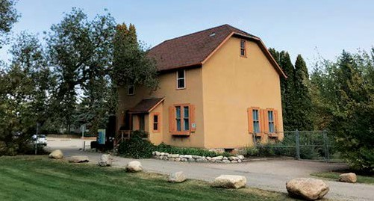
Bunkhouse
Artists in Place: The Bunkhouse Project is an artist-in-residence pilot program sponsored by the City of Saskatoon, with a grant from the Saskatchewan Arts Board’s Artists in Communities program.

Muveddet Al-Katib – artist-in-residence
The current issue of Planning + Design is available for download at saskatoon.ca
The information contained in this publication is not copyright protected and may be used freely. The Community Services Department believes all information and sources in this publication to be correct, but cannot guarantee accuracy and assumes no responsibility for its use. Planning + Design is provided as an informational service to the general public and agencies who regularly do business with City Hall. Readers should not act upon the information contained in this publication without seeking professional advice.

City of Saskatoon Planning & Development 222 – 3rd Avenue North Saskatoon, SK S7K 0J5 306-975-2645
city.planning@saskatoon.ca

