Touchless Accessible Pushbutton Project

The City of Saskatoon has received funding through the Canada Healthy Communities Initiative to install touchless accessible pushbuttons at approximately 20 Accessible Pedestrian Signal (APS) locations in 2023.

What is a Touchless Accessible Pedestrian Signal?
With touchless accessible pushbuttons, the APS can be activated by waving your hand in front of the pushbutton or by pressing the button, which includes a vibrating arrow. As part of a future initiative for the City, these pushbuttons may be activated remotely via an accessible smartphone application.
There are 318 signalized intersections in Saskatoon. These include locations with traffic signals or pedestrian-actuated signals, where the traffic signal is activated by a pushbutton. APS is already installed at 164 intersections, with touchless APS at Redberry Road & Reindeer Road near Lawson Heights School.

What are we proposing?
The City is proposing to install the new touchless accessible pushbuttons in and around the Downtown, at the locations listed below.
List of Proposed Intersections for Touchless APS
24th Street &  Ontario Avenue | 2nd Avenue &  20th Street | 2nd Avenue &  21st Street | 2nd Avenue &  22nd Street
2nd Avenue &  23rd Street | 2nd Avenue &  24th Street | 3rd Avenue &  20th Street | 3rd Avenue &  21st Street
3rd Avenue &  22nd Street | 3rd Avenue &  23rd Street | 3rd Avenue &  24th Street | 4th Avenue &  24th Street
24th Street &  Spadina Avenue | 19th Street &  Avenue A | 19th Street &  Avenue B | 19th Street &  Avenue C
20th Street &  Avenue B | 20th Street &  Avenue C | 20th Street &  Avenue D

A map of these intersections is included on the following page (Figure 1). Existing APS locations that may be eligible for this project (subject to infrastructure assessments), are included in Attachment 1. Wherever possible, the existing APS that is removed will be re-installed at a new location in the City.
Intersections located along future Bus Rapid Transit (BRT) routes are not being included in this project, as they will receive APS upgrades in conjunction with BRT.

When will the new touchless accessible pushbuttons be installed?
The installations are planned for Spring/Summer 2023.
In the future, new APS installations will use touchless accessible pushbuttons. The City has a program in place to add APS to existing signalized intersections each year.

Have Your Say! We Want Your Feedback:
We want your feedback on where these touchless accessible pushbuttons should go in Saskatoon, and how the City should prioritize intersections for future APS installations.

Take Our Survey
Complete our online survey to share your feedback on accessible pedestrian signals in Saskatoon.
The survey should take about 5-10 minutes to complete: https://forms.office.com/r/m7iBLV2GZB
Or, submit your comments to the project team by email at transportationsurvey@saskatoon.ca

Figure 1: Map of Proposed Touchless Accessible Pedestrian Signal (APS) Locations

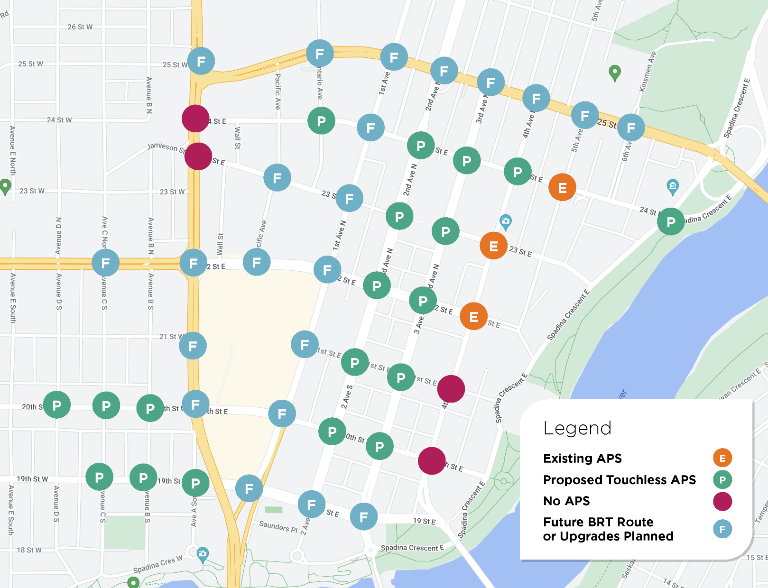

Attachment 1: Eligible Accessible Pedestrian Signal Locations
(Excluding Bus Rapid Transit Routes and Planned Upgrades)
108th Street & Egbert Avenue
115th Street & Forrest Drive
19th Street & Avenue A
19th Street & Avenue B
19th Street & Avenue C
20th Street & Avenue B
20th Street & Avenue C
20th Street & Avenue D
20th Street & Avenue H
20th Street & Avenue M
20th Street & Avenue P
20th Street & Avenue Q
24th Street & Spadina Avenue
2nd Avenue & 20th Street
2nd Avenue & 21st Street
2nd Avenue & 22nd Street
2nd Avenue & 23rd Street
2nd Avenue & 24th Street
2nd Avenue & 26th Street
33rd Street & Avenue D
33rd Street & Avenue W
33rd Street & Confederation Drive
33rd Street & Northumberland Avenue
33rd Street & Valens Drive
3rd Avenue & 20th Street
3rd Avenue & 21st Street
3rd Avenue & 22nd Street
3rd Avenue & 23rd Street
3rd Avenue & 24th Street
4th Avenue & 24th Street
51st Street & Warman Road
8th Street & McPherson Avenue
Acadia Drive & Centre Mall
Avenue H & 23rd Street
Avenue P & 23rd Street
Avenue W & Rusholme Road
Berini Drive & 115th Street
Boychuk Drive & Highway 16
Boychuk Drive & Slimmon Road
Boychuk Drive & Taylor Street
Brighton Gate & Secord Way/Gibson Bend
Central Avenue & 108th Street
Central Avenue & Fedoruk Drive
Central Avenue & Konihowski Road
Circle Drive & Avenue C
Clarence Avenue & 14th Street
Clarence Avenue & Main Street
Clarence Avenue & Ruth Street
Clarence Avenue & Wilson Crescent
Diefenbaker Drive & Centennial Drive
Fairlight Drive & Diefenbaker Drive
Idylwyld Drive & 36th Street
Laurier Drive & Diefenbaker Drive
Lenore Drive & Redberry Road East
Lenore Drive & Russell Road
Lorne Avenue & Ruth Street
Market Drive & Meadows Parkway
Marquis Drive & Arthur Rose Avenue
Marquis Drive & Burron Avenue
Marquis Drive & Siemens Avenue
McKercher Drive & 105th Street
McKercher Drive & Avondale Road
McKercher Drive & Parkdale Road
McOrmond Dr & Stensrud Road North
McOrmond Drive & Brighton Gate
McOrmond Drive & Central Avenue
McOrmond Drive & College Drive North
McOrmond Drive & College Drive South
McOrmond Drive & Evergreen Blvd/Baltzan Boulevard South
McOrmond Drive & Fedoruk Drive/Baltzan Boulevard North
McOrmond Drive & Feheregyhazi Boulevard
McOrmond Drive & Kenaschuk Crescent/Henry Dayday Road
McOrmond Drive & Kerr Road/Stensrud Drive
McOrmond Drive & Lowe Road/Range Road 3050
McOrmond Drive and Kenaschuk Crescent/Aspen Ridge Road
McOrmond Drive and Range Road 3051
Meadows Parkway & Big Box
Spadina Ramp & Spadina Crescent
Stonebridge Boulevard & Cope Lane
Stonebridge Boulevard & Wellman Crescent/Cope Way
Taylor Street & Arlington Avenue
Taylor Street & McKercher Drive
Taylor Street & Rosewood Gate North
Taylor Street & Weyakwin Drive/Heritage Crescent
Wanuskewin Road & Marquis Drive
Wiggins Avenue & Temperance Street
Zimmerman Road & Market Drive
Zimmerman Road & Meadows Parkway

